|  |
| --- |
| Figure 1 |
| **SAILING SCHEDULE**  **QUANTUM SOP – OCEAN** |
| |  |  |  | | --- | --- | --- | | CGL/HKG – DENNIS LAW | 4/1/21 | COPYRIGHT @Chain Global Limited | |

CONTENTS

OVERVIEW – SAILING SCHEDULE 2

PROCESS OVERVIEW – SAILING SCHEDULE 3

PREREQUISITES 4

SEARCH/VIEW SAILING SCHEDULE 5

CREATE SAILING SCHEDULE 7

LINK SAILING SCHEDULE 8

Booking 8

Shipment 8

UPDATE SAILING SCHEDULE 9

Edit Sailing Schedule 9

Update the shipment linked with schedule 10

TRACKING 11

REPORT 12

FAQ 13

Helpdesk Contact 13

DOCUMENT HISTORY 14

# OVERVIEW – SAILING SCHEDULE

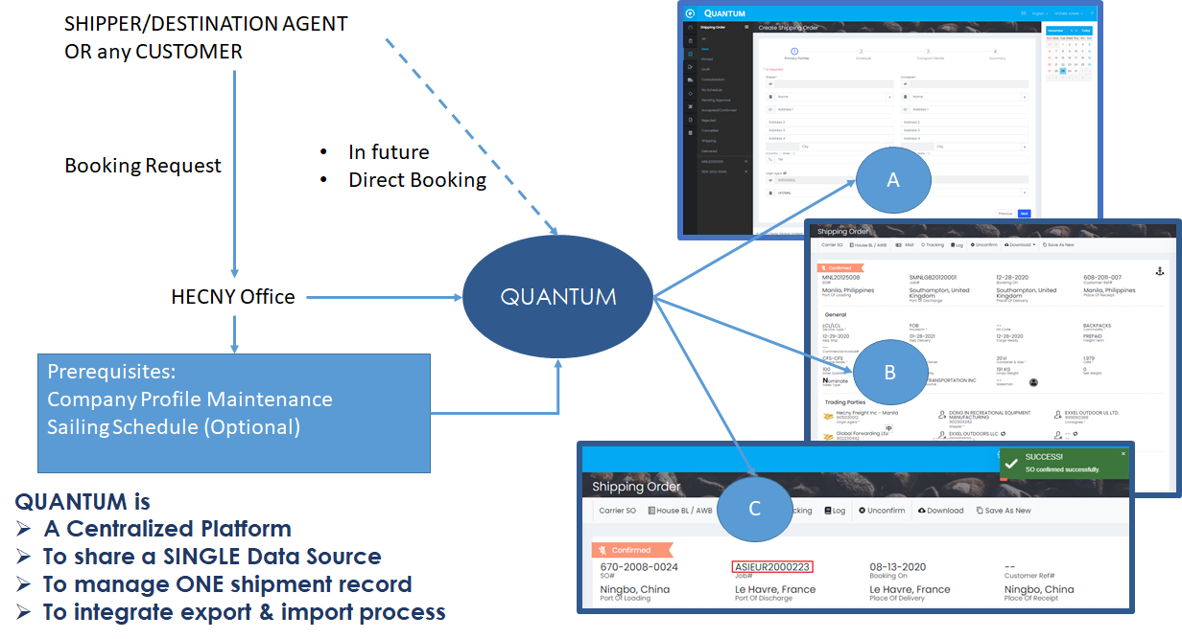

In Quantum, we strive for the data integrity to reduce duplicate effort to complete the booking and shipment. If the prerequisites have done well, user who do the booking would be comfortable and confident.

To maintain single data source, we enforce user to use Quantum to maintain the sailing schedule. User should follow the SOP to create, maintain and confirm sailing schedule.

# PROCESS OVERVIEW – SAILING SCHEDULE

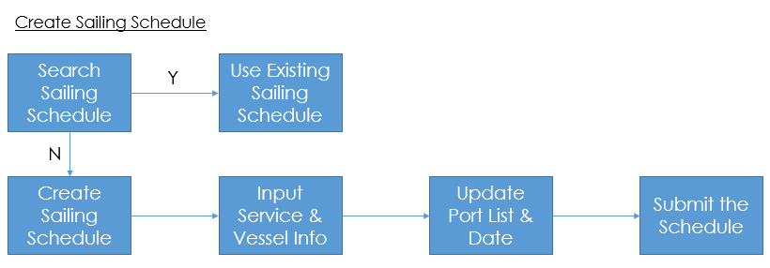

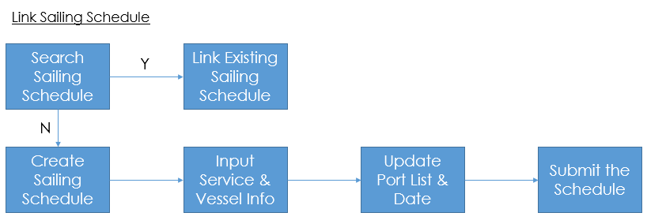

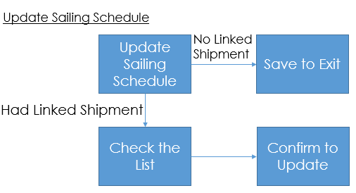

# PREREQUISITES

Sailing schedule is only for mother vessel from POL to POD.

Service maps has already in Quantum. User may view/search them but not edit it. If there is any missing service map, please seek assist from Support Team.

Before create sailing schedule, user should have the basic information of the sailing schedule which shown as below:

Vessel Information

1. Service map/code
2. Carrier code
3. Vessel Name
4. Voyage#

Port List (optional at this moment)

1. Port detail
2. ETD/ETA
3. CFS/CY closing
4. SI/VGM cutoff

# SEARCH/VIEW SAILING SCHEDULE

**Purpose**: Ensure no duplicate sailing schedule/update the sailing schedule

**When**: Before create sailing schedule/looking for sailing schedule to update

1. Go to **Master** and select **Sailing** **Schedule**
2. View the pre-filtered list
3. Search from the search panel to look up for required sailing schedule
4. Click the down arrow to see the detail of port list
5. Click **Sailing Schedule Ref#** to see the complete detail

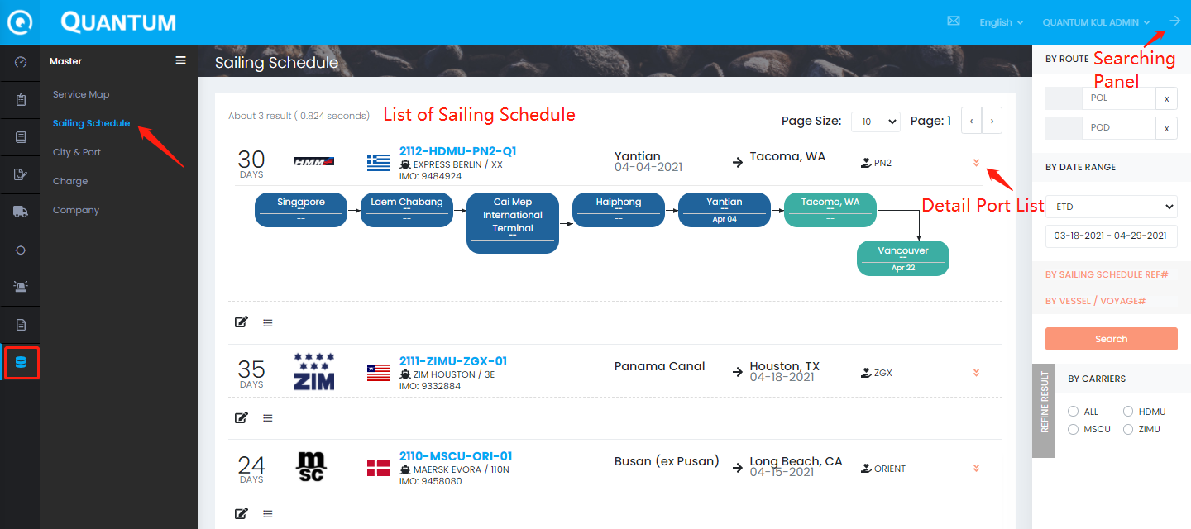

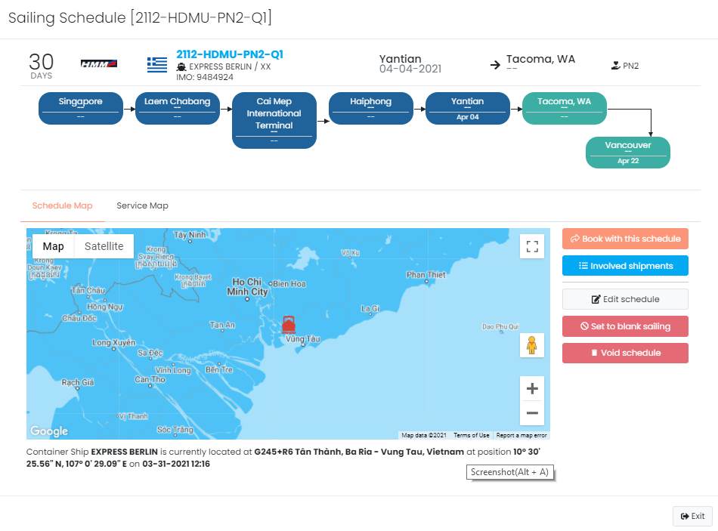

In the detail, there are 5 functions which could be performed,

1. **Book with the schedule** – redirect to create shipping order
2. **Involved shipments** – show the shipment list by this schedule
3. **Edit schedule** – show the edit panel to edit the schedule detail
4. **Set to blank sailing** – either disable whole vessel or some of the ports (not docked)
5. **Void schedule** – void the schedule and no one can use that anymore

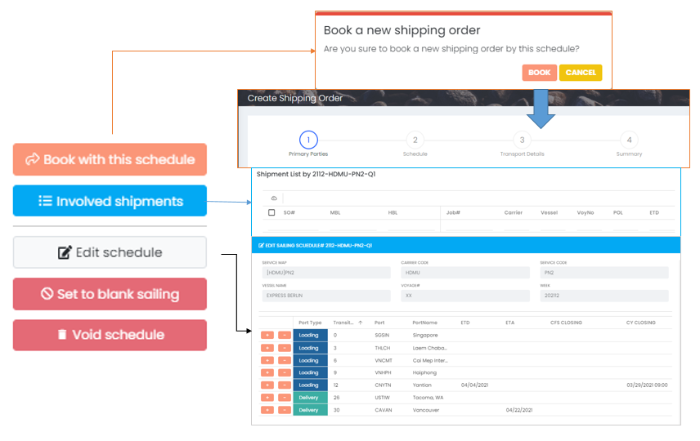

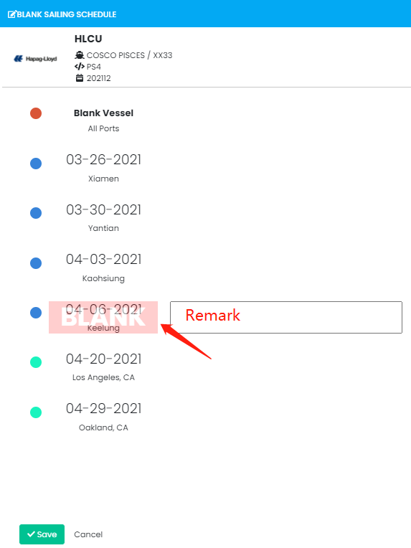

# CREATE SAILING SCHEDULE

**Purpose**: Create the sailing schedule for SO/Shipment to link up

**When**: No existing available/valid sailing schedule

1. Click the + button (right-hand side, bottom corner) to open create panel
2. Input service, vessel information
3. Click Next to update port list
4. Submit to confirm the schedule

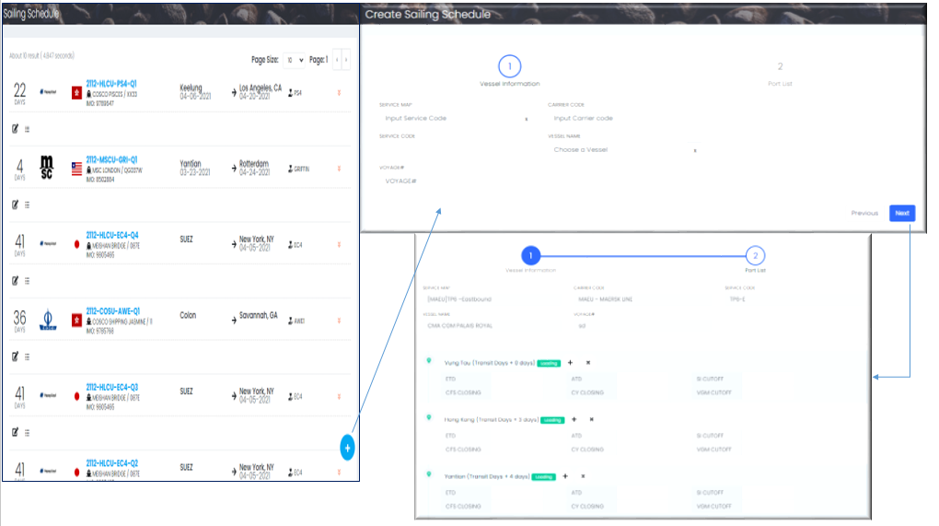

After submit the schedule, the sailing schedule reference no. would be automatically linked

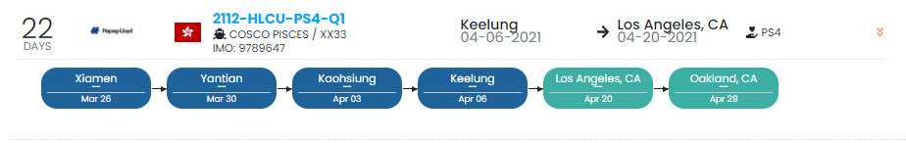

# LINK SAILING SCHEDULE

**Purpose**: Link the sailing schedule with shipping order

**When**: After create shipping order

## Booking

Except link the booking when create sailing schedule, user can do it after create booking.

1. Go to **Shipping Order** and the processing **order detail**
2. Edit **Schedule**
3. Click the search button on the top of the pop-up panel
4. **Search** sailing schedule
5. **Select** the sailing schedule
6. **Submit** to link up the schedule and the shipping order
7. If no available sailing schedule, user should create the sailing schedule which has similar process in above section

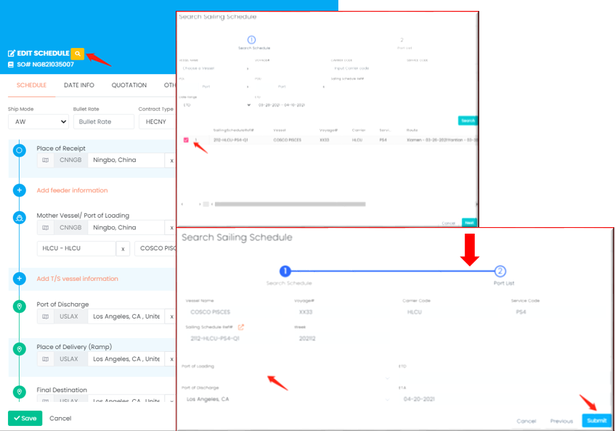

If no available schedule,



## Shipment

The sailing schedule should be carried from booking to shipment.

# UPDATE SAILING SCHEDULE

**Purpose**: Update the sailing schedule

**When**: Receive the updated information, i.e. ETD, transition time, etc.

## Edit Sailing Schedule

1. Go to list of sailing schedule
2. Click **Edit** to open the detail
3. Amend the detail if necessary
4. Click **Save** to confirm the changes
5. Input **Reason** and click **OK** to proceed

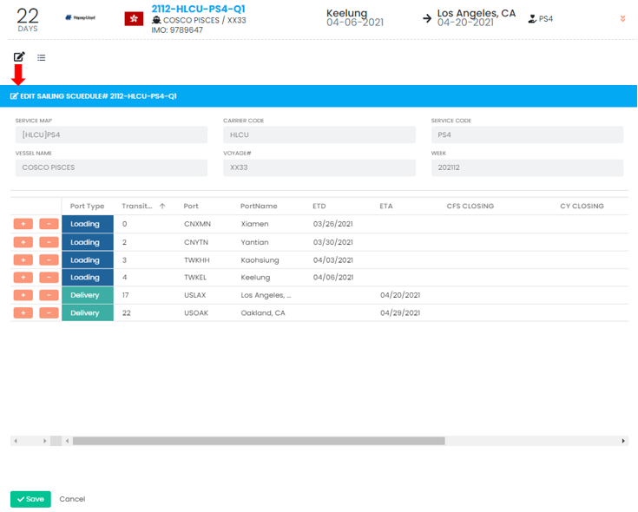

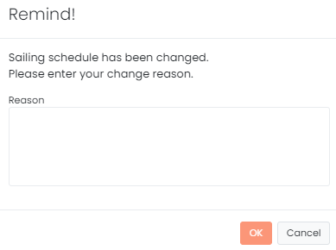

## Update the shipment linked with schedule

1. Go to list of sailing schedule
2. Click the **List** to show the shipment list linked with this schedule
3. If there is any mismatch detail with the schedule (updated schedule), red color would be shown to warn the user
4. User should **select** the shipment under their management (**check the box** on the left-hand side)
5. Click **Update Date** to update the shipment
6. Click anywhere outside the panel to exit

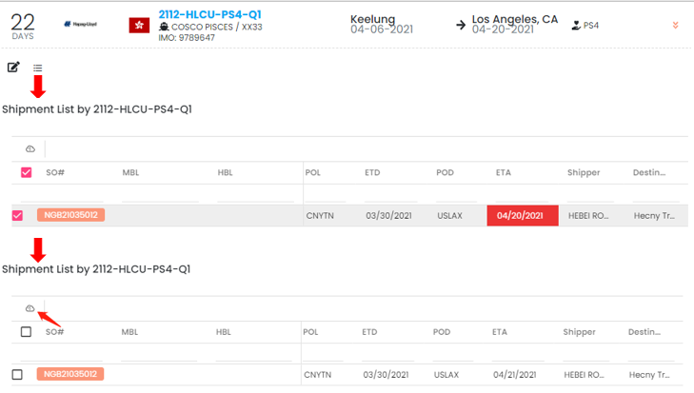

# TRACKING

**Purpose**: Showing the last event and the tracking

**When**: Whenever user would like to track the containers, shipments, POs

1. Go to **Tracking** and select the tracking type
2. Search date range, number, customer name in the search panel
3. View the list of result with last event
4. Click on the numbers, i.e. container#, seal# to view the tracking

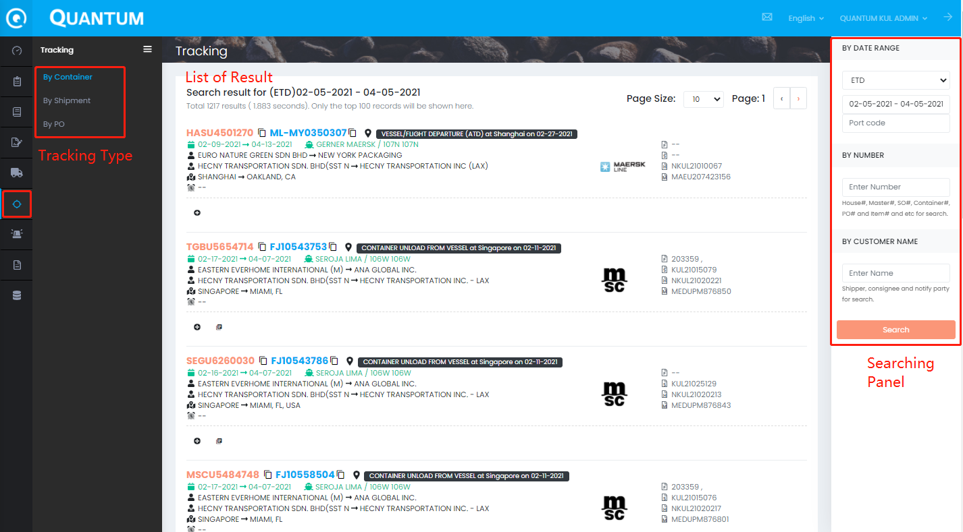

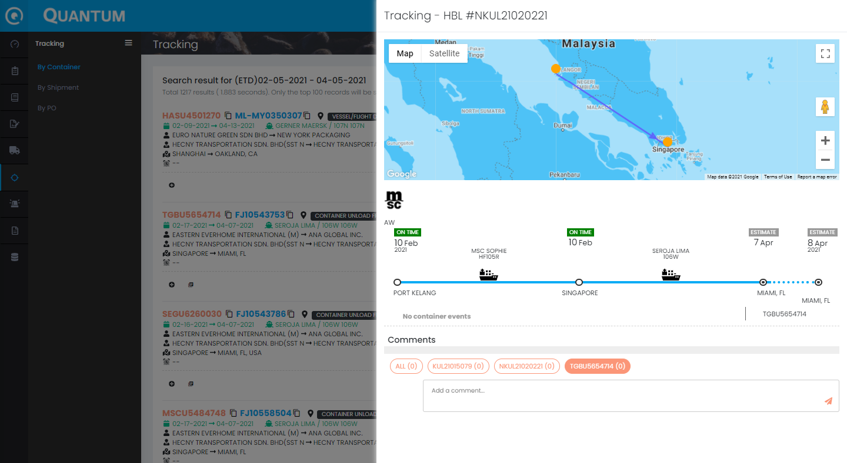

# REPORT

**Purpose**: Generate the station report

**When**: Based on request

1. Go to **Reports**
2. Select **Station** folder
3. Click **Setting** to select the criteria
4. Amend the criteria
5. Click **Generate** to export the raw data/**Submit to Report Agent** to generate the report from report server

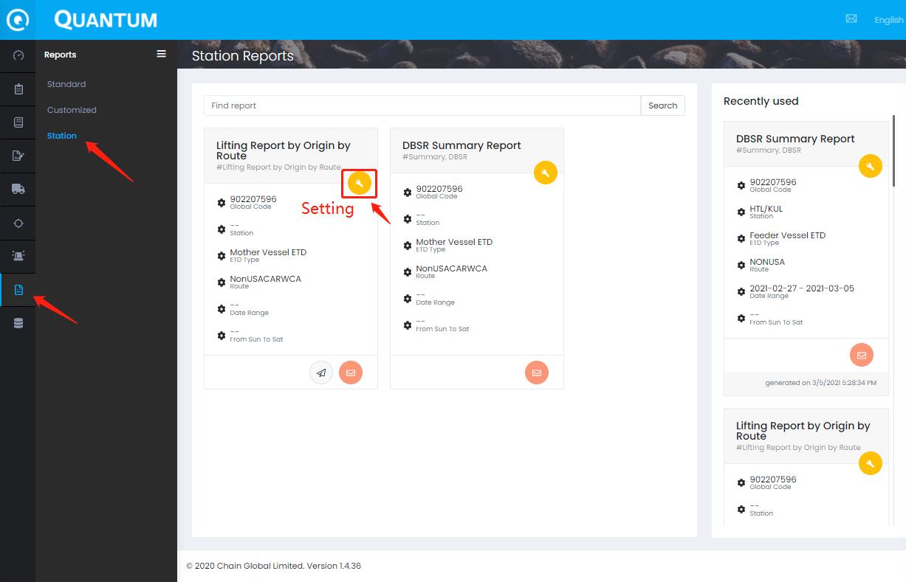

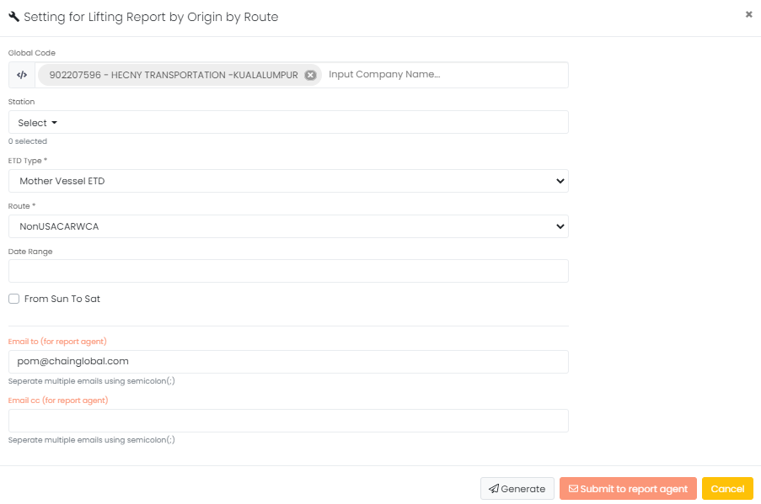

# FAQ

## Helpdesk Contact

The Quantum Team is responsible for system testing, implementation, and helpdesk. If need any enquiry, you can contact the following key persons to resolve the daily operation issue.

|  |  |  |  |
| --- | --- | --- | --- |
| Name | Role | Contact Information | Service Regions |
| Happy Lee | Helpdesk Manager | [happylee@chainglobal.com](mailto:happylee@chainglobal.com) | International |
| Eric Chan | Supply Chain Officer | [ericchan@chainglobal.com](mailto:ericchan@chainglobal.com) | International |
| Support Team | Support Team | support@chainglobal.com | International |
| Judy Qin | Import Lead | judyqin@chainglobal.com | China & Taiwan |
| Chris Chen | Export Lead | [chrischen@chainglobal.com](mailto:chrischen@chainglobal.com) | China & Taiwan |

# DOCUMENT HISTORY

|  |  |  |  |
| --- | --- | --- | --- |
| Date | Prepared by | Change description | Reviewed by |
| 2021-04-01 | Dennis Law | Initiation | Johnny Ko |
|  |  |  |  |
|  |  |  |  |
|  |  |  |  |
|  |  |  |  |
|  |  |  |  |