**Quantum SOP – HBL PRINT (Copy)**

-Add copy function (refer to OF6)

Version : Version 1.4.141

1. Go to HBL Print - Copy HBL – Input the HBL# which you want to copy from

在HBL PRINT 点击COPY HBL 输入想要COPY的旧HBL#

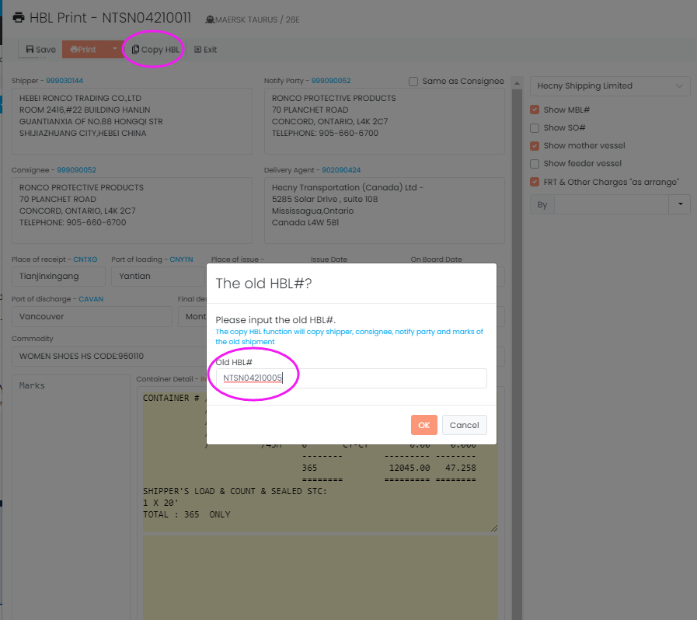

1. Copy Shipper/Consignee/Notify/Marks/Description into HBL Print successfully .

Edit HBL print info and save .

Then Marks, Description would be save back to HBL - Marks, Description.

将从旧HBL#复制Shipper/Consignee/Notify/Marks/Description到当前HBL Print.

复制完成后，用户继续编辑当前HBL PRINT内容。也可以直接修改Marks/Description

保存HBL PRINT 后Marks/Description会直接保存回HBL CNTR下面的Marks/Description

Attention : No need to input Marks, Description before HBL Print now.

注意： 如果想要COPY用户就不提提前在HBL CNTR下先维护Marks/Description

