|  |
| --- |
| Figure 1 |
| **BOOKING**  **QUANTUM SOP – OCEAN EXPORT** |
| |  |  |  | | --- | --- | --- | | CGL/HKG – DENNIS LAW | 1/12/21 | COPYRIGHT @Chain Global Limited | |

CONTENTS

OVERVIEW – BOOKING 2

PROCESS OVERVIEW - BOOKING 3

PREREQUISITES 4

Company Profile Maintenance 4

General 7

Contact 8

Accounting 9

Operation 10

Multiple Address 15

Attachments 16

Assigned OPN 18

Quotation 19

Sailing Schedule (Optional) 22

CREATE BOOKING 25

MAINTAIN BOOKING 29

General Information 30

Trading Parties 33

Sailing Schedule 35

Container 39

Attachment 40

Comment 41

CASE STUDY – T/S Shipment (SO#) 43

CONFIRM BOOKING 44

FOLLOW-UP 46

FAQ 49

Helpdesk Contact 49

DOCUMENT HISTORY 50

# OVERVIEW – BOOKING

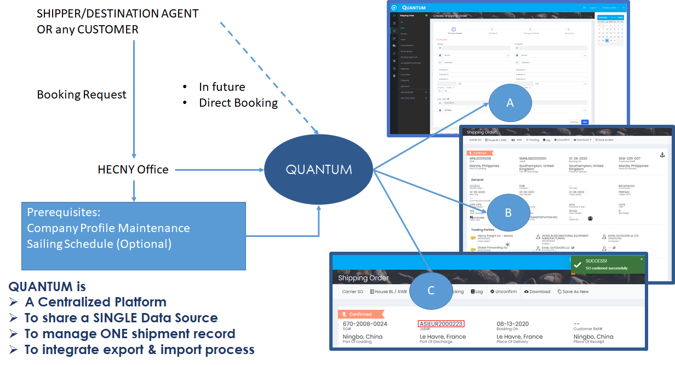

Booking is the beginning stage of a shipment. In Quantum, we strive for the data integrity to reduce duplicate effort to complete the booking and shipment. If the prerequisites have done well, user who do the booking would be comfortable and confident.

To maintain single data source, we enforce user to use Quantum to do the booking. Once user received the booking request from customer, user should follow the SOP to create, maintain and confirm booking.

There are three major process

1. Create Booking – follow the 4 steps in Quantum to create draft of shipping order
2. Maintain Booking – update the shipping order, i.e. sailing schedule, container
3. Confirm Booking – confirm the shipping order after confirmation of sailing schedule and carrier SO number

# PROCESS OVERVIEW - BOOKING

Create Booking

Maintain Booking

Confirm Booking

There are 3 major steps to complete booking, i.e. create, maintain and confirm booking. In each major step, user need to base on the information to process the booking. All of the steps should be achieved in **Shipping Order** menu.

# PREREQUISITES

## Company Profile Maintenance

Company profile contains contacts, accounting terms and operation rules maintenance in order to improve SOP quality and Customer Relationship Management. There are 6 tabs in company profile.

**Purpose:** Create a new company for shipment.

**When**: Company is not existing in system.

1. Go to Company folder then input company name to search. Click **here** to create new company if not found

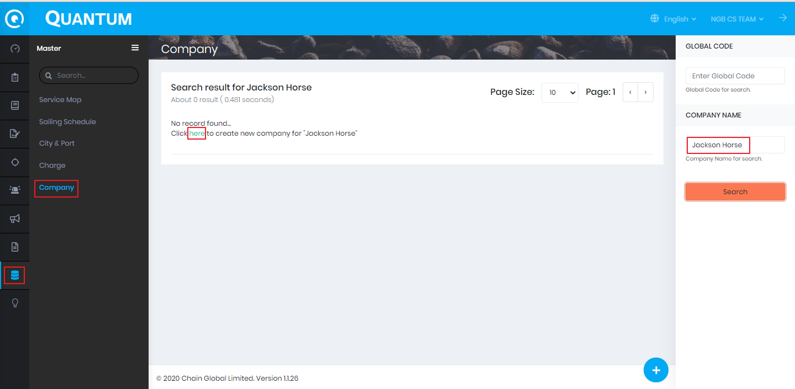

1. Input from **Display Name** to **Industry** then click **Submit**

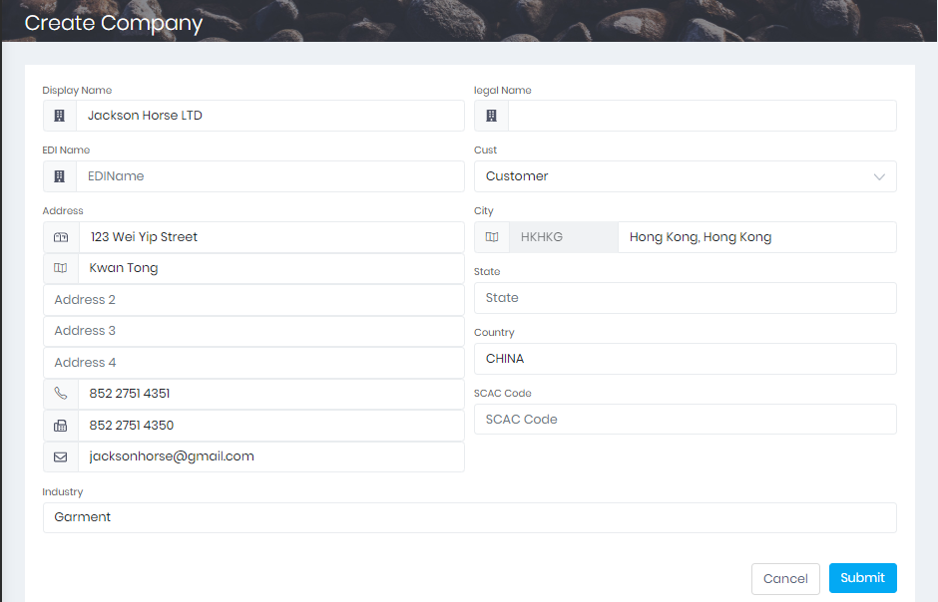

1. Global Code (Company) Code has been created. Click the code for further edition

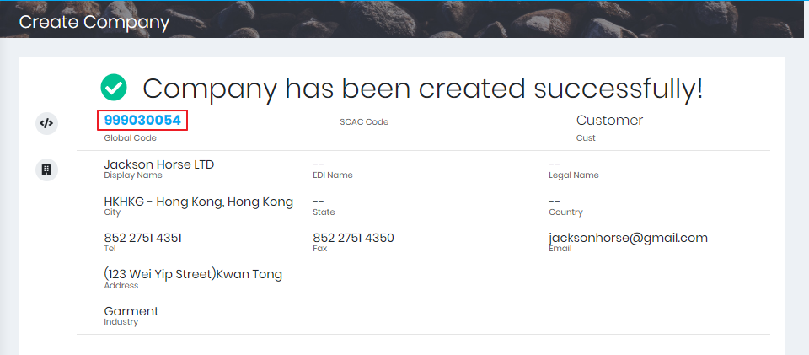

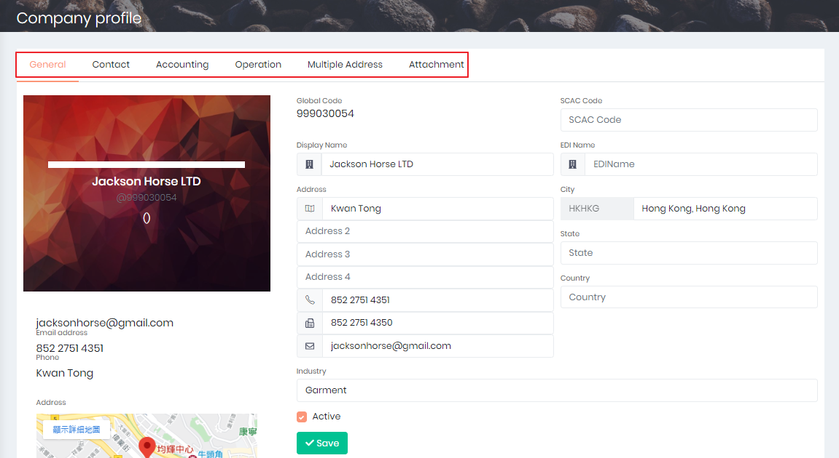

### General

**Purpose:** Overview of company general information such as Global Code, contact, address and logo

1. Check the accuracy of general information

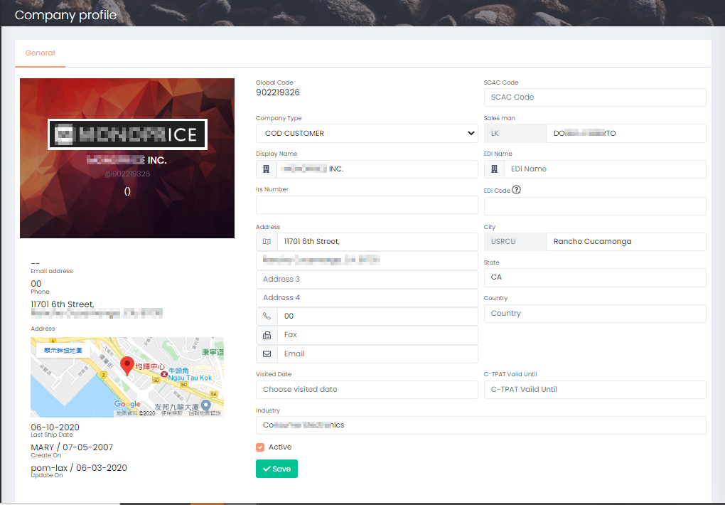

### Contact

**Purpose**: Company main staff contact

1. Click +/+10 to add row(s) of the contact list of the company
2. Input Display Name, Gender, Job Title, etc.
3. Click Save when the contact list has updated

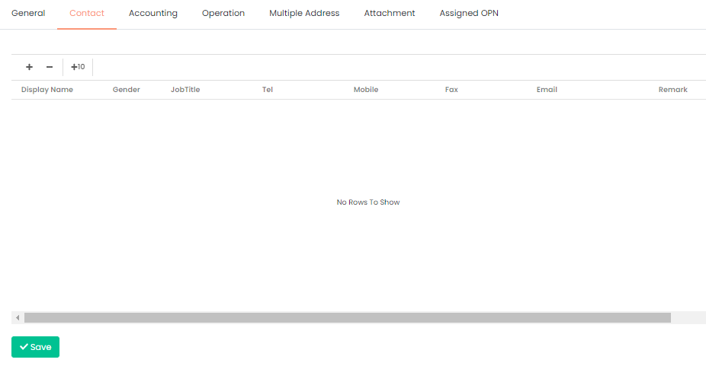

### Accounting

**Purpose**: Setup Credit Term and AR Aging.

In this section, it consists of 4 types of accounting information, i.e. Credit Term, AR Aging, RSR, Reference. If the information is missing, it would affect the <<>>.

1. Edit if there is related information

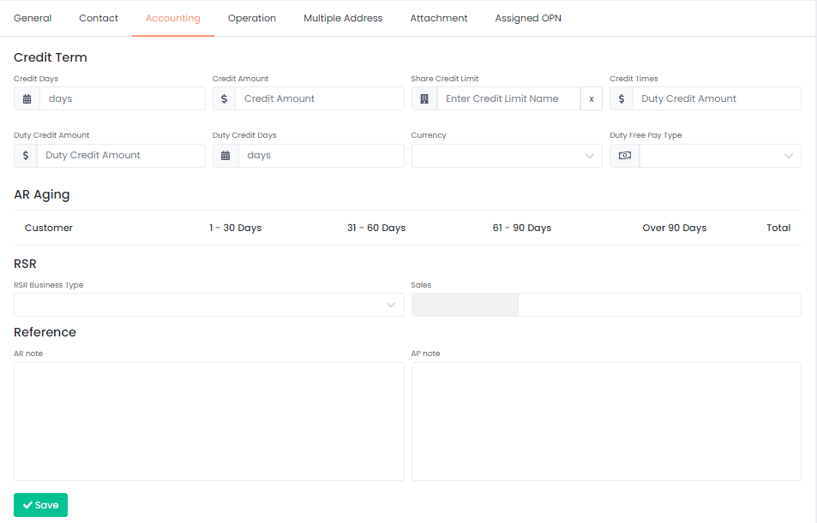

### **Operation**

**Purpose**: Setup company operation rules such as essential document, deliverable, email recipient and broker etc.

In this section, all operation related setting has to be settled before operation.

1. File Check, if the document has been uploaded to section Attachment, red cross would turn into green tick to indicate upload successfully.
   1. POA: Import Power of Attorney
   2. EIN: Employer Identity Number
   3. Bond: Customs bond
   4. Special Handling Instruction: Any special handling instruction
2. Sections
   1. Redirect the user to the sections below
3. Setting
   1. AN Show PO#: Indicate whether the email subject of sharing AN need to show PO#
   2. Need ISF: Need Importer Security Filing
   3. Need Cancel IT: Need cancel IT
   4. Need charges on Arrival Notice: Show charges on Arrival Notice
   5. Need PO No: Show PO# in VIP report
   6. Inv Need Cons Address
   7. Our Brokerage Service: Our brokerage service customer
   8. Need IP (Commercial Invoice & Packing List): Need customer submits the IP for customs clearance
   9. Combine HBS
   10. Combine Invoice
   11. HBS No Chk VSL
   12. POM Cons: POM Customer

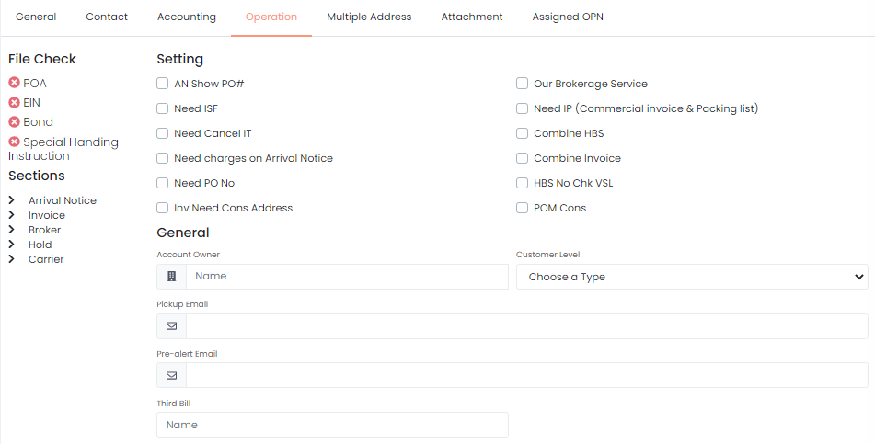

1. General

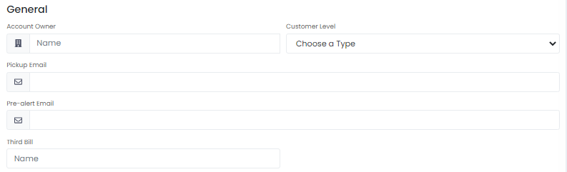

* 1. Account Owner: auto complete and select the company which own this account
  2. Customer Level: indicate it is E-booking client or POM buyer
  3. Pickup Email: Email contact for pickup
  4. Pre-alert Email: Email contact for pre-alert
  5. Third Bill: auto complete and select the company which is third bill

1. Arrival Notice

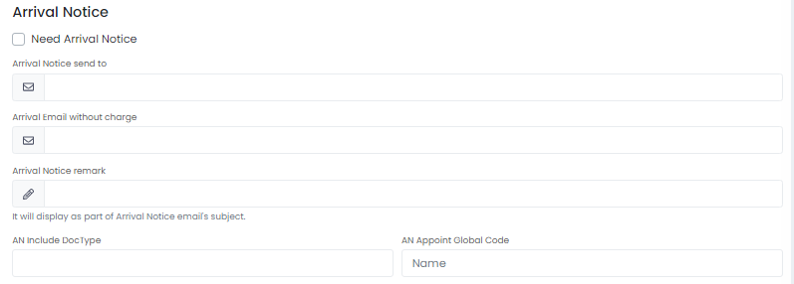

* 1. Need Arrival Notice: check if the company need to receive arrival notice
  2. Arrival Notice send to: enter email contact of the default recipients of arrival notice with charge
  3. Arrival Email without charge: enter email contact of the default recipients of arrival notice without charge
  4. Arrival Notice remark: it will display as part of Arrival Notice email’s subject
  5. AN Include Doc Type: input the document type that include in AN
  6. AN Appoint Global Code: auto complete, select the company appointed the AN

1. Invoice

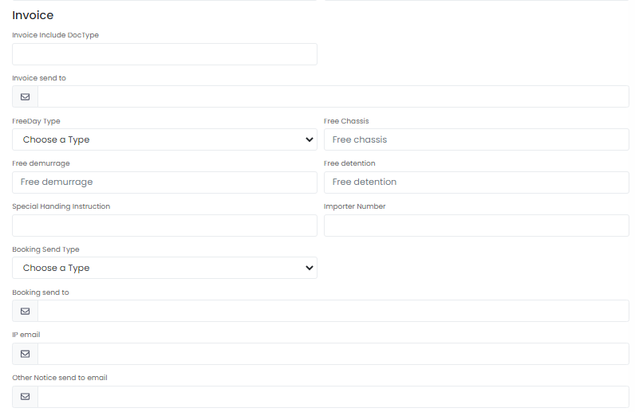

* 1. Invoice include Doc Type: input the document type that include in the invoice
  2. Invoice send to: enter email contact of the default recipients of the invoice
  3. Free Day Type: select from the drop down list, i.e. calendar day, working day
  4. Free Chassis: the minimum
  5. Free demurrage: No. of day for free demurrage (from in gate to out gate in CY or CFS)
  6. Free detention: No. of day for free detention (from out gate to empty return)
  7. Special Handling instruction: Special handling instruction
  8. Importer Number: Customs-assigned identification
  9. Booking Send Type: need booking confirmation reply from consignee. Notification -> Booking notification only.
  10. Booking send to: enter email contact of the default recipients of the invoice
  11. IP email: email address for tracing IP submission
  12. Other Notice send to email: enter email contact of the default recipients of other notice

1. Broker

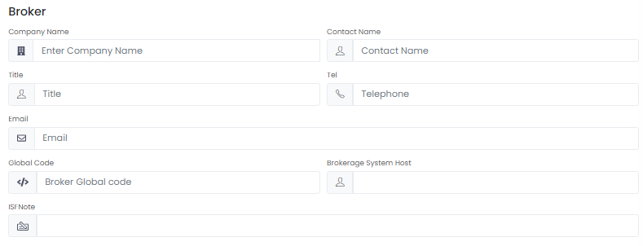

* 1. Company Name: auto complete, select the company as broker
  2. Contact Name: enter contact person name
  3. Title: enter contact person title
  4. Tel: enter contact person phone number
  5. Email: enter contact person email
  6. Global Code: auto-filled by system after select the company
  7. Brokerage System Host: database name of Henry brokerage system
  8. ISF Note: note for handling Importer Security Filing

1. Hold

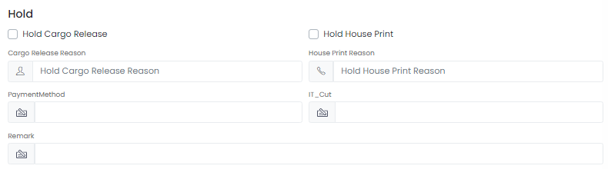

* 1. Hold Cargo Release: check if this company need to hold cargo release
  2. Hold House Print: check if this company need to hold house print
  3. Cargo Release Reason: input the reason to hold cargo release
  4. House Print Reason: input the reason to hold house print
  5. Payment Method: input the payment method
  6. IT Cut: Custom clearance at the end of rail service
  7. Remark: any remark of the operation in cargo release

1. Carrier

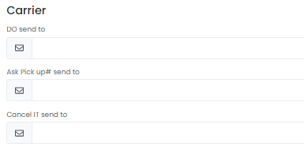

* 1. DO send to: enter email contact of the default recipients of Delivery Order
  2. Ask Pickup# send to: enter email contact of the default recipients for asking pickup number
  3. Cancel IT send to: enter email contact of the default recipients for cancelling IT

After finished the setting in this section, click ‘Save’ before exit or proceed to next page.

### Multiple Address

**Purpose**: Setup different addresses for delivery, billing and so on

As a company would have multiple addresses, user could manage the address under this section.

1. Click +/+10 to add rows
2. Input the detail information of the address (swipe right via scroll bar)
   1. Type: Invoice Address/Delivery Address
   2. Company Name
   3. City Name
   4. State Code
   5. Address1
   6. Address2
   7. Address3
   8. Postal Code
   9. Country Code
   10. Tel
   11. Fax
   12. Email
   13. Contact
   14. Trucker
3. Click ‘Save’ to confirm the address
4. Click ‘Edit Address’ to amend the address

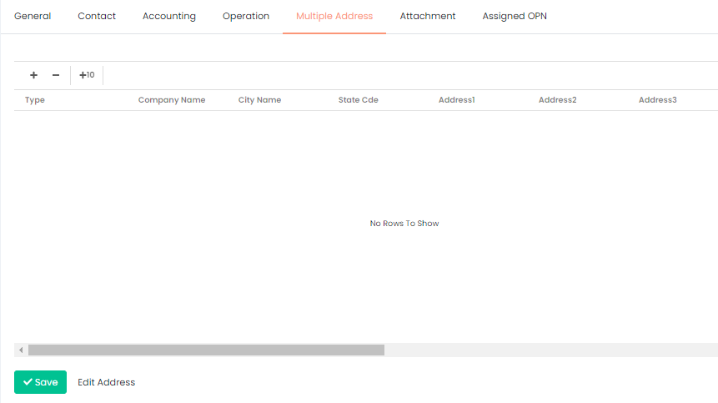

### Attachments

**Purpose**: Keep important information such as BOND file, SOP, certificates, special handling instruction

In section Operation, there is a part File Check. By uploading the required document according to the company nature, the red cross would be become green tick to indicate the successful approval.

1. Click ‘Upload’ to open the File Uploader panel
2. Drag and drop to this panel to upload the file
3. Select document type from the drop down list after uploading to this panel
   1. AP SOP
   2. AR SOP
   3. BOND File
   4. Company Logo
   5. Credit Control Approval
   6. Employer Identification Number
   7. General Profile
   8. Insurance Certificate
   9. Power of Attorney
   10. Sales Call
   11. Special Handling Instruction
   12. Trucking Company
4. Input any remark if needed
5. Click ‘Remove’/’Remove all’ if the document is invalid
6. Click ‘Upload all’ if the files and types are confirmed to be valid

Remarks:

File size limit: 5MB

Support file types: jpg,png,jpeg,bmp,gif,pdf,doc,xlsx,xls,docx,png,zip,msg,txt,tif

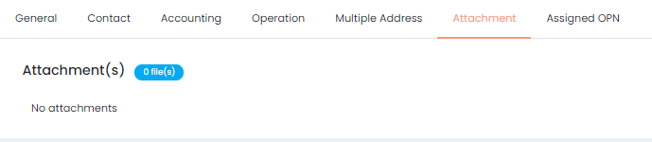

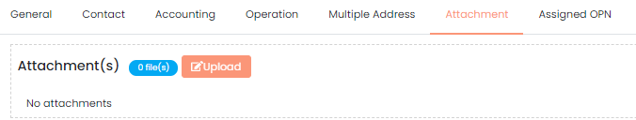

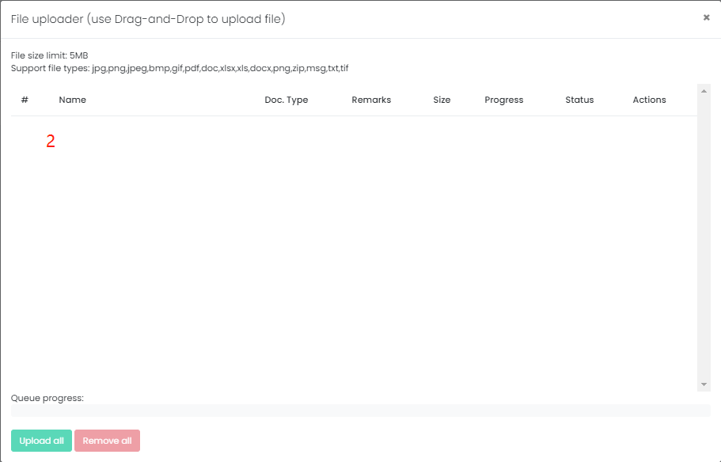

### Assigned OPN

**Purpose**: Identify the agent, operation and operation type

In this section, user would identify the origin/destination agent, operation and operator’s type who handle this company

1. Click +/+10 to add rows
2. Input the detail information of the address
   1. Agent: auto complete after key in the keyword, showing the company name
   2. Operation: auto complete after key in the keyword, showing the operation under the company
   3. Type: select from the drop down list to indicate the type of operation
      1. AIR Export
      2. AIR Import
      3. Ocean Export
      4. Ocean Export FCL
      5. Ocean Export LCL
      6. Ocean Import
      7. Ocean Import FCL
      8. Ocean Import LCL

Remark: the difference between Ocean Export and Ocean Export FCL/LCL is that some company would differentiate FCL & LCL but some would not, therefore Ocean Export would include both FCL & LCL, vice versa

1. Click ‘Save’ to confirm the agent

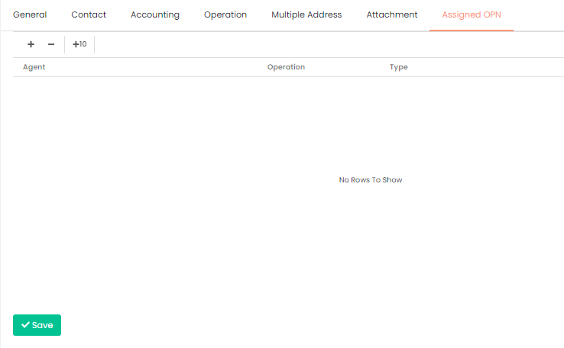

### Quotation

**Purpose**: Record the quotation detail and provide evidence to FMC

**When**:

**Regular check & update to prevent from FMC’s penalties (starting from USD 5,000)

Currently, the detail come from OID, but in the future, all the process should be done in Quantum.

In this session, user could add, amend, copy and share the quotation information. Once the quotation information share/send to consignee, the quotation detail could not be changed anymore. The **Send Consignee Date** would be shown in detail as below:

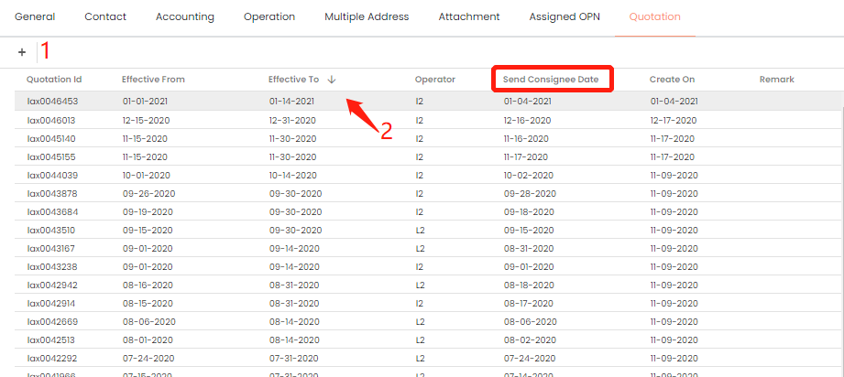

1. Create/Add quotation button
   1. Click to add new quotation
   2. Follow the 4 steps to create new quotation, please make sure you have the basic information, detail, other charge (if any), other remarks before create

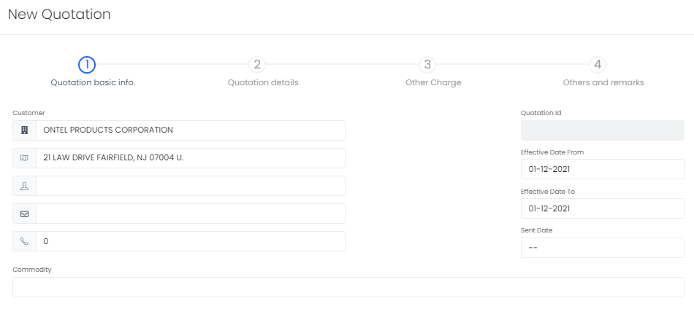

1. Quotation List
   1. Basic information could be view from the list, i.e. quotation reference id, effective date range, send consignee date, create date, remark
   2. Click to view/amend the detail, if there is send consignee date already, no amendment could be made

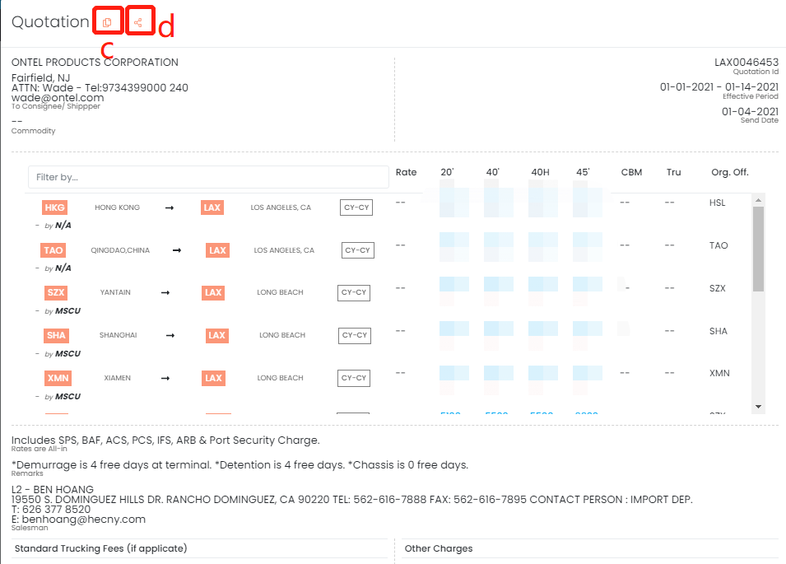

* 1. In the detail panel, apart from amend the detail, you may copy to prepare next quotation, click **Copy** to create new quotation with the same quotation detail, amend it (especially effective date) and save it to complete new quotation

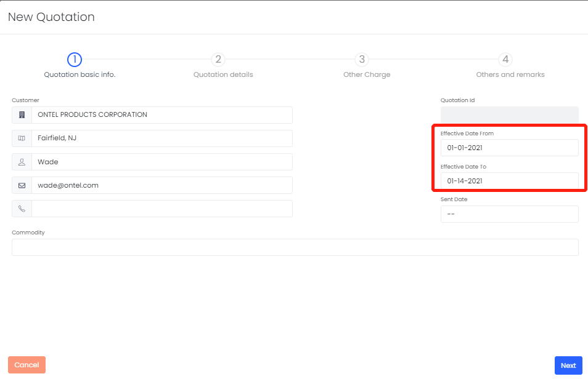

* 1. You may share the quotation detail to requested parties, click **Share** to send email

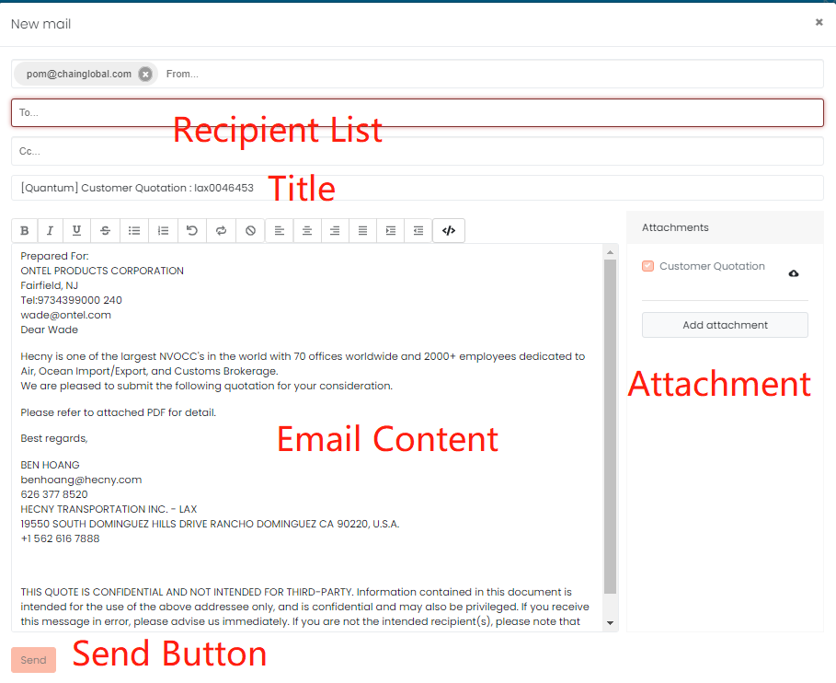

1. Recipient List: ensure the list is correct as quotation information is sensitive
2. Title: if there is any special request, you may edit the email title as well
3. Email Content: if there is any special request, you may edit the content as well
4. Attachment: you may download the quotation to preview in advance to check the accuracy, or you may add other attachment(s)
5. Send Button: check the above 4 elements before click the send button to send the email

## Sailing Schedule (Optional)

Apart from the company profile, sailing schedule could be set in **Master** in advance. The benefit to set in **Master** is that this sailing schedule could be share to multiple station/origin and shipments. The adjustment on the sailing schedule need to be updated in **Master** but not go to every booking/shipment having the same sailing schedule.

**Purpose:** Create a new sailing schedule/Search for existing sailing schedule.

**When**: A new booking has created/Receive new sailing schedule from carrier.

1. Go to **Master** folder and select **Sailing Schedule**

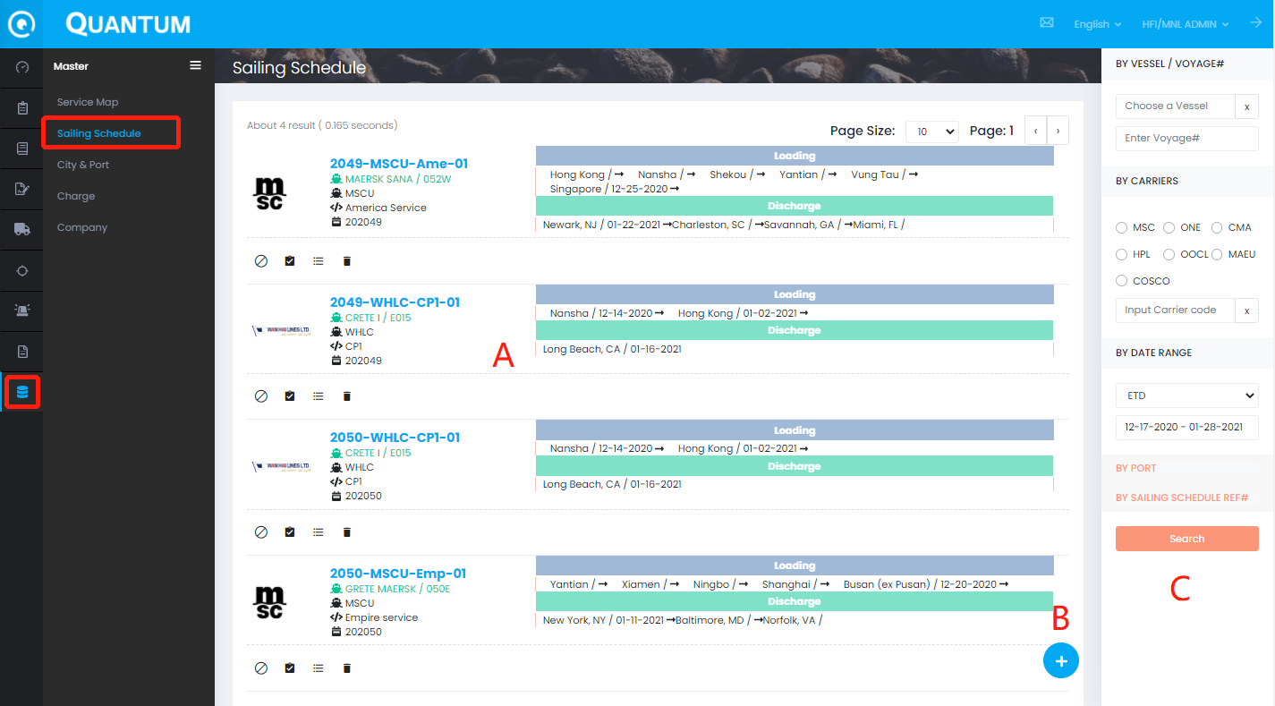

A – List of sailing schedule

B – Create button: click to create new sailing schedule

C – Search panel: enter the searching criteria based on the shipment and search for the existing sailing schedule

1. **List of Sailing Schedule**

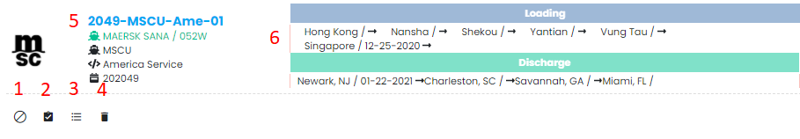

1. Blank:
2. Book: redirect user to create new booking with the sailing schedule information
3. List: show the shipping order that used this schedule
4. Remove: delete the schedule from the list
5. Sailing Schedule Vessel Information: include reference number, vessel name, voyage, etc., user may move the cursor to check the meaning
6. Loading & Discharge Detail: include port and date information
7. **Create New Sailing Schedule**

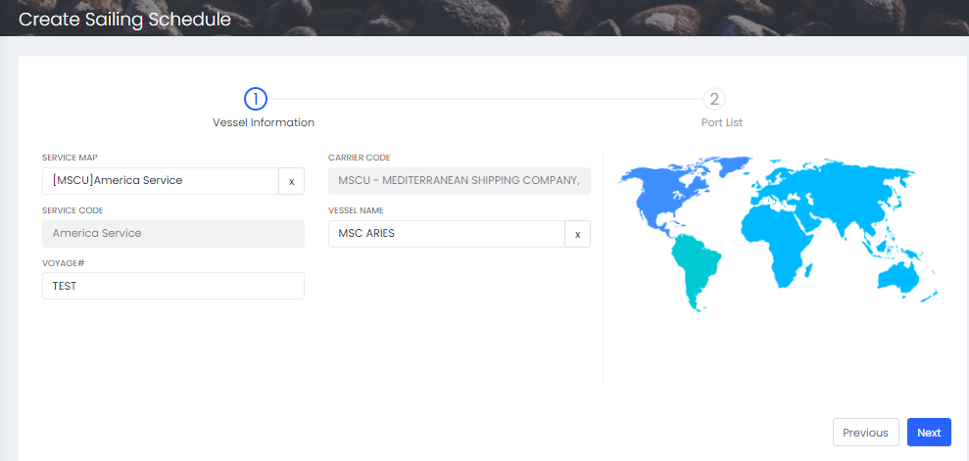

1. Click the button to go to create session
2. Create session includes 2 parts, i.e. Vessel Information, Port List
3. Input vessel information, i.e. service code, carrier code, vessel name, voyage
4. Click **Next** to enter **Port List**
5. Input transit time, port type, ETD, ATD, SI CUTOFF, CFS CLOSING, CY CLOSING, VGM CUTOFF for each port (if any)
6. Click **Previous** if this is the schedule you want
7. Click **Submit** if you confirm the information of the schedule
8. **Search Panel**

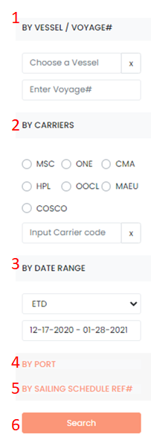 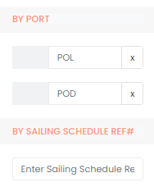

There are 5 searching criteria available in the search panel. User does not need to fulfill all of the 5 criteria only if user want to specify the criteria.

1. BY VESSEL/ VOYAGE#: input the vessel/voyage
2. BY CARRIERS: choose from the checkbox list or input the carrier code (if the carrier is not from the list)
3. BY DATE RANGE: choose the date type and choose the date range
4. BY PORT: click to expand this session, input the POL/POD
5. BY SAILING SCHEDULE REF#: input the sailing schedule reference number

# CREATE BOOKING

**Purpose**: Create a new booking for client’s shipment. This function is available for all trading parties (shipper/consignee/forwarders/sales).

**When**: Origin receives booking request from shipper/destination agent/consignee. Or customers would like to submit booking themselves.

1. Click **New** under Shipping Order in menu

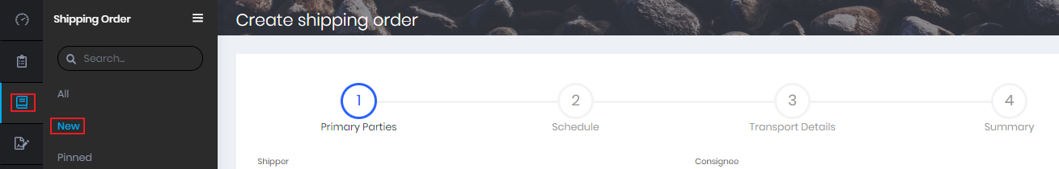

1. Input from **Shipper** to **Origin Agent**. Click **Next** (Origin Agent will be auto assigned based on the login ID)

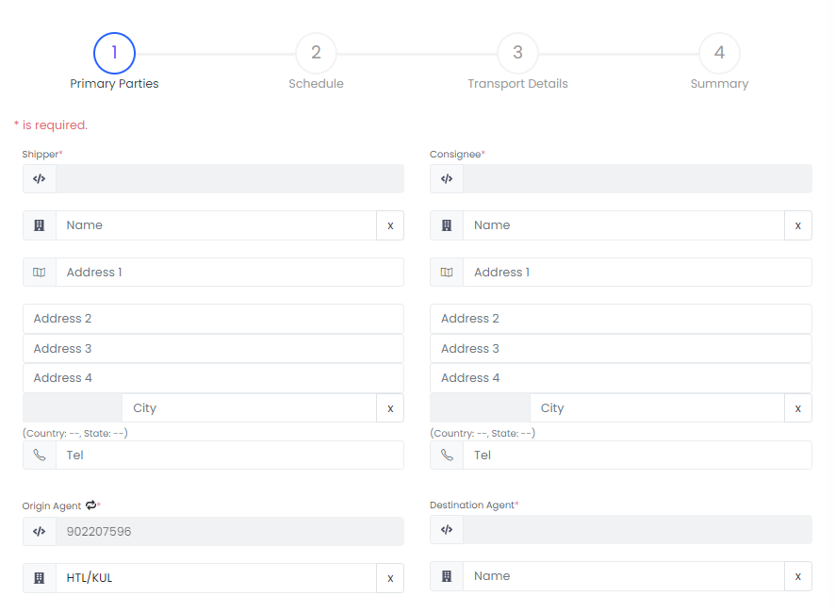

1. Input from **Cargo Ready Date** to **Request Delivery Date**. Click **Next**

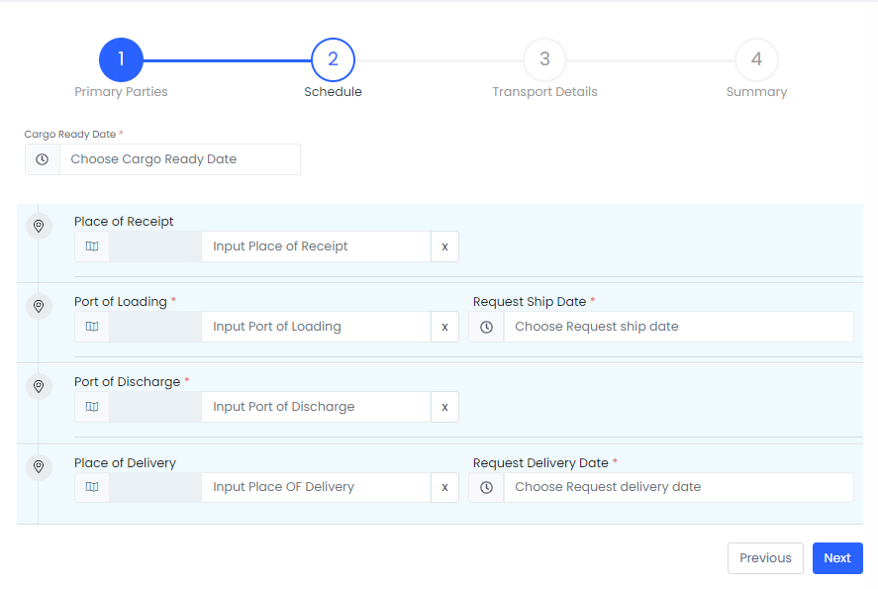

1. Input from **Transport method** to **Remarks**. Input PO Items if available. Click **Next**.

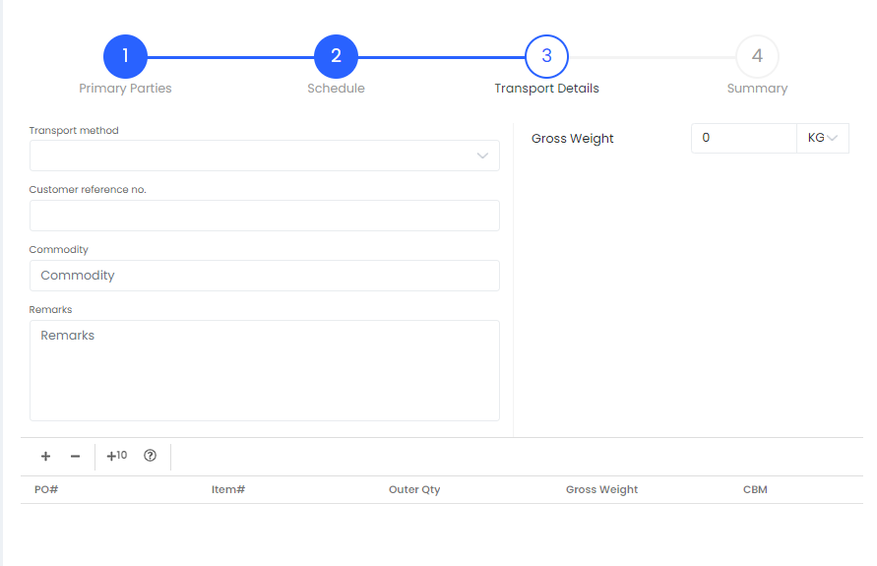

1. Review the booking detail and click **Submit**. You can click **Previous** to amend the booking information if needed
2. There is a warning message if any required information missing in the booking

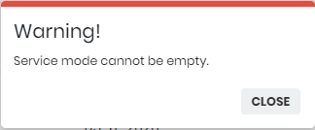

1. The SO# will be generated when the booking is created successfully. You can click on the SO# to continue to edit the booking

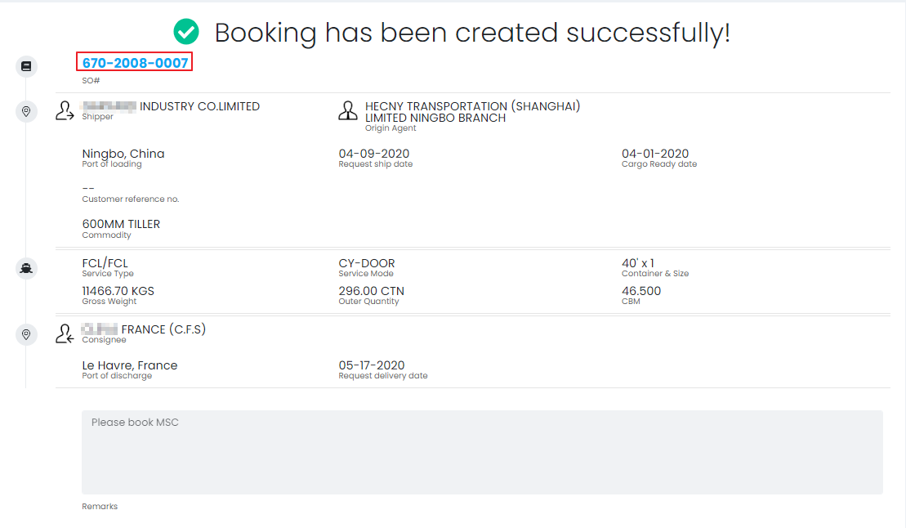

1. System will deliver an alert email of shipping order to origin agent

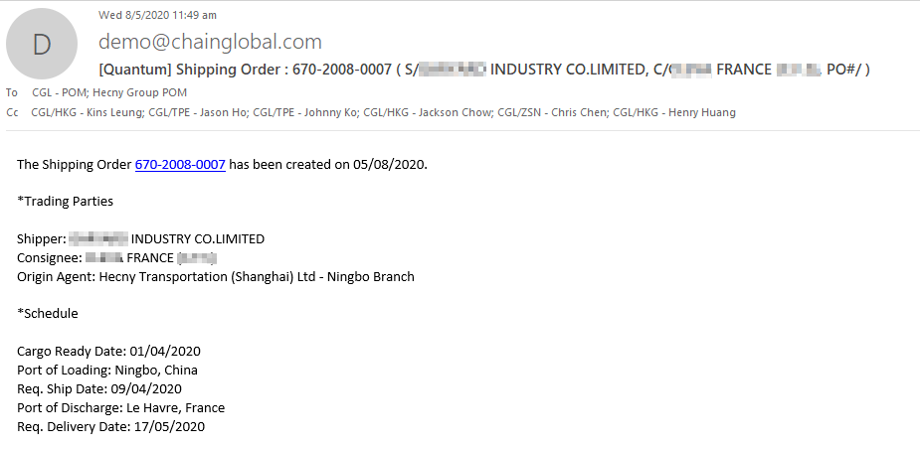

1. The email will be shown in mail log

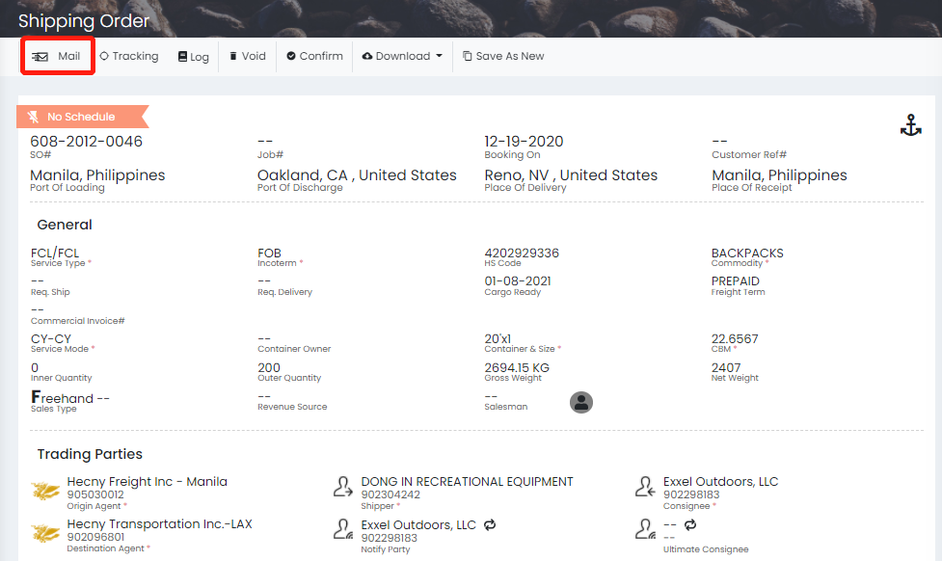

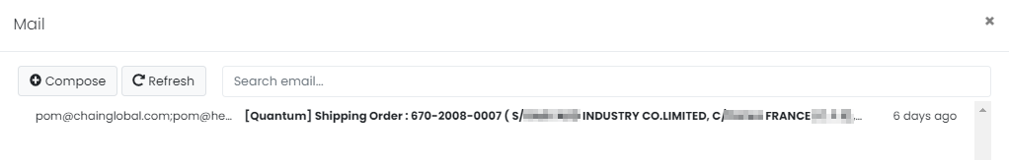

# MAINTAIN BOOKING

**Purpose**: Edit and update essential information to complete the booking

**When**: Once after the booking created

1. Click on the SO# in alert email for quick access or search in shipping order section then click the SO# to open in shipment list

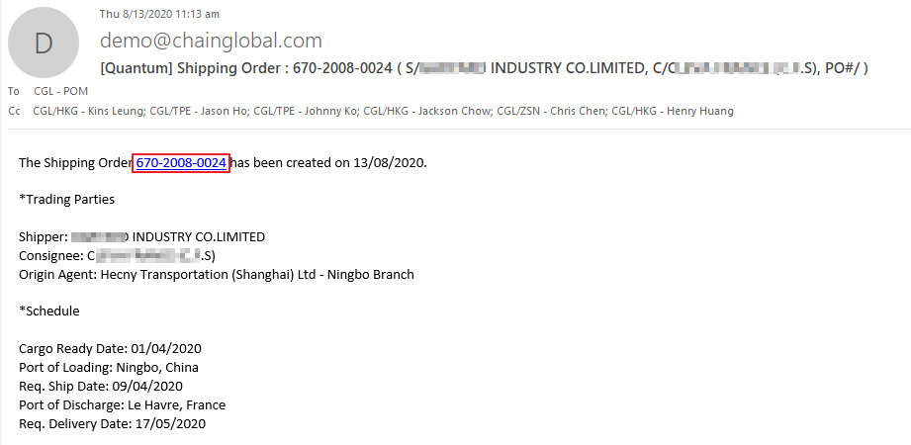

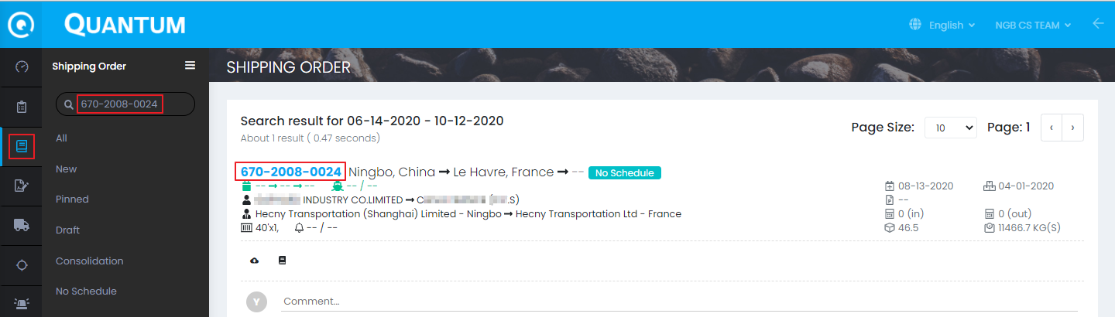

## General Information

1. Move cursor to **General** section and click **Edit**

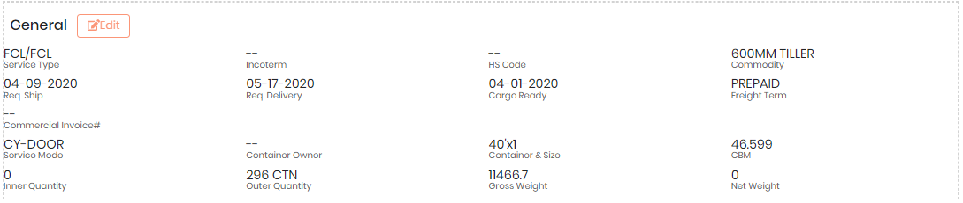

1. Input from **Customer reference no** to **Contain Solid Wood Packing**

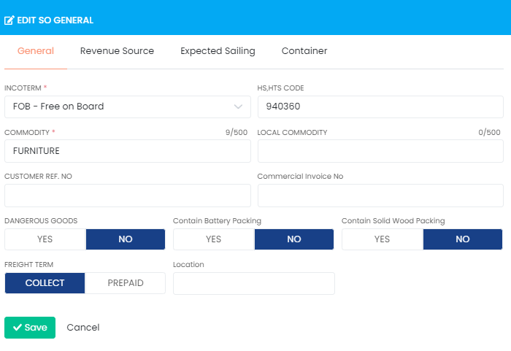

1. Input from **Revenue Source** to **Co-load** under **Revenue Source**

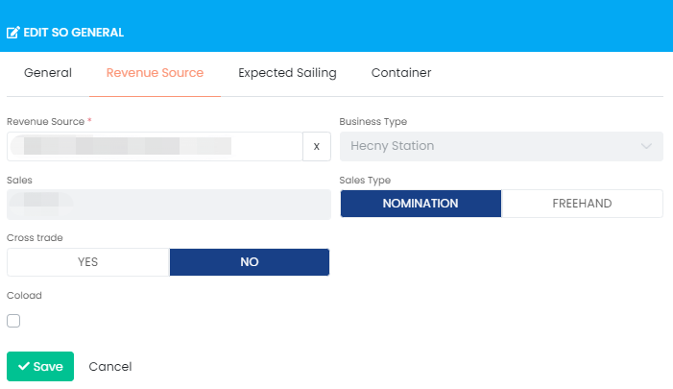

1. Input from **Cargo Ready Date** to **Place of Delivery** under **Expected Sailing**

Expected Sailing is only for the beginning phase. For the actual sailing schedule, please refer to section Sailing Schedule

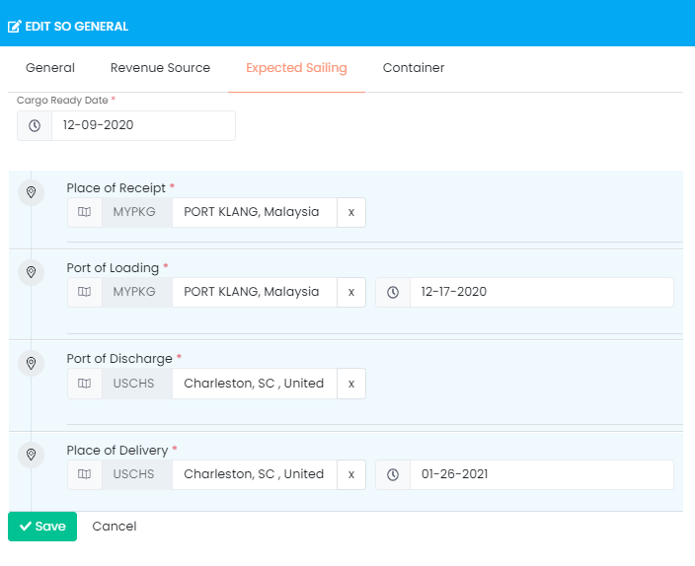

1. Input from **Transport method** to **Remark** under **Container**

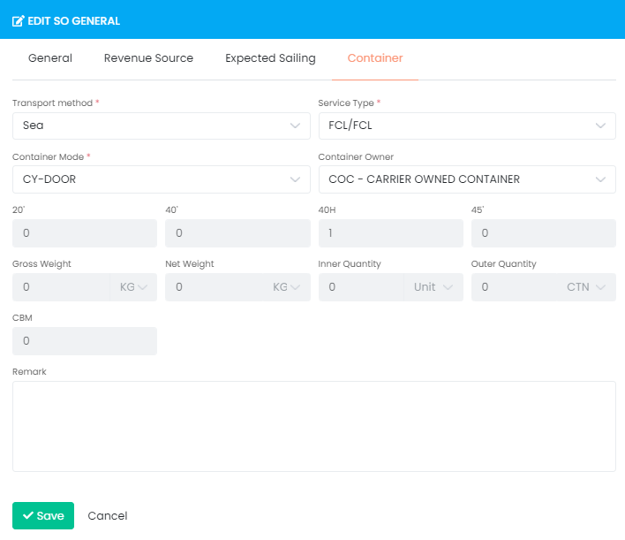

1. Once complete the editing in **General** section then click **Save**

## Trading Parties

1. Move the cursor to **Trading Parties** and **click Edit**

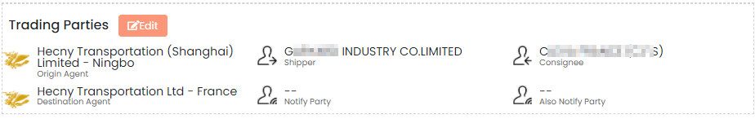

1. Input from **Shipper** to **Ultimate Consignee** if any under **Trading Parties**

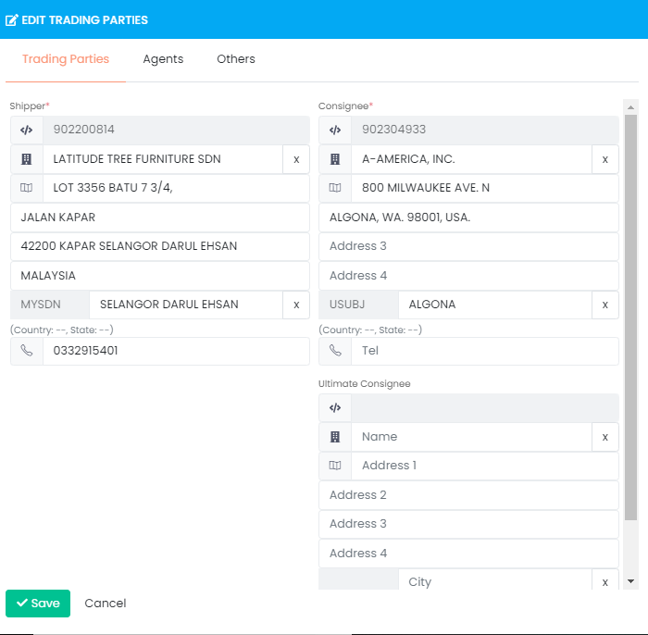

1. Input **Destination Agent** if missing under **Agents**

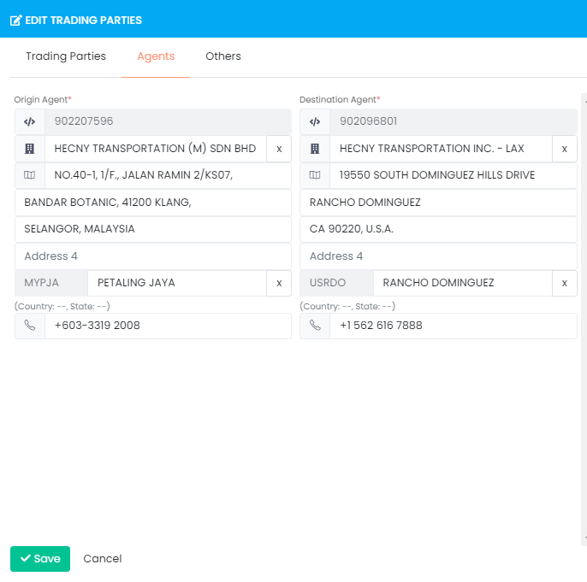

1. Input **Notify Party** or check the box **Same as Consignee** under **Others**

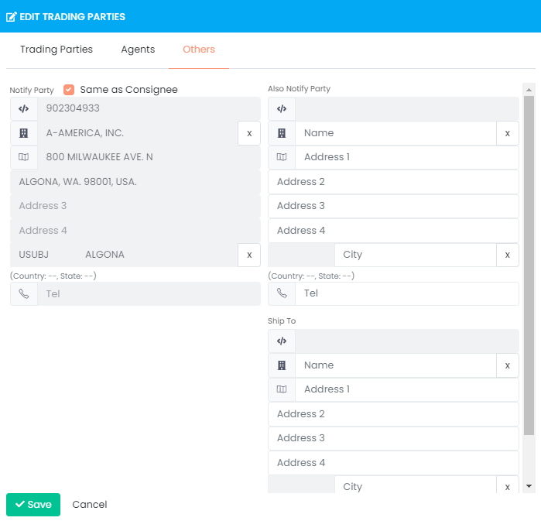

1. Click **Save** to exit

## Sailing Schedule

There are two ways to add sailing schedule, i.e. A: **New Schedule**, B: **Search Schedule**. It also allows more than 1 schedule per booking.

1. **New Schedule**
2. Move the cursor to **Schedule(s)**
3. Click **New Schedule**
4. The existing information came from the draft of booking/Expected Sailing
5. Input from Ship Mode to Final Destination

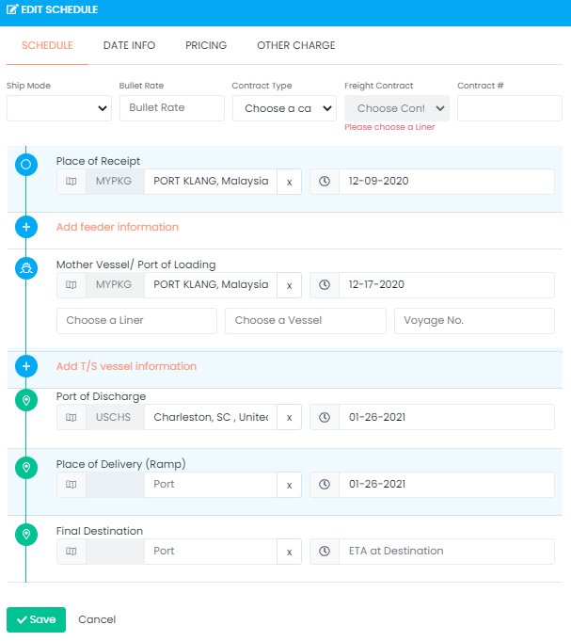

1. Input in **DATE INFO**

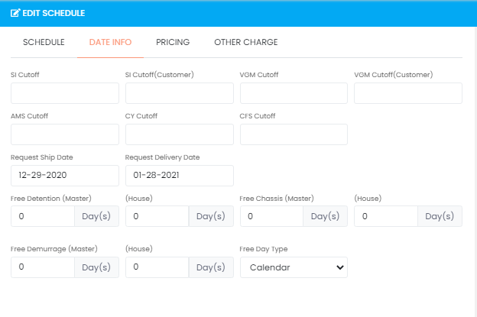

1. Input pricing information under **PRICING** to **OTHER CHARGE** if any

*The selling rate and buying rate must be entered before confirm booking because of the FMC issue. The punishment would be from USD 9,000 to 25,000.

Selling rate and buying rate here are **freight rate** only.

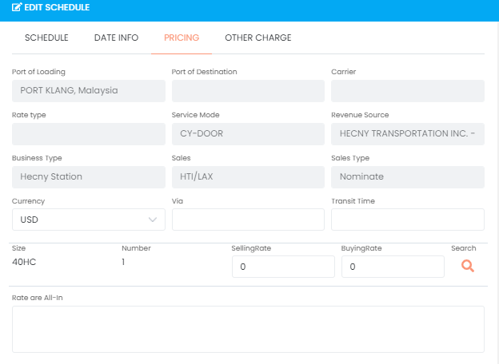

Click the **Search** button and the **Search Rate** Panel would be shown as below.

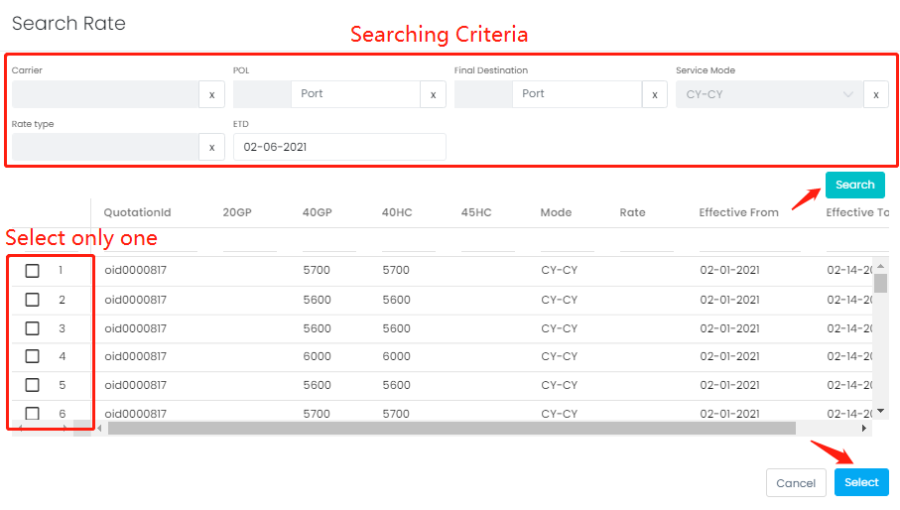

The searching criteria source would be the input in shipping order before. But if you could not find any record, you may still adjust the criteria to search the possible quotations. Click **Search** to load the record from Quotation.

Select one matched quotation (check the box) and click **Select** button. The quotation detail would fill in.

The logic to update selling rate

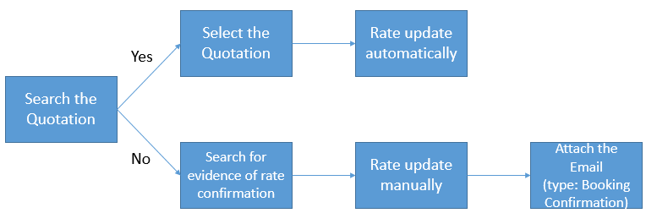

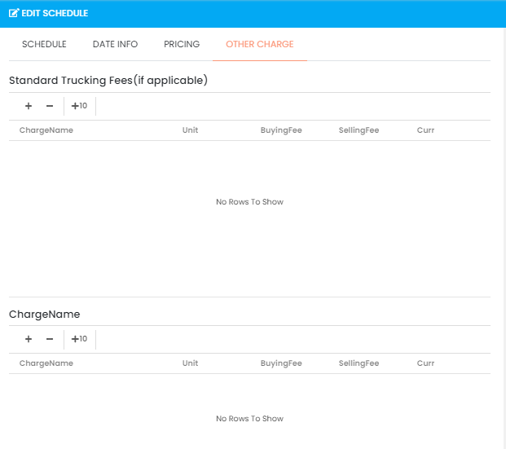

1. User can view, edit, and delete the schedule if required

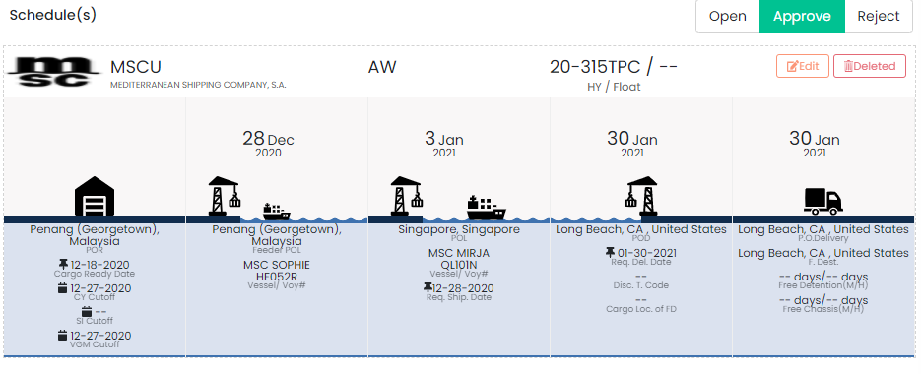

1. **Search Schedule**

It required the practice to maintain sailing schedule in advance. Please refer to [Sailing Schedule](#_Sailing_Schedule_(Optional)).

1. Move the cursor to **Schedule(s)**
2. Click **Search Schedule**
3. Input searching criteria and click **Search**

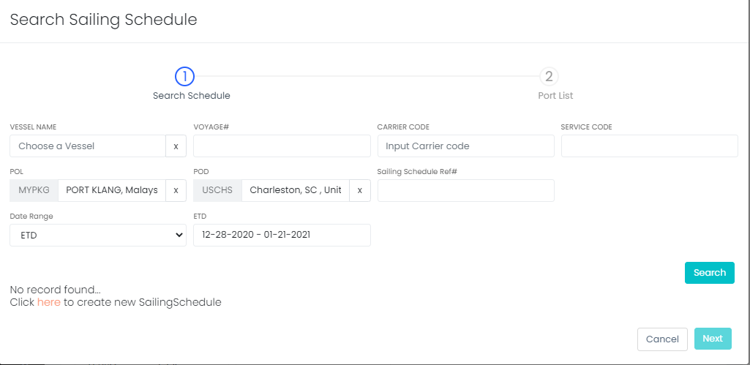

1. Select the sailing schedule if any match result and click **Next**
2. If system prompt ‘No record found’, it indicates there is no any match result, please refer A to add new sailing schedule or [Sailing Schedule](#_Sailing_Schedule_(Optional)) in prerequisites

## Container

1. Click  to edit container,  to delete container,  to add new container

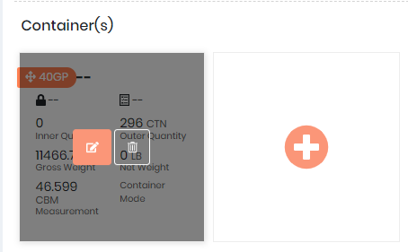

1. Input Carrier SO#

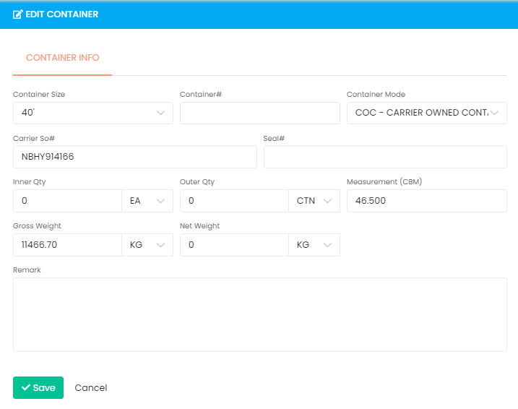

1. Update the information if needed
2. Click **Save** to exit

## Attachment

There are different types of documents need to be uploaded as supporting material. To keep the documents tidy, user could upload attachments here.

1. Move cursor to **Attachment(s)**
2. Click **Upload**
3. Drag and drop the file (max. 5 MB per file) from PC or the attachment from email or click **Choose Files** to select from folder
4. Select **document type**, input **Remarks** then click **Upload all**
5. Status with means upload successful
6. Click **Remove** to remove fail file
7. Click **x** to exit

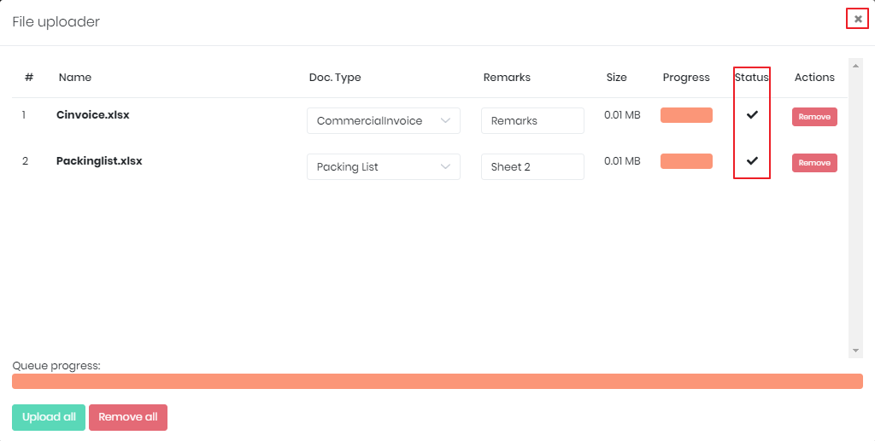

1. User can delete or download the attachments when move the cursor to the end of the file

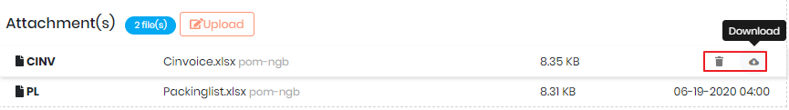

## Comment

You can input and reply to the comment to share message with other parties. The comment will be showed under same booking/shipment to other parties’ account. You can review previous comments in this section as well. *Please do not input confidential information in comment

Choose the type from the tab, i.e. all, booking, container.

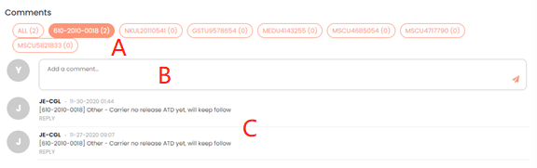

A – Comment type: booking, shipment, container

B – Comment box: the area user typing comment

C – Comment history: recent comments

There are notifications in the top of the website once there are comments from other parties under same booking.

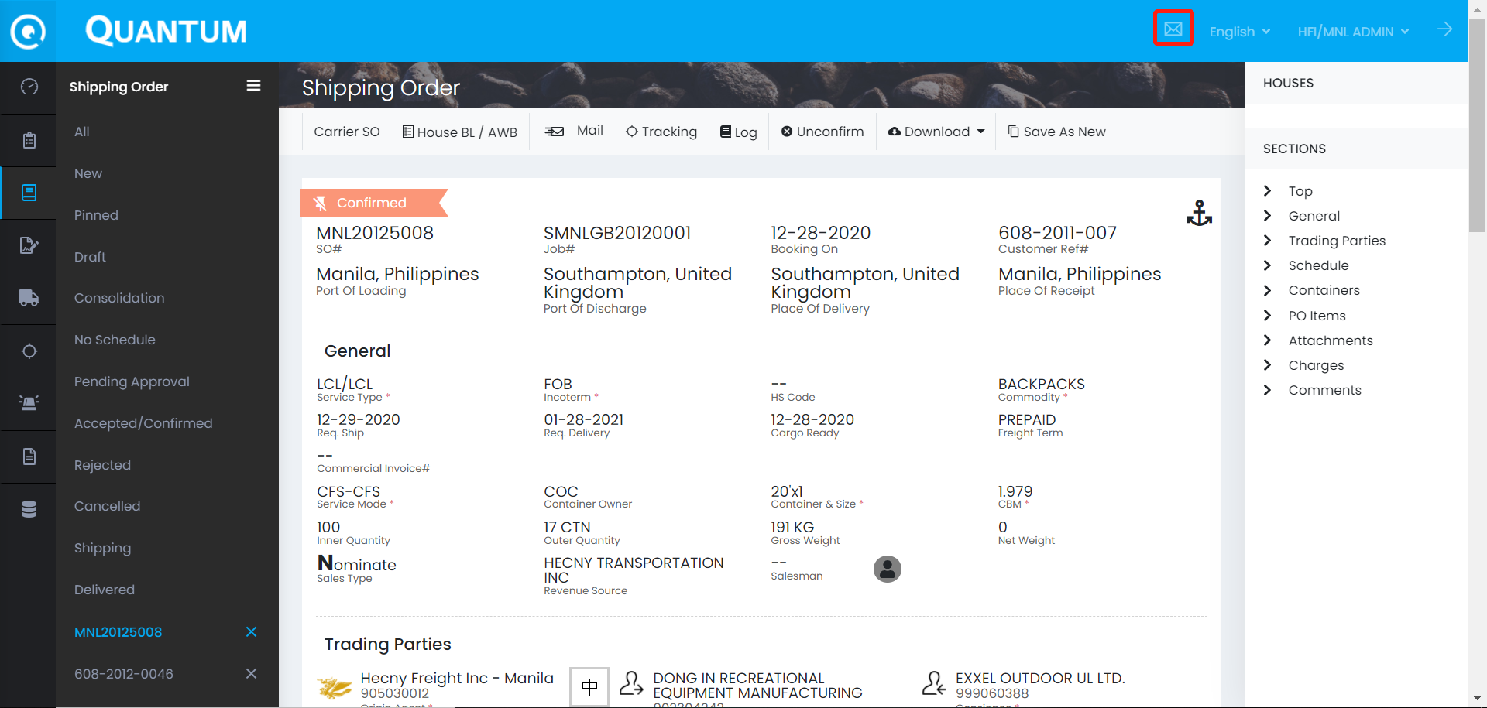

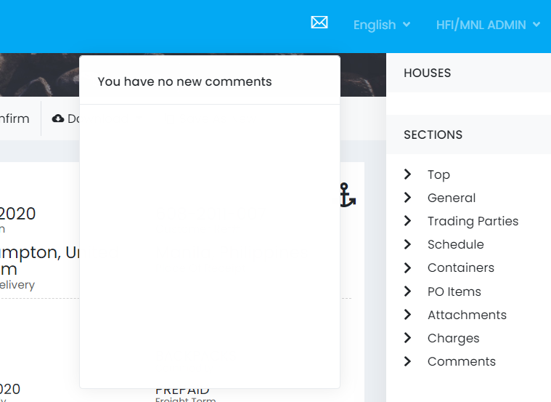

# CONFIRM BOOKING

**Purpose:** Confirm the correctness and completion of the booking in order to create job number

**When:** After the below steps has been done:

1. Confirm sailing schedule by destination agent/sales
2. Booking released by carrier and return the carrier SO number
3. Origin input the carrier SO number
4. Quotation information has updated

Update & Checking Procedure of the Above Steps

1. Confirm sailing schedule by destination agent/sales
   1. Check the comment/email to confirm the sailing schedule is accurate
2. Booking released by carrier and return the carrier SO number
   1. Receive the notification from carrier that booking is released and attached with carrier SO number
3. Origin input the carrier SO number
   1. Go to **Container**
   2. Click **Edit** to amend the detail
   3. Input the **Carrier SO#**

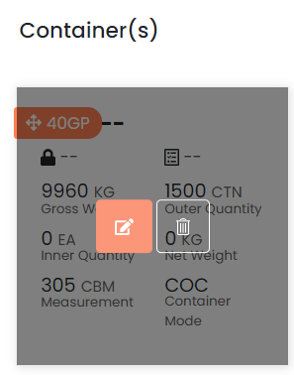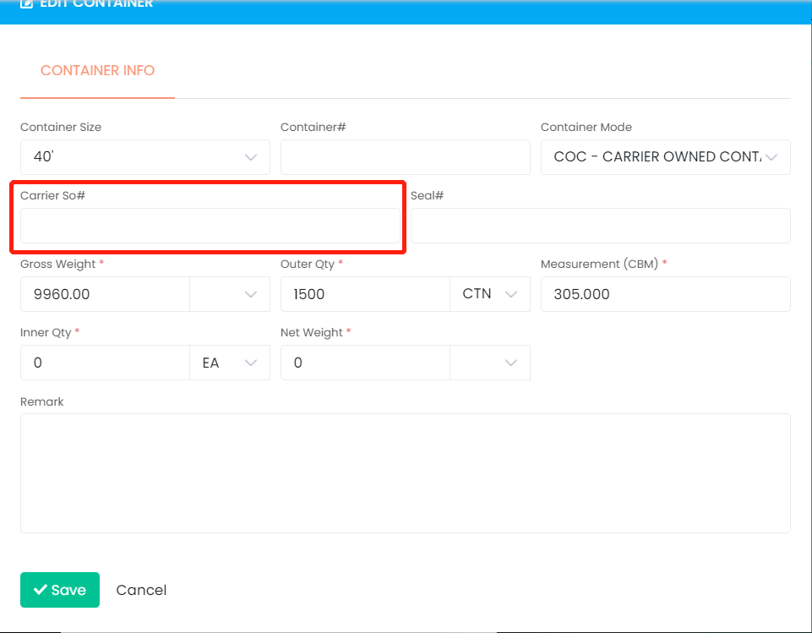

1. Quotation information has updated
   1. Ensure quotation detail has updated, refer to the comment/email
   2. The update procedure may refer to Quotation

Confirm Booking Procedure

1. Click **Confirm**

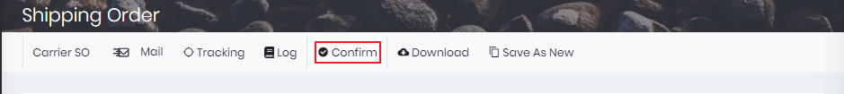

1. System will alert if any information missing

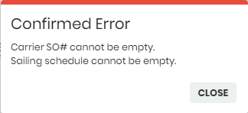

1. If confirm successful, job# will be created and the SO status change to Confirmed

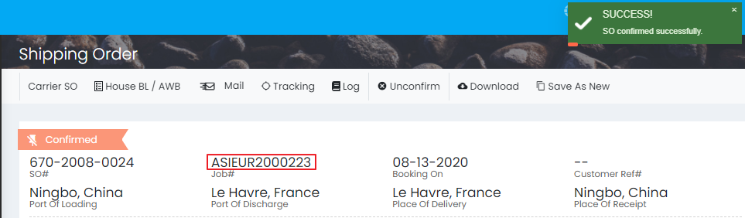

1. The shipping order can be auto-approved by following scenarios:

a. Booking is created by Origin

b. Customer allows to auto approve (controlled by company profile setup)

1. Send SO to carrier (to be advised)

# CREATE HBL#

**Purpose:** Create HBL# and move forward to **Shipment**

**When:** After **confirm booking**, and no error message in **Shipping Order Log**

1. Click **House BL/AWB** in tool bar on top

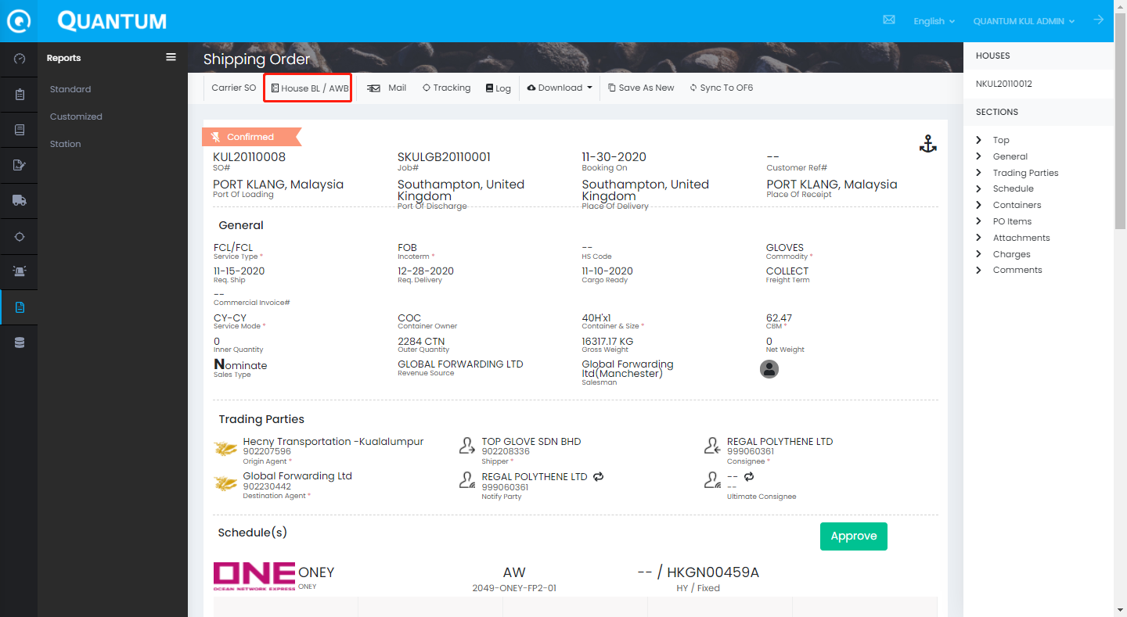

1. HBL# management panel would be shown
2. Input/select the type, number or house#, revenue source, sales type, cross trade
3. Click **Save** to generate the HBL#

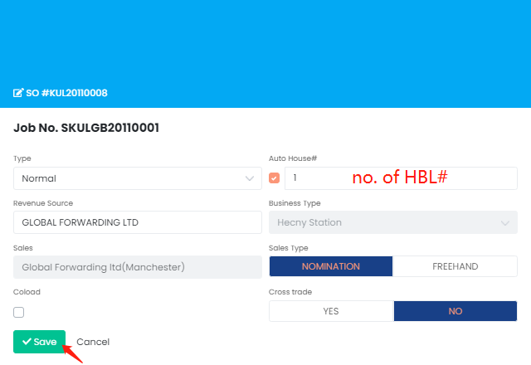

1. If it is successful, user should be able to view it in **Shipment** and OF6
2. The rest of the task should perform in **Shipment,** please refer to Quantum SOP - Shipment

# FOLLOW-UP

**Please ignore this part if you can create HBL# in Quantum and transfer the data back to OF6 successfully.

In the future, all the process should be handled in Quantum.

The temporary procedure is performing in OneFreight6.

1. Booking in Quantum transfer to OneFreight6 (**OF6**) automatically
2. Origin complete the rest of the parts of **HBL**

<<HBL in OF6>>

1. If the booking could not be found in OF6, origin need to check the log in SO to see if any mismatch global code

To check the mismatch global code, user can either go to

1. Menu Shipping Order Folder: (All)/(Accepted/Confirmed) Search by SO#

Click  Log to view the mismatch global code

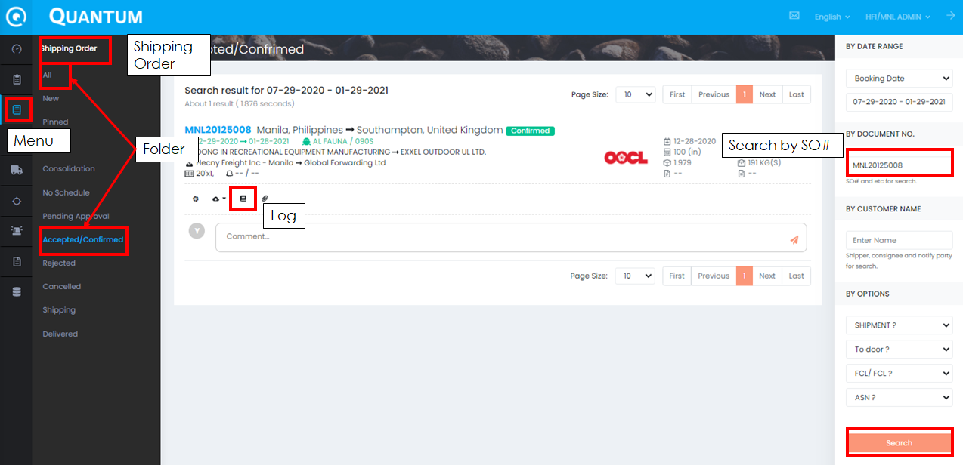

1. In the Shipping Order detail Click  Log to view the mismatch global code

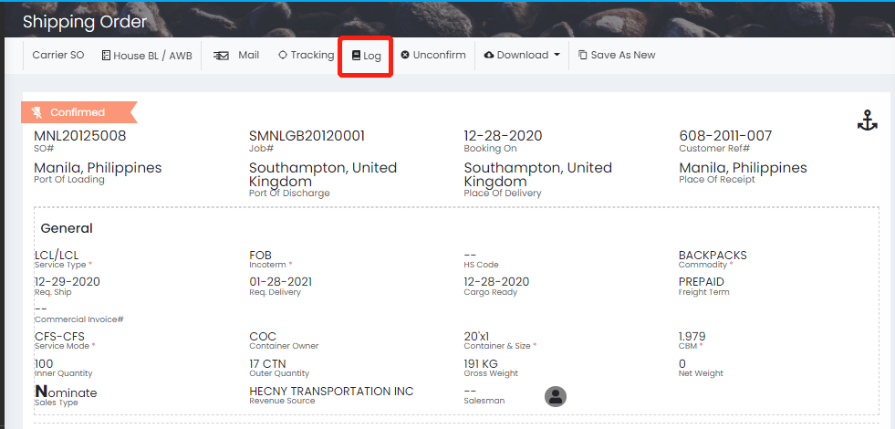

Example shown as below:

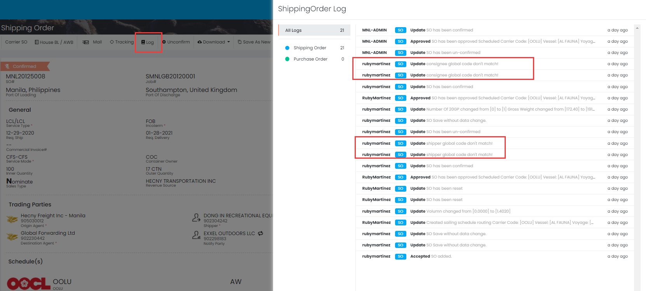



For mismatch global code, in order to get rid of redundant record, origin need to follow the below steps to ensure the data integrity

1. Contact the document center (support@chainglobal.com;ChrisChen@chainglobal.com) and ask for the assistance to check whether open new company profile or use existing company profile
2. After the amendment, origin can re-confirm the booking and continue to finish the rest of the HBL procedure, for more detail, please refer to SOP about HBL

# FAQ

## Sales & RSR Selection

For SEA office,

1. we should select correct sales for USA shipments
2. if this is USR R/O, please use consignee + USA sales as RSR
3. if it is only Hecny USA station business, we should select Hecny USA station as RSR
4. if any missing, please contact support@chainglobal.com

## Helpdesk Contact

The Quantum Team is responsible for system testing, implementation, and helpdesk. If need any enquiry, you can contact the following key persons to resolve the daily operation issue.

|  |  |  |  |
| --- | --- | --- | --- |
| Name | Role | Contact Information | Service Regions |
| Happy Lee | Helpdesk Manager | [happylee@chainglobal.com](mailto:happylee@chainglobal.com) | International |
| Eric Chan | Supply Chain Officer | [ericchan@chainglobal.com](mailto:ericchan@chainglobal.com) | International |
| Support Team | Support Team | support@chainglobal.com | International |
| Judy Qin | Import Lead | judyqin@chainglobal.com | China & Taiwan |
| Chris Chen | Export Lead | [chrischen@chainglobal.com](mailto:chrischen@chainglobal.com) | China & Taiwan |

# DOCUMENT HISTORY

|  |  |  |  |
| --- | --- | --- | --- |
| Date | Prepared by | Change description | Reviewed by |
| 2020-12-29 | Dennis Law | Initiation |  |
| 2020-12-30 | Dennis Law | Maintain Booking & Comment |  |
| 2020-12-31 | Dennis Law | Sailing Schedule |  |
| 2021-01-08 | Dennis Law | Confirm Booking |  |
| 2021-01-12 | Dennis Law | Quotation |  |
| 2021-02-03 | Dennis Law | Create HBL# |  |
| 2021-04-07 | Dennis Law | FAQ – Sales & RSR |  |