Figure 1

SHIPMENT
QUANTUM SOP – OCEAN EXPORT
CGL/HKG – DENNIS LAW | 2/3/21 | COPYRIGHT @Chain Global Limited

CONTENTS
OVERVIEW – SHIPMENT 3
PROCESS OVERVIEW – SHIPMENT 3
先决条件 4
客户档案的管理 4
General 7
Contact 8
Accounting 9
Operation 10
Multiple Address 15
Attachments 16
Assigned OPN 18
Quotation -报价单 19
Sailing Schedule (Optional) 23
确认Booking 28
产生HBL# 29
维护 SHIPMENT 31
General (MBL & HBL info) 33
Trading Parties 34
Schedule 36
Container(s) 41
SOC Container (如果Container Mode= SOCH) 46
Marks & Description 47
PRINT HBL 48
Attachment(s) 52
Charges 53
Comments 53
CHANGE JOB -功能还未完成 54
SWITCH BILL 55
HBL电放或HBL正本状态 56
方法1 在HBL里面设置的TELEX/ORIGINAL BL状态 56
方法2 到 Shipment菜单下的 Telex Release 目录 59
3. 列印TELEX BL 60
4. 正本提单列印 61
SUBMIT SI (ESI)/VGM – CARRIER-未完成 61
SUBMIT AMS/ISF - USA CUSTOMS-未完成 62
SUBMIT ACI - CAN CUSTOMS-未完成 63
发送PRE-ALERT给国外代理 64
TRACKING 66
REPORT 67
FAQ 68
Sales & RSR Selection 68
Helpdesk Contact 69
DOCUMENT HISTORY 69

OVERVIEW – SHIPMENT
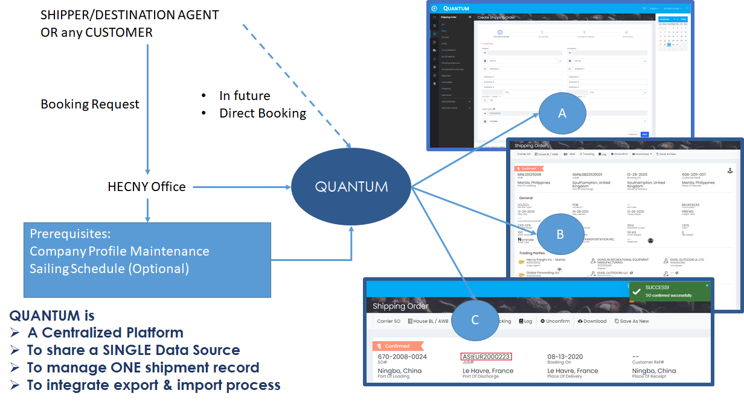
在Quantum中，我们力求数据的完整性，以减少完成预订和提单的重复工作。如果先决条件做得好，使用这个平台的用户做的预订将是舒适和自信。

为了维护单一的数据源，我们强制用户使用Quantum进行BOOKING/HBL操作。用户应按照SOP创建、维护和确认提单。

PROCESS OVERVIEW – SHIPMENT
Confirm Booking

CARRIER SO NO. 也可以在确认BOOKING 后输入，但必须在生成HBL#前要完成。
Maintain Shipment

完成一票提单有三个主要步骤，即创建、维护和确认提单。在每个主要步骤中，用户都需要根据信息来处理预订。所有步骤都应在SHIPMENT菜单中实现。

先决条件

客户档案的管理
Company profile contains contacts, accounting terms and operation rules maintenance in order to improve SOP quality and Customer Relationship Management. There are 6 tabs in company profile.
由于Company Profile需要在Quantum和OF6 DB关联。如果大家不能在Quantum找到对应公司时，需要回到OF6建档，然后写邮件通知Support@chainglobal.com 去Mapping globalcode.
暂不开放Quantum-Company功能给大家操作
Purpose: Create a new company for shipment. - forbidden
When: Company is not existing in system.
- 进入到Company 目录后在右手边的搜索框里
输入部分公司名称，如果有特殊空格，符号的，可以用%替代进行模糊查询。
会有同事反映说看不到搜索框，请调整你们的网页显示比例，调小一些就出来了
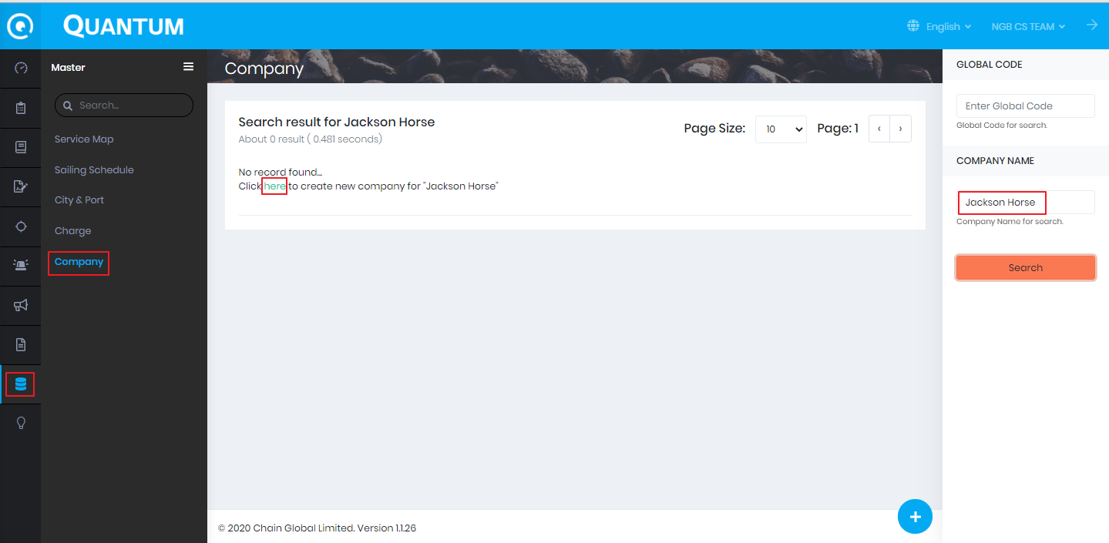
查询不到结果的，回到OF6创建好LOCAL CODE再写邮件给 support@chainglobal.com
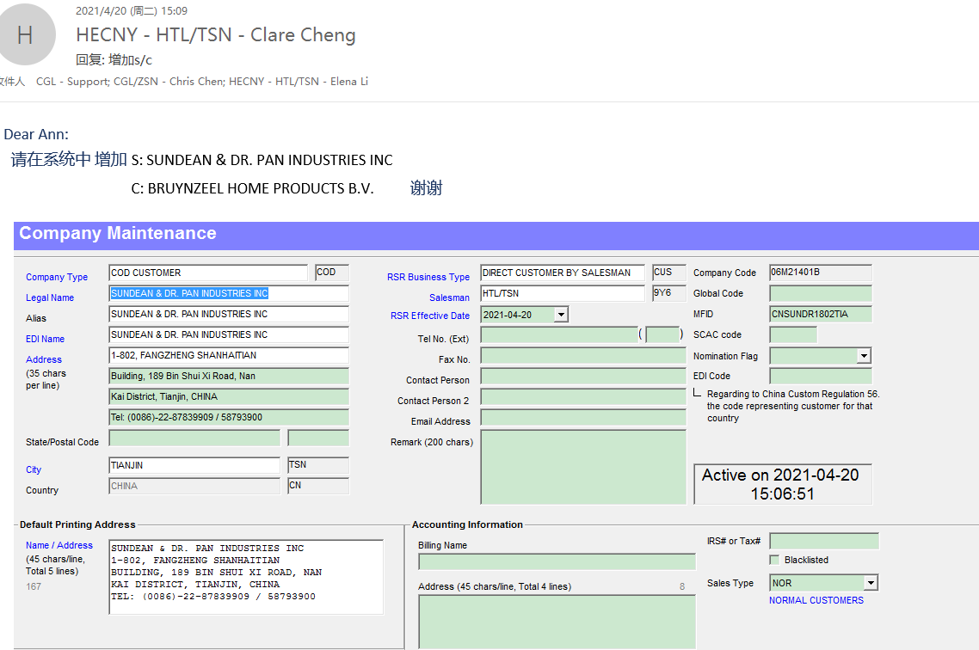
Global code mapping 成功后。用户就可以用NAME或者GLOBALCODE在Quantum搜索。
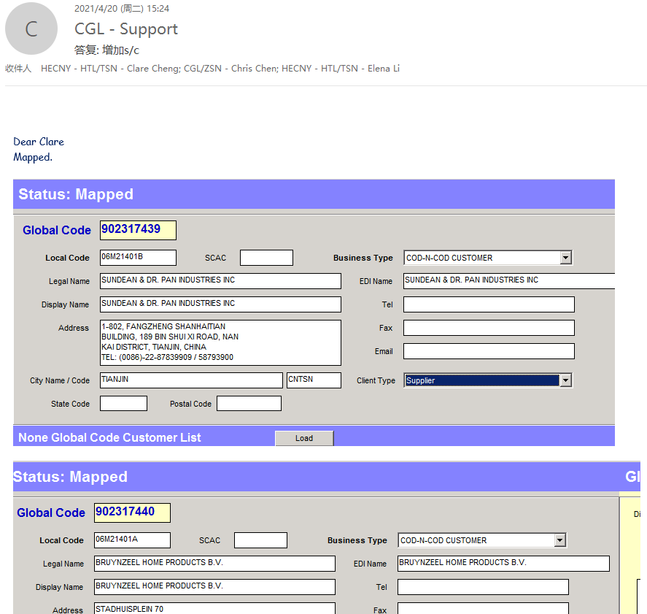

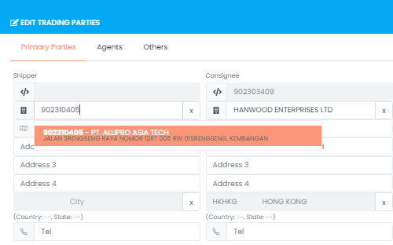
********灰色部分供大家了解，暂时还未开放给大家使用********************
Quantum Company

General
Purpose: Overview of company general information such as Global Code, contact, address and logo
- Check the accuracy of general information
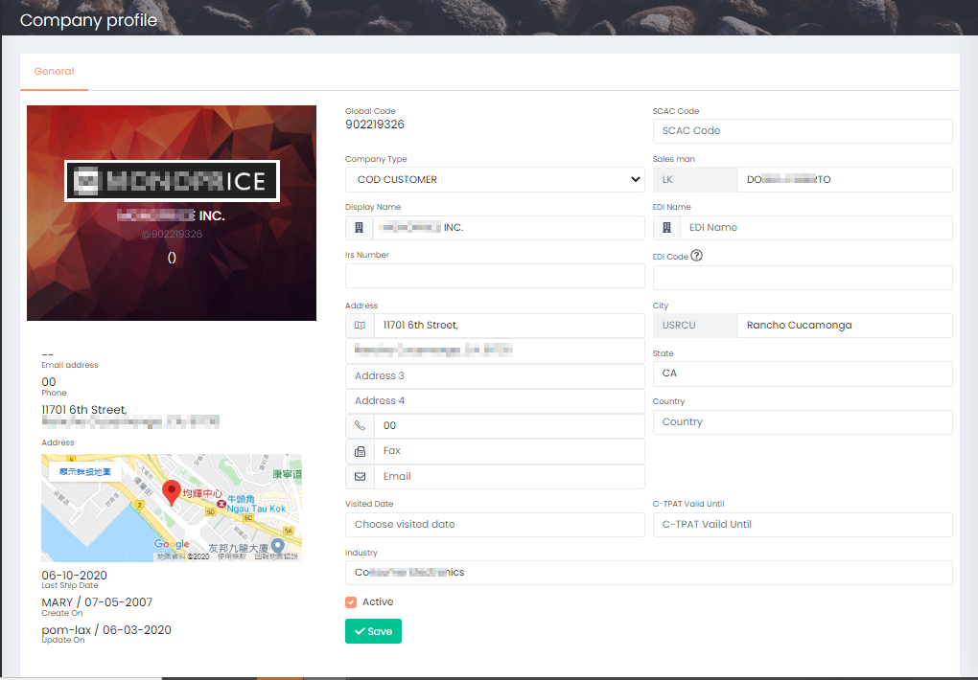

Contact
Purpose: Company main staff contact
- Click +/+10 to add row(s) of the contact list of the company
- Input Display Name, Gender, Job Title, etc.
- Click Save when the contact list has updated
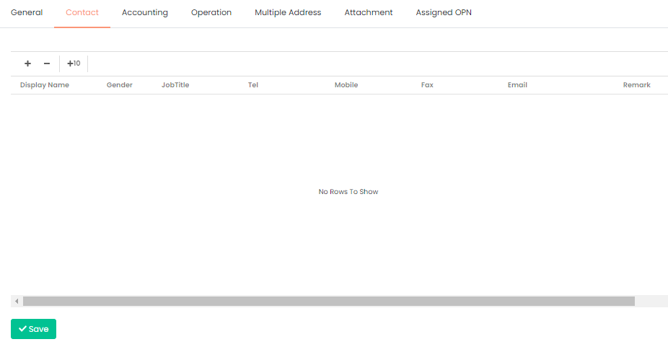

Accounting
Purpose: Setup Credit Term and AR Aging.
In this section, it consists of 4 types of accounting information, i.e. Credit Term, AR Aging, RSR, Reference. If the information is missing, it would affect the <<>>.
- Edit if there is related information
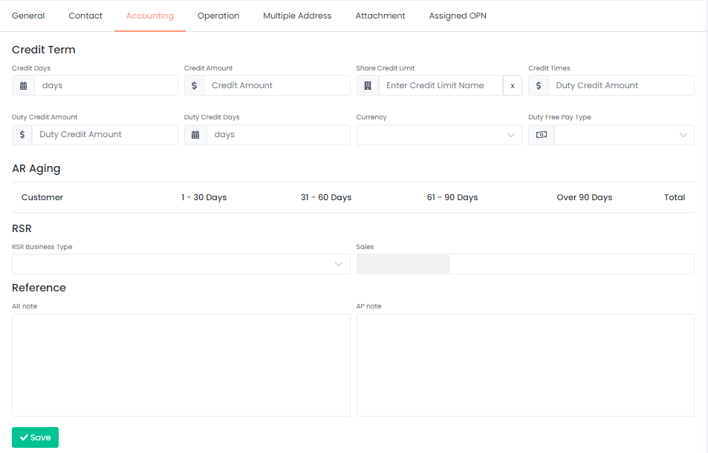

Operation
Purpose: Setup company operation rules such as essential document, deliverable, email recipient and broker etc.
In this section, all operation related setting has to be settled before operation.
- File Check, if the document has been uploaded to section Attachment, red cross would turn into green tick to indicate upload successfully.
  - POA: Import Power of Attorney
  - EIN: Employer Identity Number
  - Bond: Customs bond
  - Special Handling Instruction: Any special handling instruction

- Sections
  - Redirect the user to the sections below
- Setting
  - AN Show PO#: Indicate whether the email subject of sharing AN need to show PO#
  - Need ISF: Need Importer Security Filing
  - Need Cancel IT: Need cancel IT
  - Need charges on Arrival Notice: Show charges on Arrival Notice
  - Need PO No: Show PO# in VIP report
  - Inv Need Cons Address
  - Our Brokerage Service: Our brokerage service customer
  - Need IP (Commercial Invoice & Packing List): Need customer submits the IP for customs clearance
  - Combine HBS
  - Combine Invoice
  - HBS No Chk VSL
  - POM Cons: POM Customer
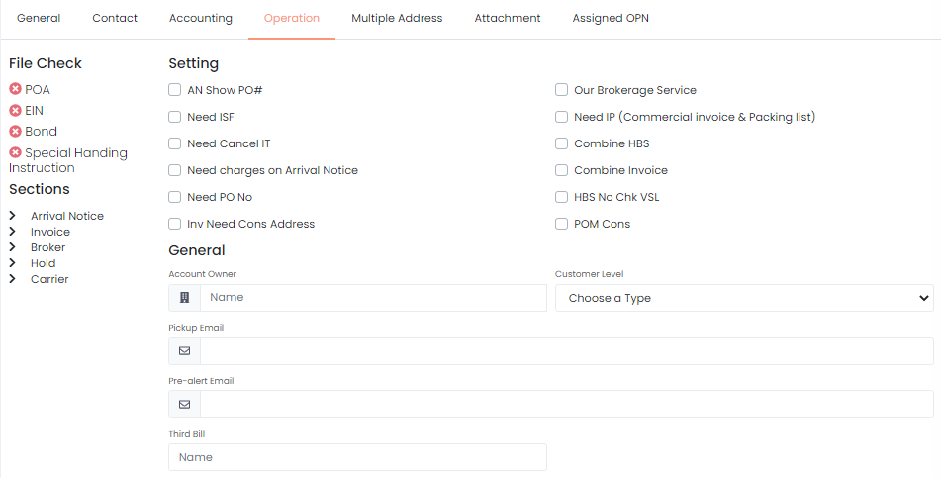
- General
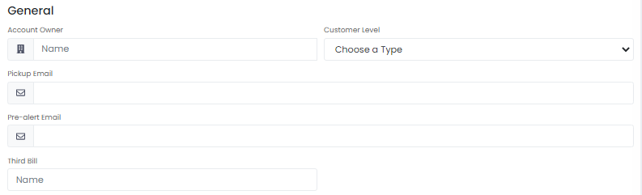
  - Account Owner: auto complete and select the company which own this account
  - Customer Level: indicate it is E-booking client or POM buyer
  - Pickup Email: Email contact for pickup
  - Pre-alert Email: Email contact for pre-alert
  - Third Bill: auto complete and select the company which is third bill

- Arrival Notice
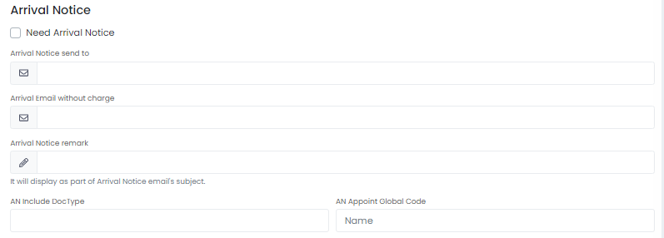
  - Need Arrival Notice: check if the company need to receive arrival notice
  - Arrival Notice send to: enter email contact of the default recipients of arrival notice with charge
  - Arrival Email without charge: enter email contact of the default recipients of arrival notice without charge
  - Arrival Notice remark: it will display as part of Arrival Notice email’s subject
  - AN Include Doc Type: input the document type that include in AN
  - AN Appoint Global Code: auto complete, select the company appointed the AN
- Invoice
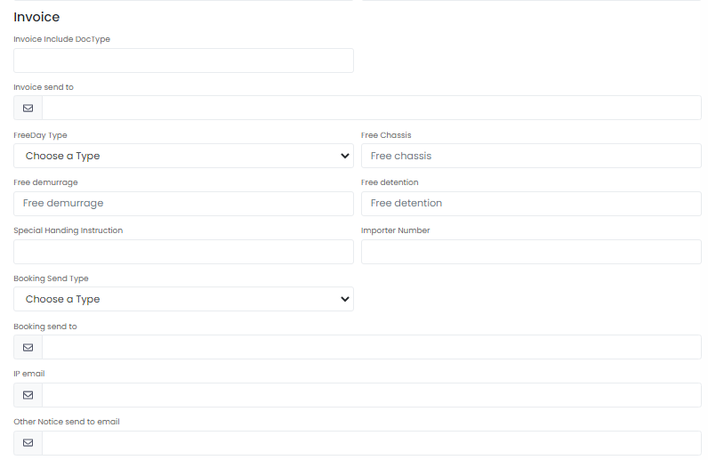
  - Invoice include Doc Type: input the document type that include in the invoice
  - Invoice send to: enter email contact of the default recipients of the invoice
  - Free Day Type: select from the drop down list, i.e. calendar day, working day
  - Free Chassis: the minimum
  - Free demurrage: No. of day for free demurrage (from in gate to out gate in CY or CFS)
  - Free detention: No. of day for free detention (from out gate to empty return)
  - Special Handling instruction: Special handling instruction
  - Importer Number: Customs-assigned identification
  - Booking Send Type: need booking confirmation reply from consignee. Notification -> Booking notification only.
  - Booking send to: enter email contact of the default recipients of the invoice
  - IP email: email address for tracing IP submission
  - Other Notice send to email: enter email contact of the default recipients of other notice
- Broker
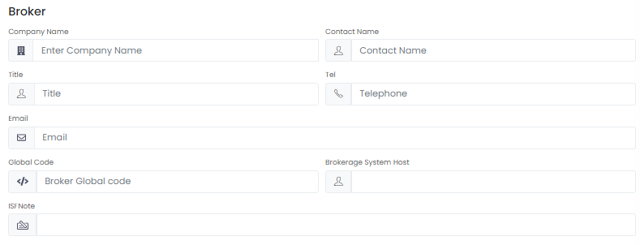
  - Company Name: auto complete, select the company as broker
  - Contact Name: enter contact person name
  - Title: enter contact person title
  - Tel: enter contact person phone number
  - Email: enter contact person email
  - Global Code: auto-filled by system after select the company
  - Brokerage System Host: database name of Henry brokerage system
  - ISF Note: note for handling Importer Security Filing
- Hold
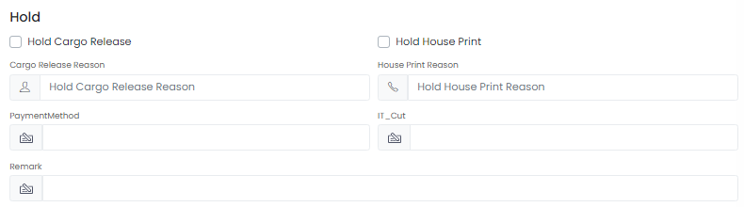
  - Hold Cargo Release: check if this company need to hold cargo release
  - Hold House Print: check if this company need to hold house print
  - Cargo Release Reason: input the reason to hold cargo release
  - House Print Reason: input the reason to hold house print
  - Payment Method: input the payment method
  - IT Cut: Custom clearance at the end of rail service
  - Remark: any remark of the operation in cargo release
- Carrier
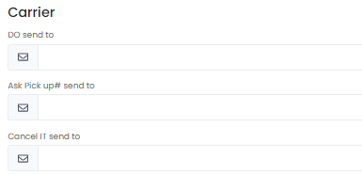
  - DO send to: enter email contact of the default recipients of Delivery Order
  - Ask Pickup# send to: enter email contact of the default recipients for asking pickup number
  - Cancel IT send to: enter email contact of the default recipients for cancelling IT
After finished the setting in this section, click ‘Save’ before exit or proceed to next page.

Multiple Address
Purpose: Setup different addresses for delivery, billing and so on
As a company would have multiple addresses, user could manage the address under this section.
一个公司对个地址时，我们使用一个GLOBALCODE +Multiple Address的做法
- Click +/+10 to add rows
- Input the detail information of the address (swipe right via scroll bar)
  - Type: Invoice Address/Delivery Address
  - Company Name
  - City Name
  - State Code
  - Address1
  - Address2
  - Address3
  - Postal Code
  - Country Code
  - Tel
  - Fax
  - Email
  - Contact
  - Trucker
- Click ‘Save’ to confirm the address
- Click ‘Edit Address’ to amend the address
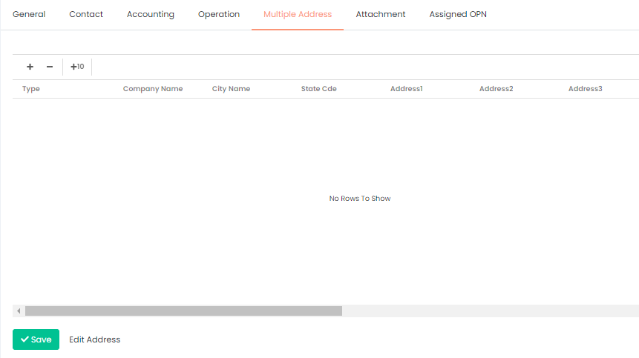

Attachments
Purpose: Keep important information such as BOND file, SOP, certificates, special handling instruction
In section Operation, there is a part File Check. By uploading the required document according to the company nature, the red cross would be become green tick to indicate the successful approval.
- Click ‘Upload’ to open the File Uploader panel
- Drag and drop to this panel to upload the file
- Select document type from the drop down list after uploading to this panel
  - AP SOP
  - AR SOP
  - BOND File
  - Company Logo
  - Credit Control Approval
  - Employer Identification Number
  - General Profile
  - Insurance Certificate
  - Power of Attorney
  - Sales Call
  - Special Handling Instruction
  - Trucking Company
- Input any remark if needed
- Click ‘Remove’/’Remove all’ if the document is invalid
- Click ‘Upload all’ if the files and types are confirmed to be valid
Remarks:
File size limit: 5MB
Support file types: jpg,png,jpeg,bmp,gif,pdf,doc,xlsx,xls,docx,png,zip,msg,txt,tif
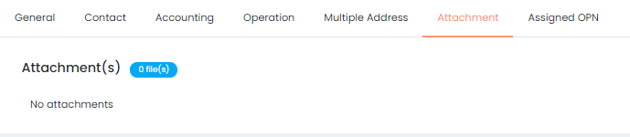
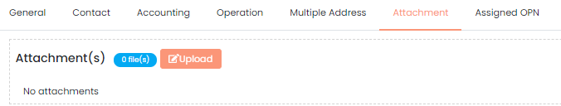
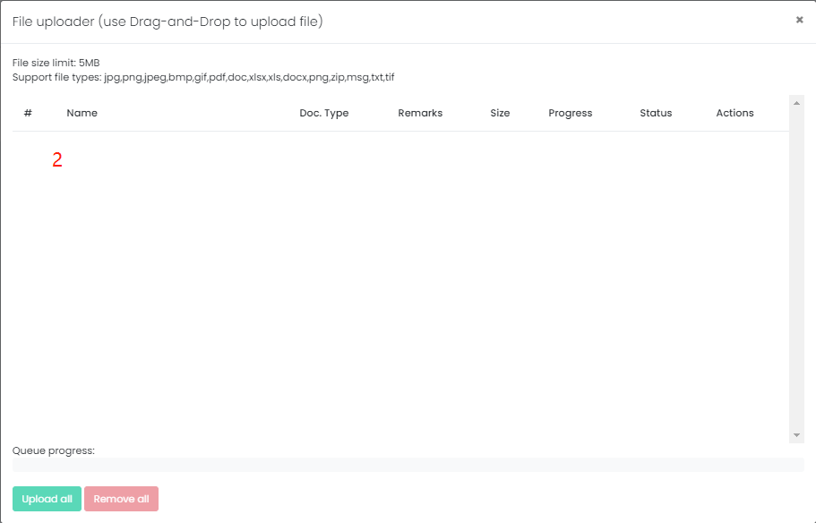

Assigned OPN
Purpose: Identify the agent, operation and operation type
In this section, user would identify the origin/destination agent, operation and operator’s type who handle this company
- Click +/+10 to add rows
- Input the detail information of the address
  - Agent: auto complete after key in the keyword, showing the company name
  - Operation: auto complete after key in the keyword, showing the operation under the company
  - Type: select from the drop down list to indicate the type of operation
    - AIR Export
    - AIR Import
    - Ocean Export
    - Ocean Export FCL
    - Ocean Export LCL
    - Ocean Import
    - Ocean Import FCL
    - Ocean Import LCL
Remark: the difference between Ocean Export and Ocean Export FCL/LCL is that some company would differentiate FCL & LCL but some would not, therefore Ocean Export would include both FCL & LCL, vice versa
- Click ‘Save’ to confirm the agent
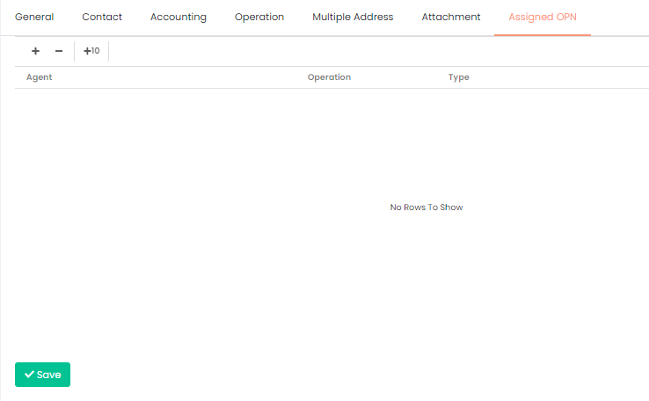

Quotation -报价单
Purpose: 记录报价细节并向FMC提供证据
When:
**Regular check & update to prevent from FMC’s penalties (starting from USD 5,000)
当前这个功能主要是对USA TRADE的，现在的信息也主要是从OID同步过来的。但是将来这些Quotation都会直接在Quantum上面操作
In this session, user could add, amend, copy and share the quotation information. Once the quotation information share/send to consignee, the quotation detail could not be changed anymore. The Send Consignee Date would be shown in detail as below:
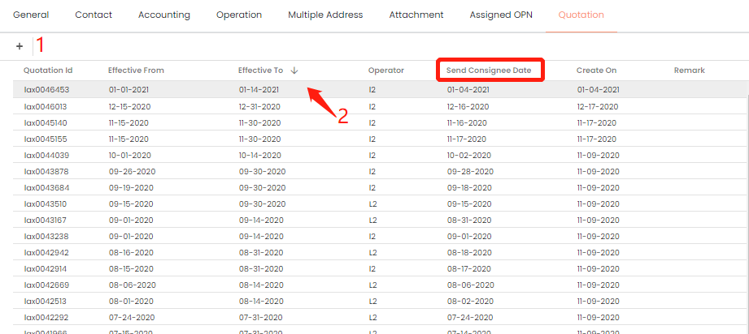
- Create/Add quotation button
  - Click to add new quotation
  - Follow the 4 steps to create new quotation, please make sure you have the basic information, detail, other charge (if any), other remarks before create
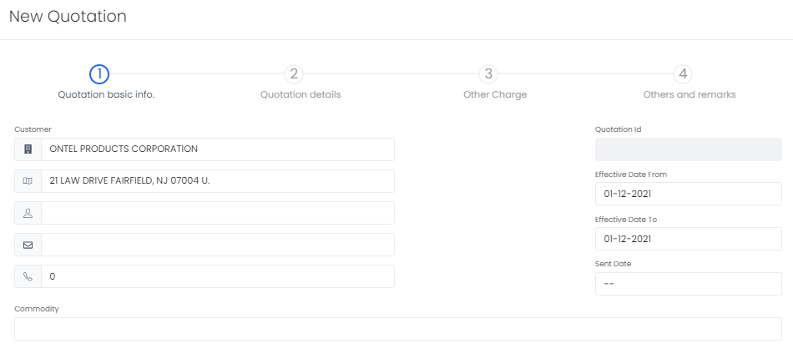
- Quotation List
  - 可以从列表中查看基本信息，即quotation reference id、生效日期范围、发送收货人日期、创建日期、备注
  - 点击查看/修改明细，如果已经有发货收货人日期，则不可修改
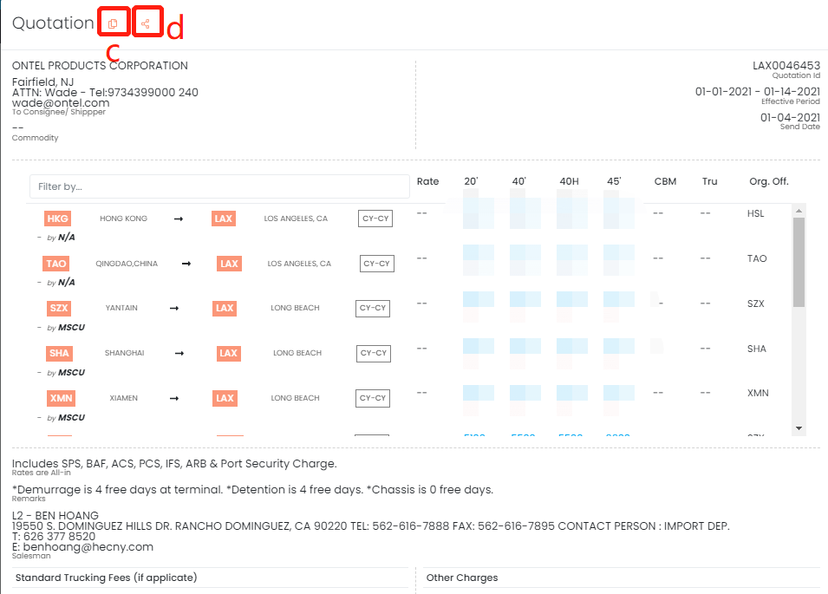
  - In the detail panel, apart from amend the detail, you may copy to prepare next quotation, click Copy to create new quotation with the same quotation detail, amend it (especially effective date) and save it to complete new quotation
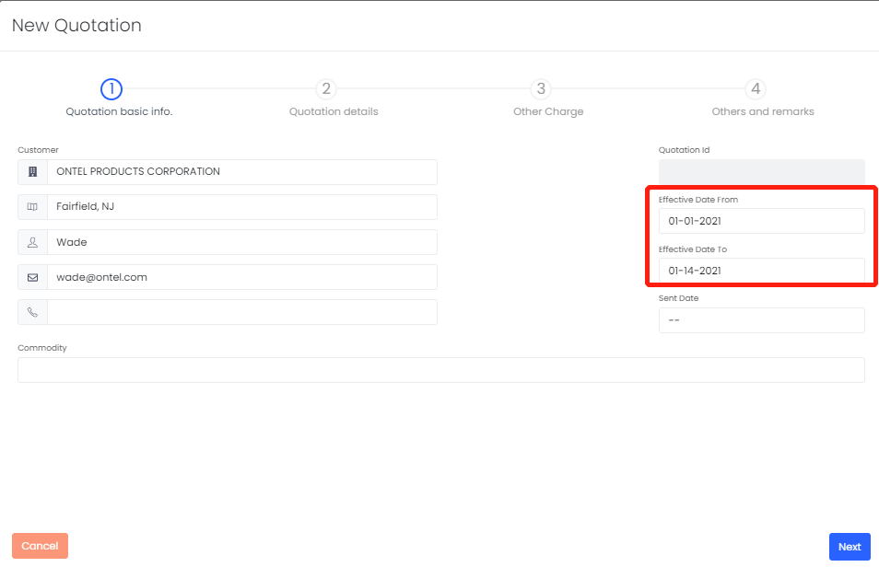
  - You may share the quotation detail to requested parties, click Share to send email
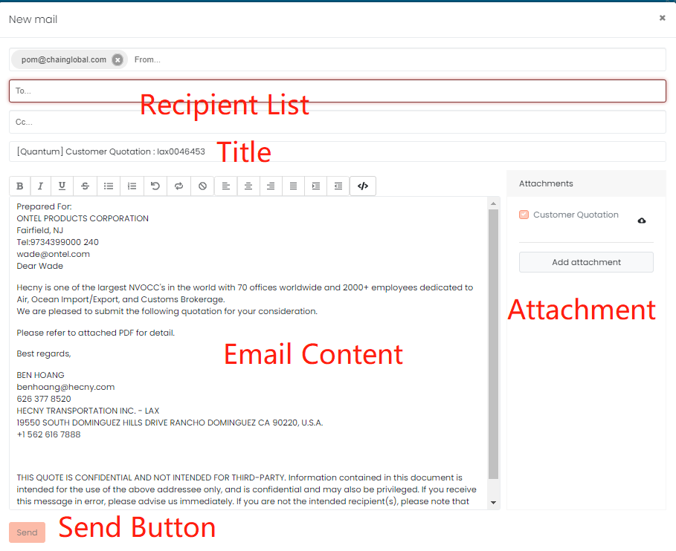
- Recipient List: ensure the list is correct as quotation information is sensitive
- Title: if there is any special request, you may edit the email title as well
- Email Content: if there is any special request, you may edit the content as well
- Attachment: you may download the quotation to preview in advance to check the accuracy, or you may add other attachment(s)
- Send Button: check the above 4 elements before click the send button to send the email

Sailing Schedule (Optional)
除客户档案外，船期可提前安排。在Master中设置的好处是，这个航行时间表可以共享给多个站点/出发地和提单。开航时间表的调整需要在Master处更新，但不适用于所有具有相同开航时间表的订舱/提单Purpose: 创建新的sailing schedule /搜索现有的sailing schedule。
When: 新的booking已创建/收到承运人的新sailing schedule。进入 Master - Sailing Schedule
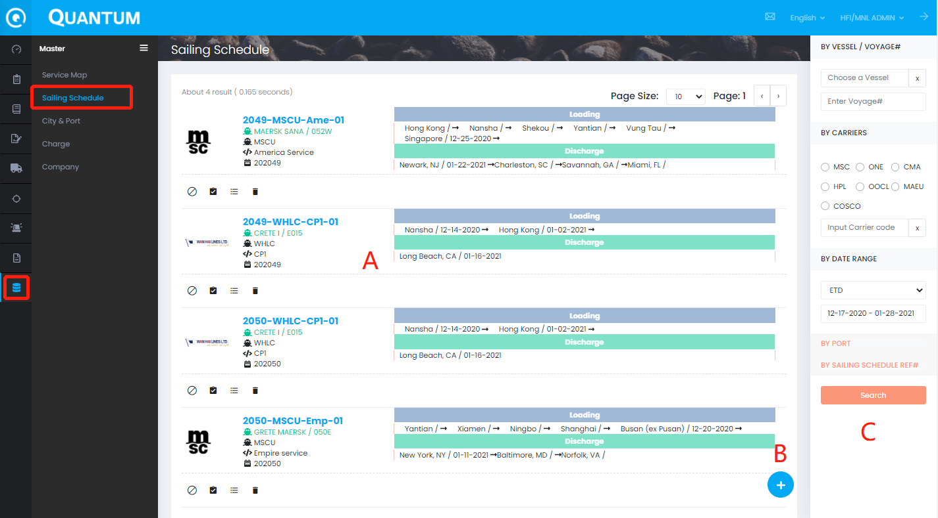
A – 看到 sailing schedule 清单
B – + 新建按钮，点击可以创建新船期
C – 搜索菜单: 输入相关条件搜索sailing schedule是否已经存在，避免重复建立
- sailing schedule 清单
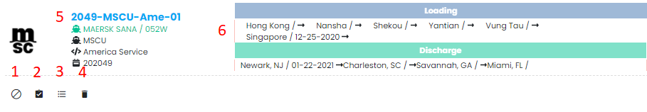
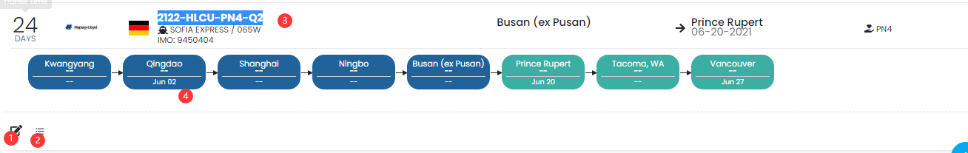
- 编辑sailing schedule按钮:
- Shipment List -点击进入查看这个Schedule关联的Booking/HBL.
- Schedule ref# -点击进入看到更多功能
  - 根据这个Schedule建立新的Booking
  - 查看这个Schedule关联的Booking/HBL. 同2功能
  - 编辑船期
  - Set to blank sailing – 如果有不停靠的港口，就可以用blank的功能。也可以blank整個schedule，或是单一一個port
我們現在沒有強制隱藏這個port 只有在SCHEDULE MAP顯示他是 blank這樣
  - VOID Schedule – 删除船期（为了避免有同事删错船期，暂时不授权给普通用户删除）
如需删除请通知 Support@chainglobal.com
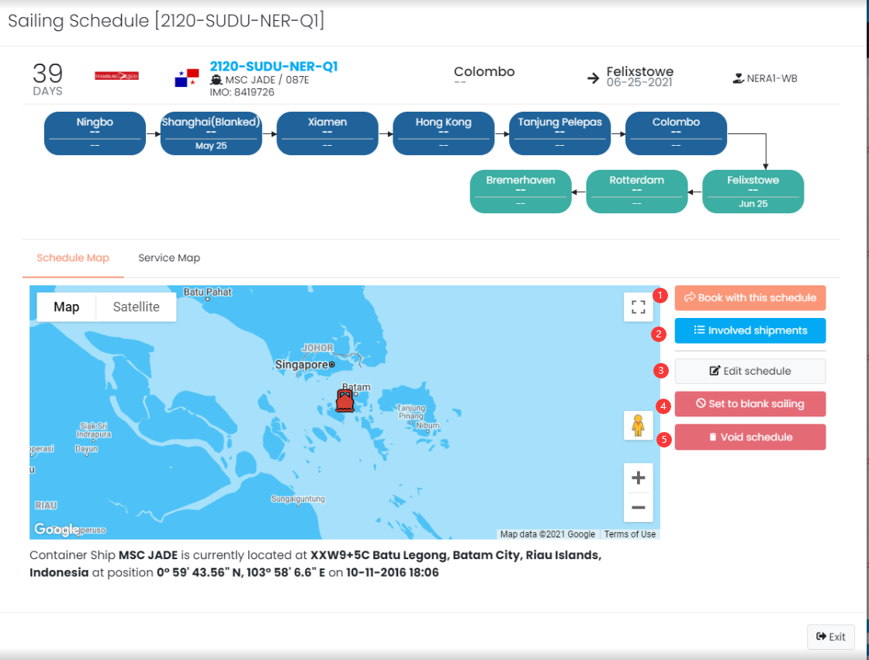
- Loading & Discharge Detail:包含港口信息和ETD/ETA日期信息

- 新建 Sailing Schedule
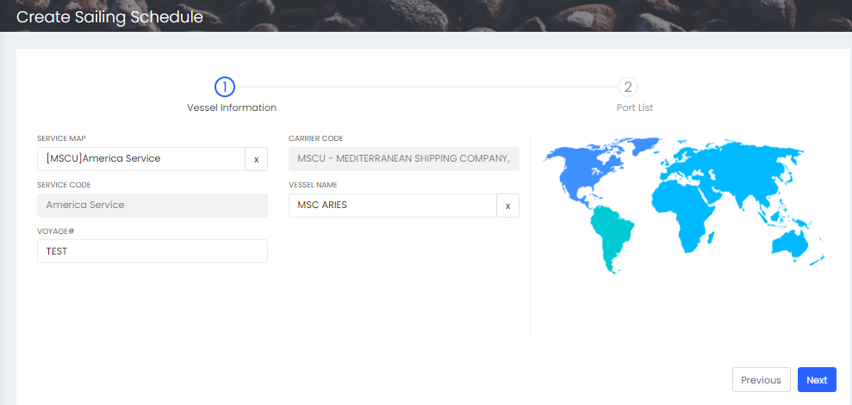
- 点击+ 号进入新建画面
- 先要Service MAP:输入SERVICE NAME ，根据跳出来的结果选择SERVICE CODE+CARRIER
Service Map没有的 USA/CAN的请联系 candywu@hecny.com 其他航线联系 Vanessachen@hecny.com
- 再输入vessel name, voyage （这些信息一旦生成REF#后无法编辑请仔细选择）
船名没有的联系 support@chainglobal.com
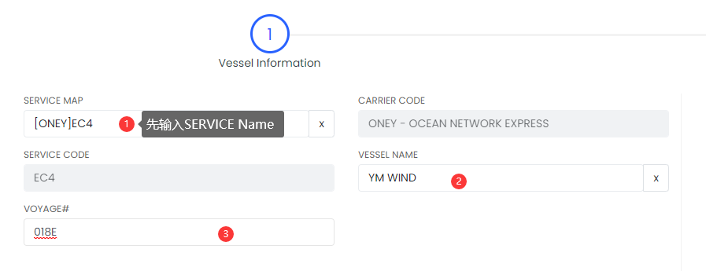
- 点击Next 进入 Port List 添加DATE & PORT
- 更新相关PORT的 ETD, ETA, SI CUTOFF, CFS CLOSING, CY CLOSING, VGM CUTOFF
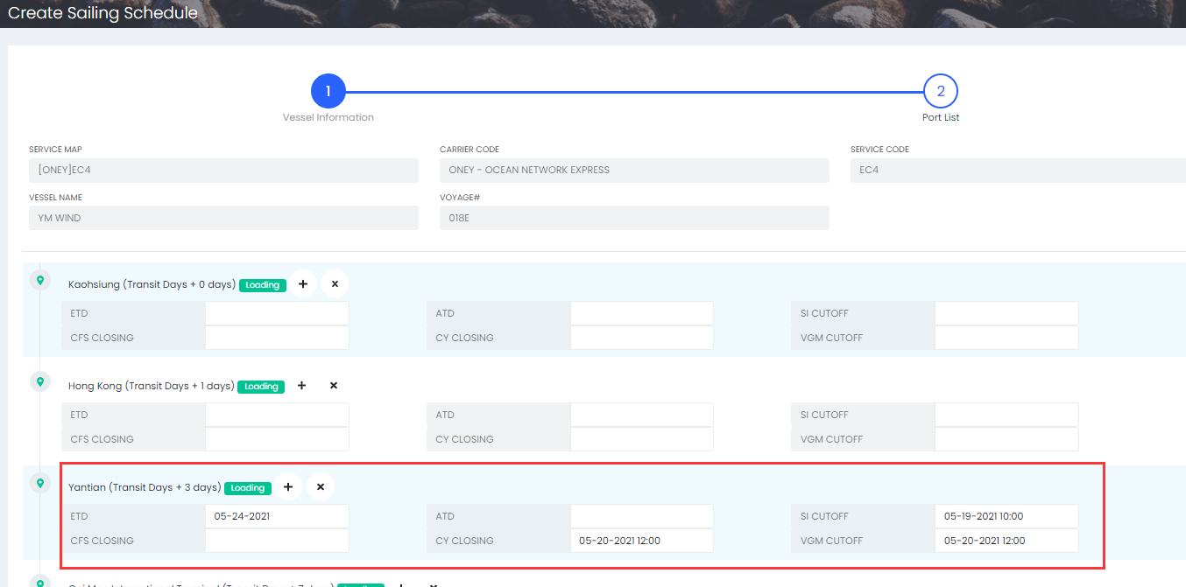
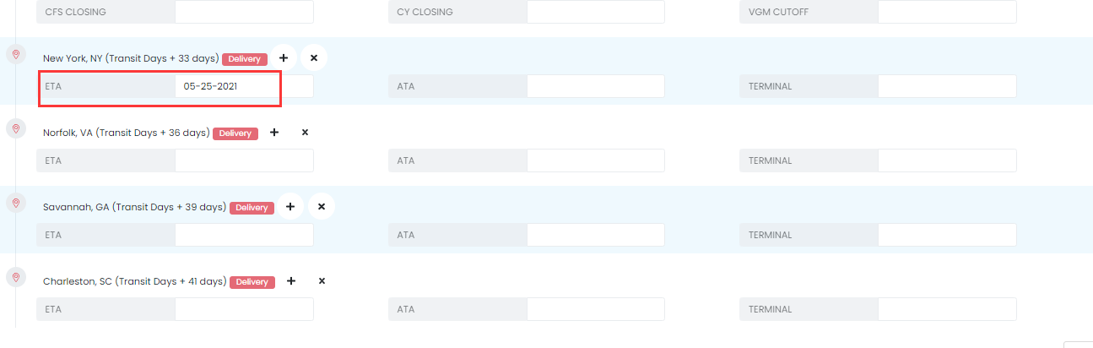
- 我们不建议手动加PORT ，如果确实SERVICE PORT有改动 请通知维护Service Map的同事进行更新. 如果是转船的，请按照F.V ,M.V, T/S V 维护BOOKING /HBL。
确实要加PORT ，选它的上一PORT，点击+
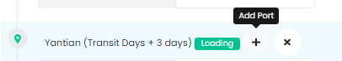
输入Port, TransiTime (注意不能与其他港口相同),Port Type,以及相关的日期信息
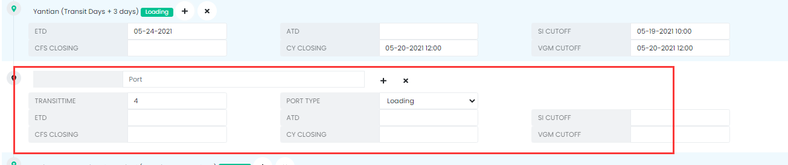
- 点击 Previous回到上一步骤修改
- 点击Submit 生成 Schedule Ref#
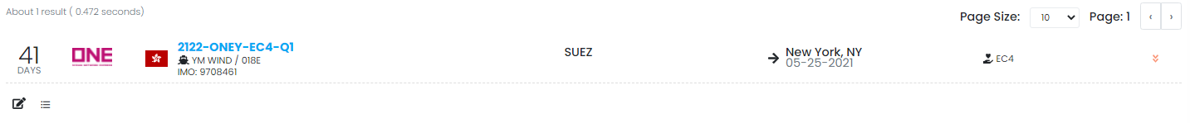
- Search 功能 -在Schedule list 的右手边
如果看不到请调整调整你的浏览器显示比例，调小就可以看到
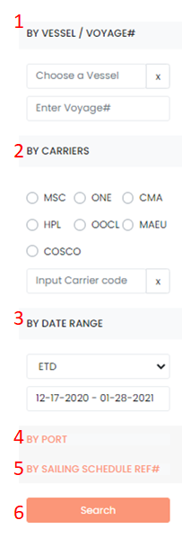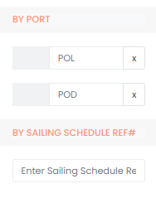
用户可以直接输入相应的搜索条件所有（不用全部填写）
- BY VESSEL/ VOYAGE#:
- BY CARRIERS:
- BY DATE RANGE:
- BY PORT
- BY SAILING SCHEDULE REF#
- 更新ETD ETA 回到BOOKING/HBL
用2. 或者3.2的方法进入到 shipment List, 点击UPDATE DATE 更新ETD,ETA
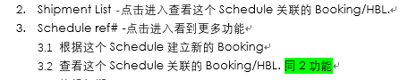

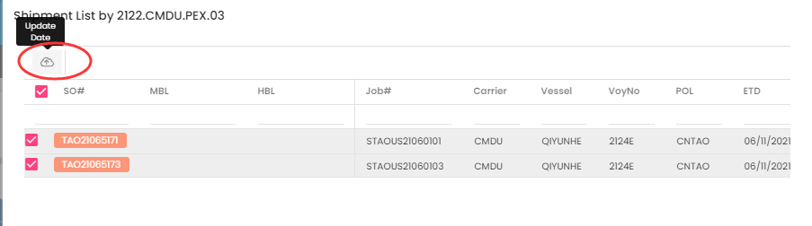

确认Booking
Purpose: 确认Booking的的正确性和完成情况，以便创建job number
When: 以下步骤完成后
- 船东已经放行了SO并提供 SO number
- Quotation 信息已经关联或者输入
确认Booking的步骤
点击Booking上方的Confirm 按钮
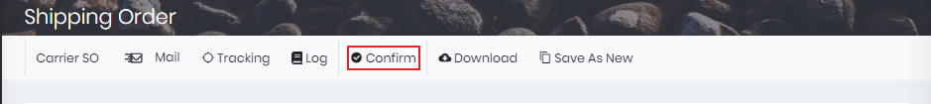
  - 如果有任何信息缺失，系统会弹出提示 ，请根据提示完善相关信息
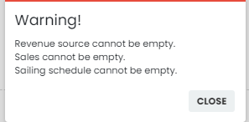
  - 如果确认成功，系统会生成job# ，并且Booking状态更新为 Confirmed

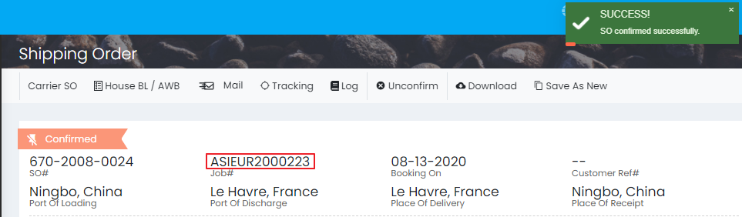

产生HBL#
Purpose: 产生HBL# 并维护 Shipment
When: 确认booking之后, 并且Shipping Order Log没有error 信息
- 在Booking上方菜单栏，点击House BL/AWB 按钮
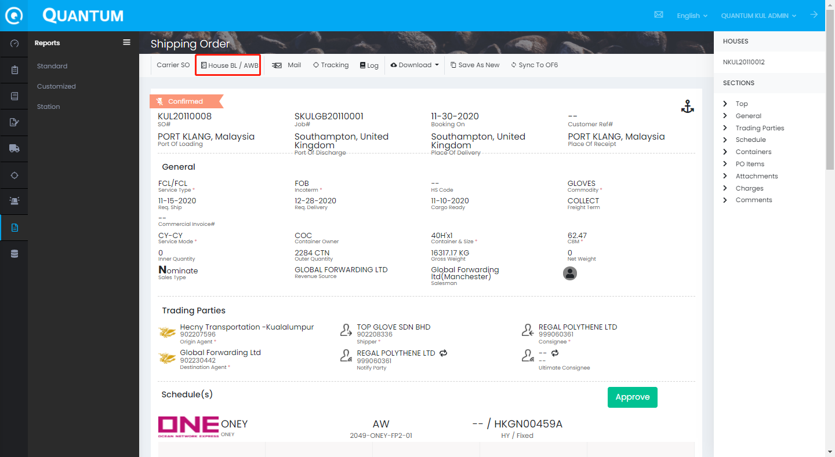
- 进入HBL# 生成界面
- 选择提单类型，提单类型如果没有在这里维护正确可以回到HBL维护。
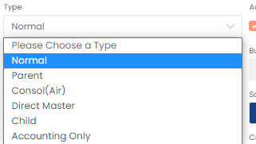

Normal – 正常出口提单
Parent -
Consol (Air) -
Direct Master -直发单
Child -
Accounting Only -只用来做账使用的提单。

- 其他
number or house# - 一次性可以生成多个HBL NO. ，用户直接填写要生成的提单数目
Revenue source, Business type, sales -从客户档案选择一个公司作为RSR，具体选择方法见RSR手册。 Business Type , Sales 需要通过客户档案更改。
Sales Type – Nomination – 国外sales,分公司，代理揽货
Freehand – 本公司sales揽货
cross trade – 通常是指另一家Origin Office揽货出口到第三地。
Sales Type/Cross trade要在生成HBL#之前选对，否则无法生成正确的N/F/X开头的HBL NO.
Coload – 同行货物要选择
Coload IN- 同行给货
Coload OUT- 给货给同行操作
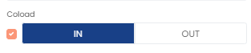
- 点击‘ Save‘生成HBL#
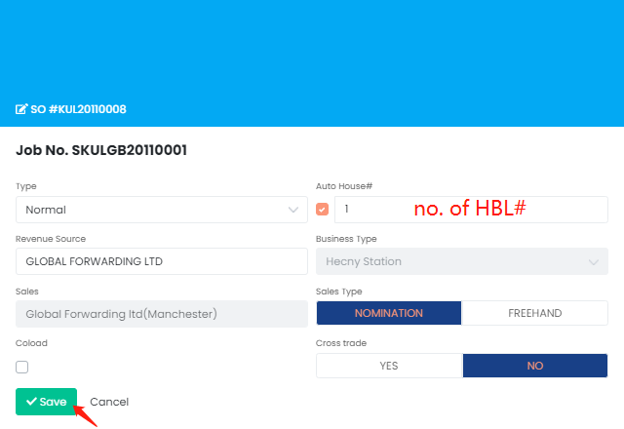
- HBL#生成成功后，用户可以在网页右手边看到 生成好的HBL#. 点击HBL#可以进入对应的提单画面
- HBL#生成不会立刻送回到OF6， 需要在Quantum编辑保存一次后，如果有ERROR MSG还应该先处理好ERROR 。

维护 SHIPMENT
提单里面包含了进口和出口部分，如果Origin/Destination Agent都在使用Quantum.那么双方都可以在平台上共享SO/HBL。 我们这里主要是讲出口操作。
**在Quantum中创建的提单只允许在Quantum中修改，反之亦然**
从 Shipping Order 进入提单,
- 点击网页右手边HOUSE的HBL#. 点击HBL#可以进入对应的提单画面
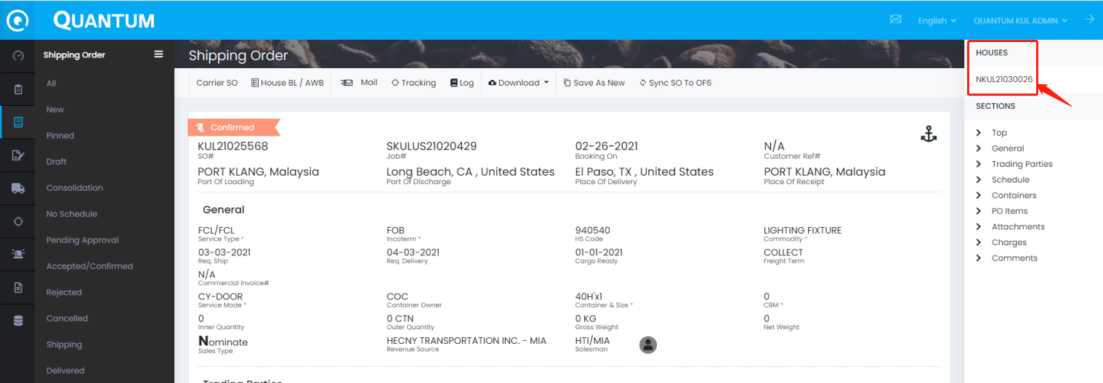
在Shipment 目录查找提单,
- 在左边菜单选择进入Shipment -ALL
- 从右边的搜索菜单搜索提单号码
看不到搜索菜单的同事要调整下网页显示比例，
调整搜索条件，找到后点击搜索结果的HBL# 进入提单编辑画面
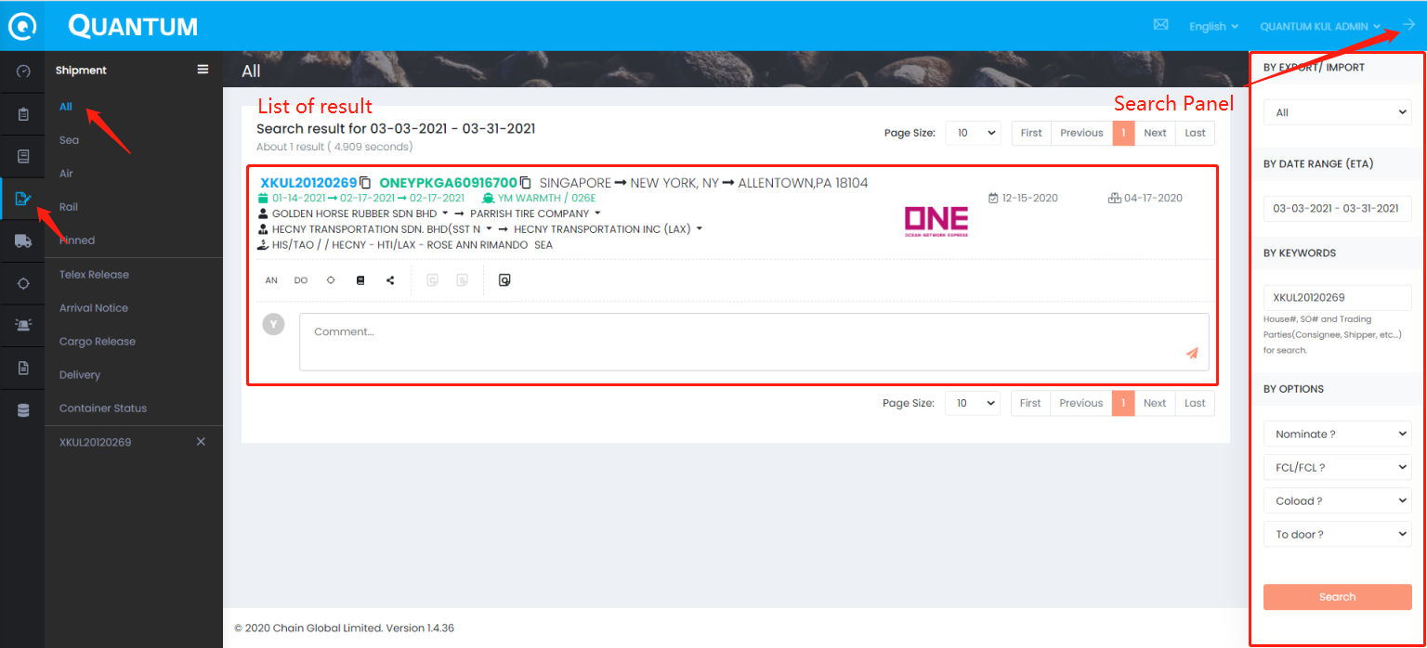
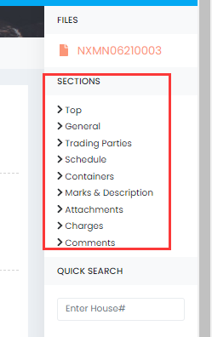
Sections
点击这些标题可以快速跳转到对应修改的位置

Quick Search :
可以输入 HBL NO. 跳转到其他HBL。

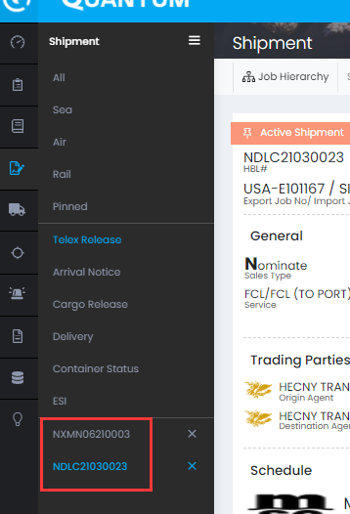

已经打开的HBL 在SHIPMENT 菜单左下角可以看到清单，可以单击HBL NO.跳转到对应HBL
点击X 可以删除记录

**此处的数据/信息至关重要，因为它们最终将发送给承运人和海关。如果有任何无效信息，处罚很重, i.e. AMS/ISF/ACI/eManifest – USD5000.

General (MBL & HBL info)
Purpose: 管理MBL和HBL之间的关系以及MBL和HBL下的一般信息
When: 创建HBL#之后（*如果MBL#在Booking时有输入，那么会从Booking带到HBL.）
- 将光标移动到“General”部分，然后单击“Edit”
- 将MBL#及其信息与每个HBL#连接起来
- 输入所需信息
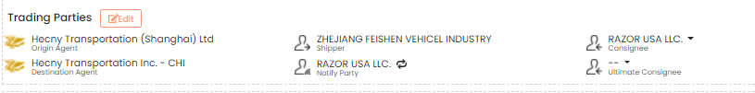
MBL Information
MBL# ,Bill Type , Service Type, Container Mode, Freight Term
HBL Information
Service Type, Container Mode, Freight Term ,
Bill Type : Telex Release / Original B/L
House Type, Sales Type, Co-Load
Revenue Source -如需更改点击X删掉重新输入公司名称选择
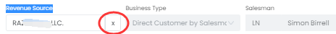
Customer Ref#1 -输入Agent Ref#
Customer Ref#2 – 输入其他需要备注的Ref# (OF6无此栏位)
Incoterm
Commodity – HBL 小品名
AMS SCAC，AMS#
Cross Trade
To Door
Dangerous Goods

修改后点击SAVE 保存，没有error的情况会同步回OF6。

Trading Parties
Purpose: 管理提单中的相关客户信息
When: 如果信息有缺失或者修改的时候
- 将光标移动到Trading Parties 点击 Edit
- Primary Parties , Agents , Others
如果修改，点击X删掉name/code ,再次从客户档搜索。
公司名称带特殊符号，空格，缩写等的，建议可以取单词或字母加%,进行模糊查找
例如搜索HECNY LAX公司，可以输入‘HECNY%LAX‘查询
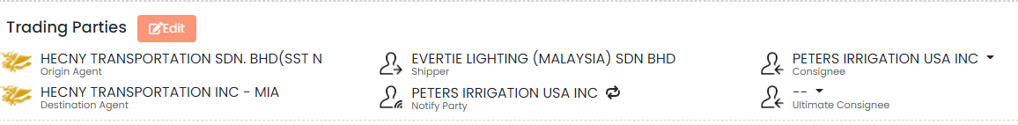
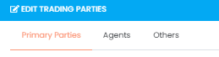
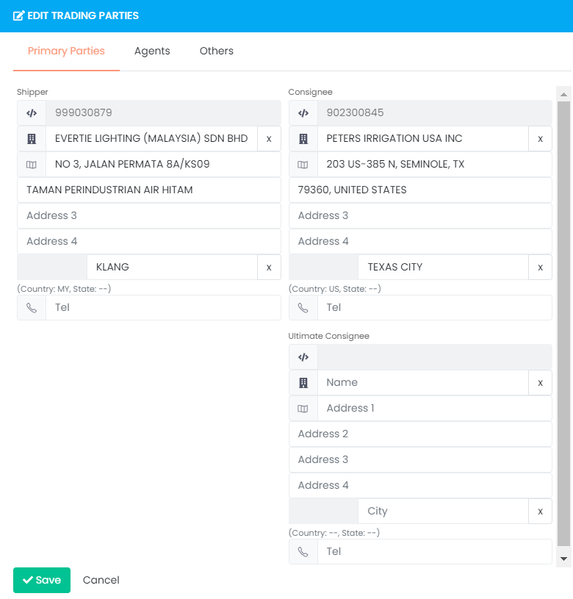
Agents
Origin Agent/Destination Agent
3rd Party Agent – CROSS TRADE 的涉及到第三个AGENT 可以填写。然后对方也可以在Quantum查看这个HBL
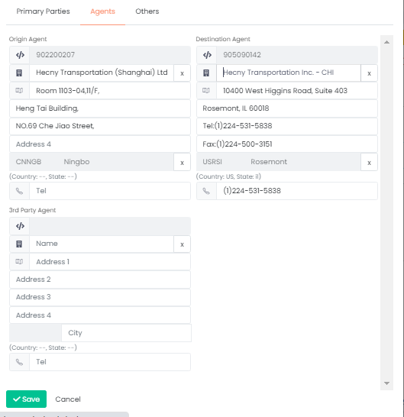
Others – Notify /Also Notify
修改后点击SAVE 保存，没有error的情况会同步回OF6。

Schedule
Purpose: 更新schedule, 尤其是一些 cut-off date, closing date
When: 一般从Booking带过来船期信息，如有变化，可以在此更新
***HBL 更新的信息会同步到这个JOB所有相关Booking & HBLs***
- 移动光标到General 点击 Edit
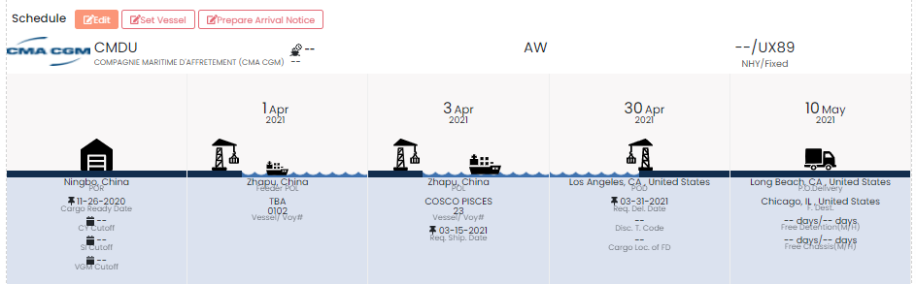
- 如果用户没有输入Schedule Ref#,那么当前画面的信息可以直接修改
如果有Schedule Ref#， 那么M/V 的信息和POD都是不能修改的，更新要重新选择Schedule Ref# 
USA/CAN的务必要选择Schedule Ref#
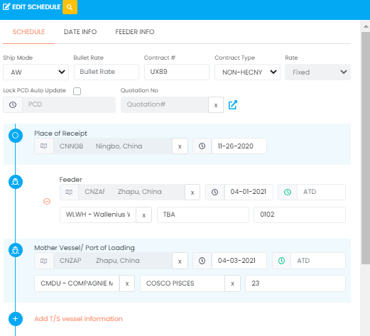

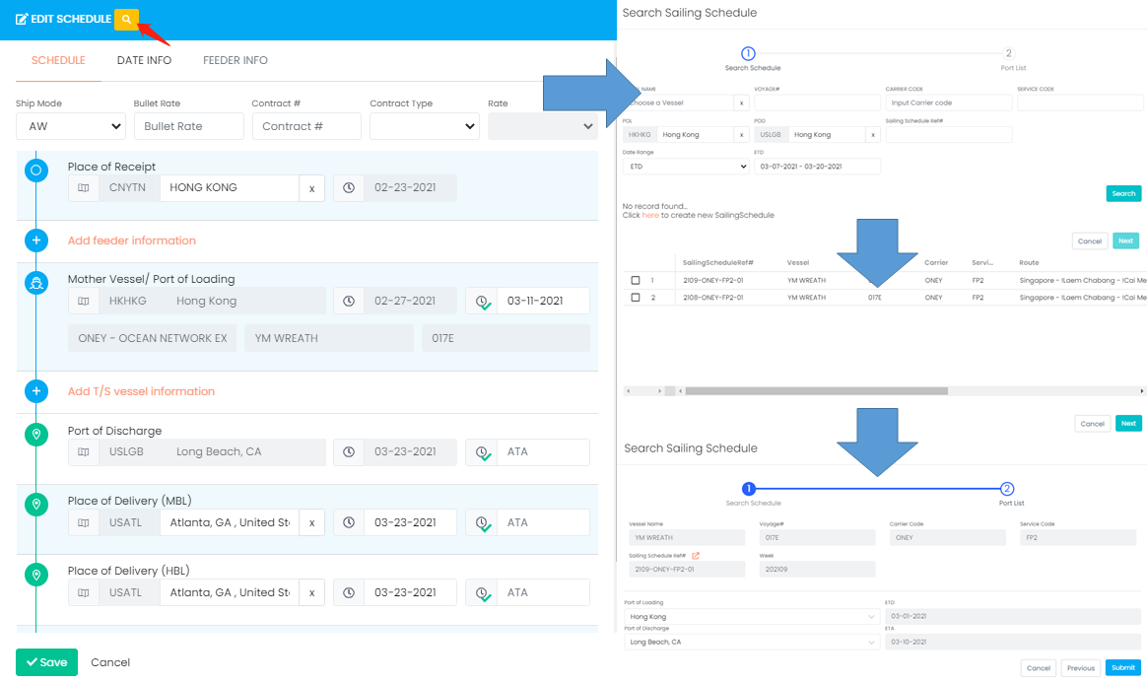
如果在第二步发现schedule有信息缺失，可以点击schedule ref#旁边的箭头跳转到sailing schedule list 更新。更新完成后，回到这个画面，点击‘Previous’ 重新选择这个Schedule就可以看到更新后的信息。
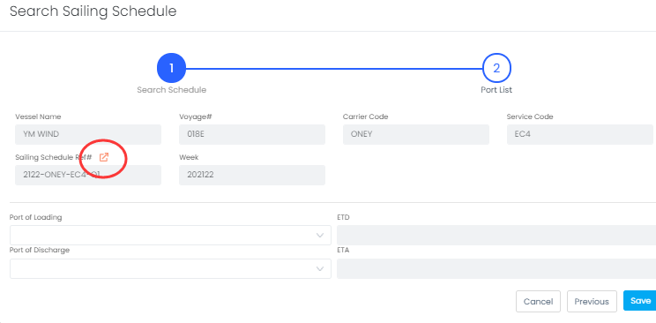
**关于 Sailing Schedule 的更新和管理, 请参考Quantum SOP – Sailing Schedule
- 其他信息
  - 合约号等信息

    - Ship MODE:
AW:全水路 (ALL WATER)
MLB：船走全水路挂靠美东基本港之后经过陆运或者是转运到各内陆点或者是其他非基本港口运输模式。
IPI:在美西卸船后转内陆运输（火车或拖车）
RIPI(Reverse Inland Point Intermodal ):在美东或墨西哥湾卸船后转内陆运输
AIR : 空运
    - Bullet Rate
也叫NAME ACCOUNT,N/A,NAC,2ND NOTIFY
是船公司和货代公司在签约价的时候，专门针对一些货物或者公司，签的价格。
    - Contract Type
HY-Hecny – Hecny和船公司签约长期的有效合约号。
合约号码只能从系统选择，如找不到合约号，请Pricing同事通知Support@chainglobal.com 添加。
NHY - Non-Hecny –使用代理或/CNEE的合约，输入对方提供的合约号
如果是LCL提单，无法得知同行约号的，可以填LCL
SR – Spot Rate 船公司针对某一票货物提供的特殊约价，用户可以手工输入约号
注意： USA TRADE 只有个别船公司允许选择SPOT RATE
BK-Booking Only
客人使用HECNY帮忙订舱，但是无需提供后面的提单等相关服务。
请慎重选择此选项，选择BK类型，则无法被统计到任何报表里面。
NYSHEX
使用NYSHEX网站第三方平台进行订舱，手动输入约号.
    - FLOATING/FIXED
一般HECNY的约都要选择，看PRICING 提供的合约明细
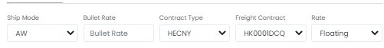
  - PCD & Quotation No.
    - PCD -主要目前用于NON USA航线，由CS维护，HBL/BOOKING保持一致
    - Quotation no - 主要目前用于NON USA航线，由CS维护，HBL/BOOKING保持一致
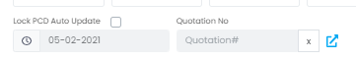
  - F. Vessel , T/S Vessel
如果有F.Vessel 和T/S vessel务必点击ADD输入准确的船期信息
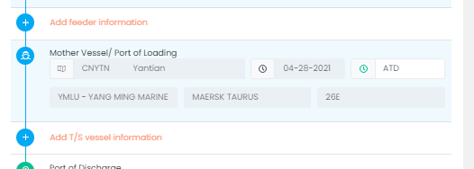
  - Ports
Place of Delivery (MBL) = Place of Delivery (HBL)
Final Destination – DOOR 点
点击X 删掉原有输入，输入Name或者五位国际城市代码，可以带出来。
如果有任何PORT/CITY缺失 ，请通知Support@chainglobal.com
请填写正确的 ETA日期。和POD不一致的港口要适当加上拖车、火车时间。
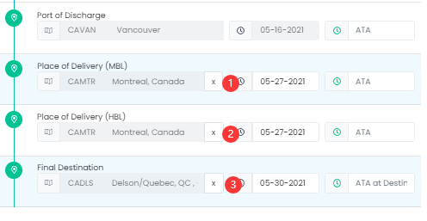
  - Date info
相关日期一般从schedule或者Booking带过来。
SI CUTOFF, VGM CUTOFF ,
FREE DETENTION & FREE CHASSIS
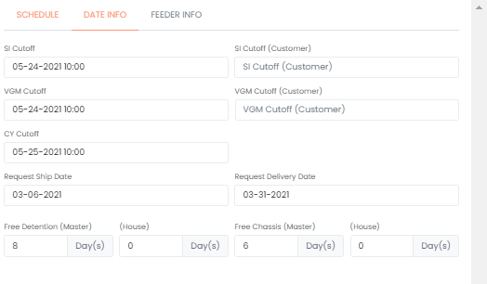

Container(s)
Purpose: 修改集装箱信息和柜子动态
When: 当集装箱信息需要更新时
集装箱维护有2个模板，大家可以根据需要切换模板更新。
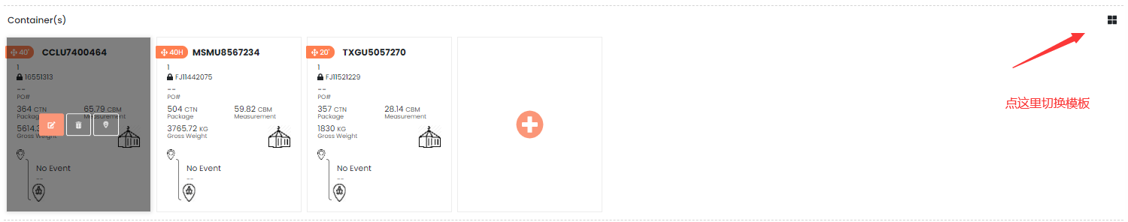
模式一
- 点击 编辑集装箱信息和柜子动态
- 点击删除整个集装箱
- 点击更新柜子动态
- 点击添加新的集装箱
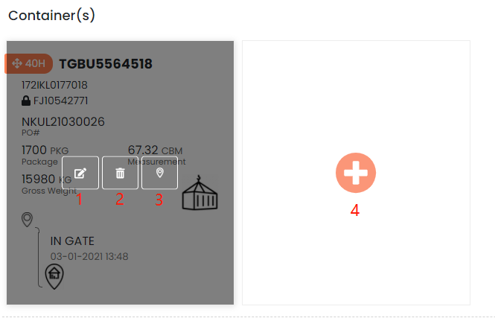
模式二
这个模板的优势在于可以整行或者整列粘贴。复制原始资料再对应的位置CTRL+V粘贴即可。
- 点击添加一个新的集装箱
- 点击删除整个集装箱
- 点击 撤回编辑集装箱信息
- 双击要编辑的栏位编辑集装箱信息
- 点击 保存集装箱信息，一定要点保存
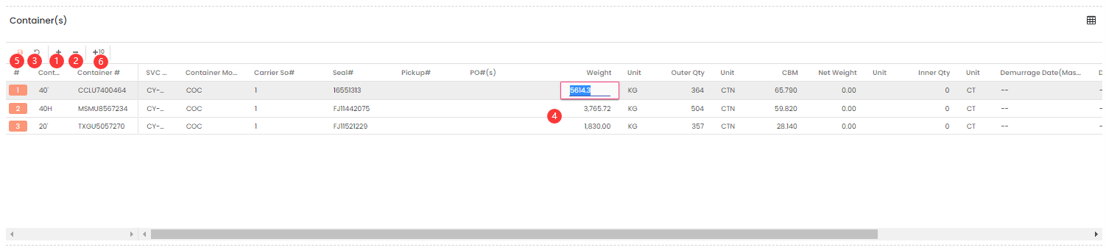

编辑container信息
- 基本信息： Container Size, Container#, Seal#, Gross Weight, Outer Qty, CBM
SVC Mode
Container Mode
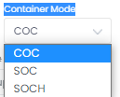
COC - 船东箱
SOC – 客人自有箱
SOCH- HECNY 自有箱
请务必不要选错箱主

- PO#
客人要求输入PO# 请记得输入，多个PO时 请按照系统提示输入 英文字符的 逗号 ‘,’隔开
- Remark
输入Conainer Remark ,比如BOB的客户要输入：PREMIUM
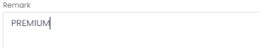
- 点击Container 右侧的 跳到下一个柜子
- 编辑完成后点击 ‘Save’ 保存’

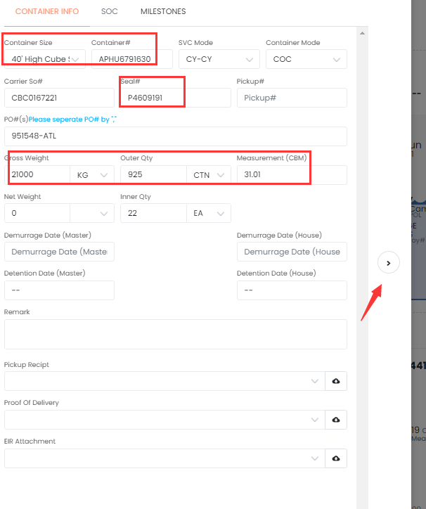

2) 删除container
方法1
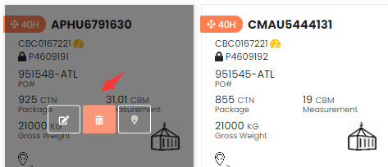

方法2 ，切换到EXCEL模板 ，可以挑中多个箱子，点击
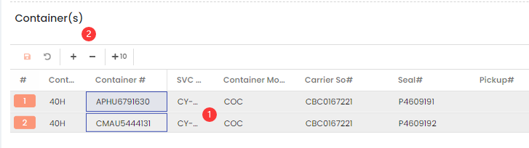
系统弹出提示是否确认删除Container ,点击YES删除。
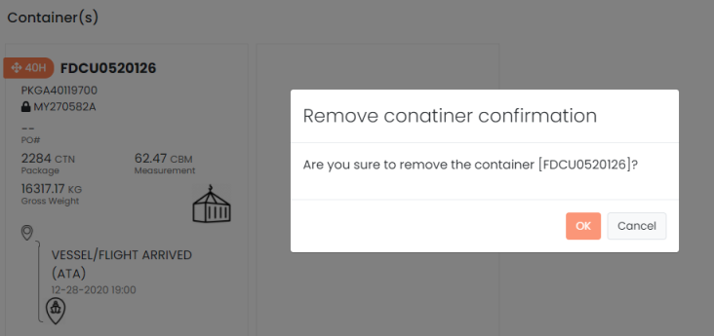
3) 添加Event 
- 选择event type及其对应 lcoation, 输入日期。 如有需要可以备注REMARK。
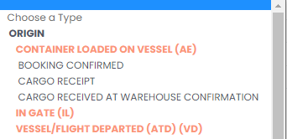
- 如果EVENT是还未发生的，选择Planned Event = YES
(主要针对POM等VIP客户的要求)
- 点击Save 保存Event
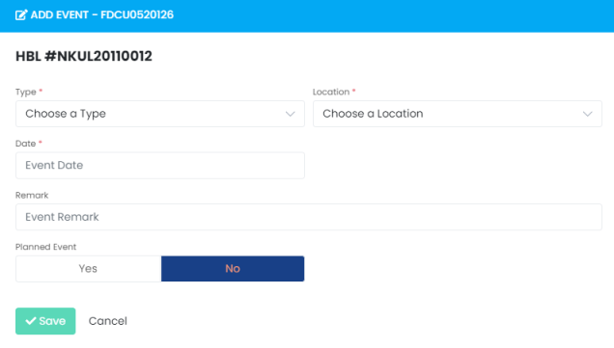

SOC Container (如果Container Mode= SOCH)
- 在Container 下面就可以点开SOC画面
- 输入Origin Depot, Dest. Depot and Gate in Date will be retrieved in SOC tab in the container
- Input Gate Out and Empty Return Date
- Click Save. The SOC information will be carried forward to import shipment and used in Delivery Order
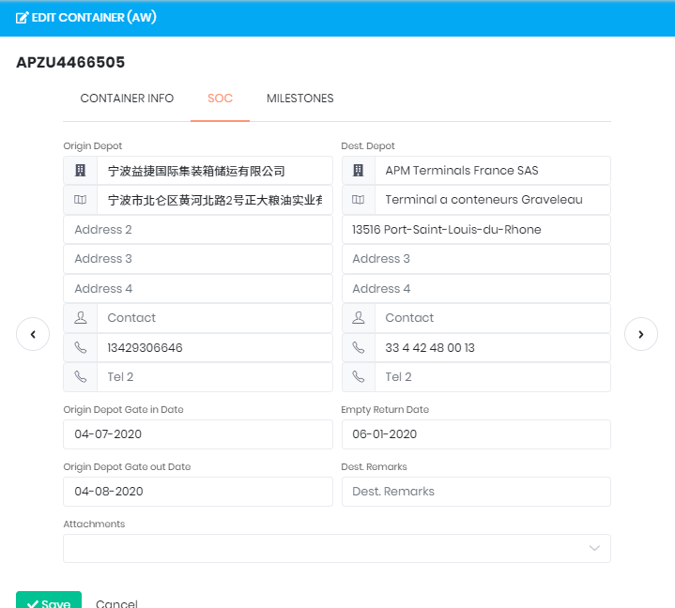

Marks & Description
Purpose: 打印HBL的关键信息
When: 收到SHPR提供的SI之后
- 移动光标到 Marks/Description
- 点击Edit
- 输入Marks (唛头)， Description (品名及其他客人希望显示在提单上的内容).
- 点击Save保存。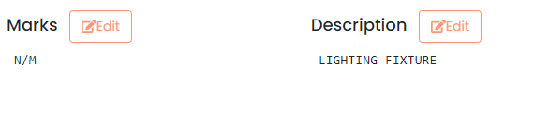
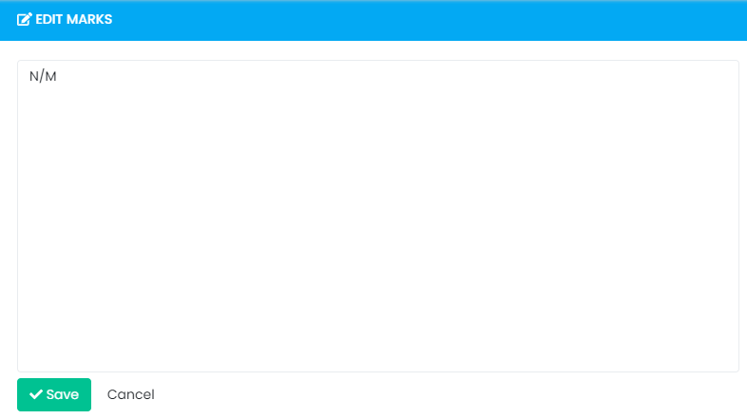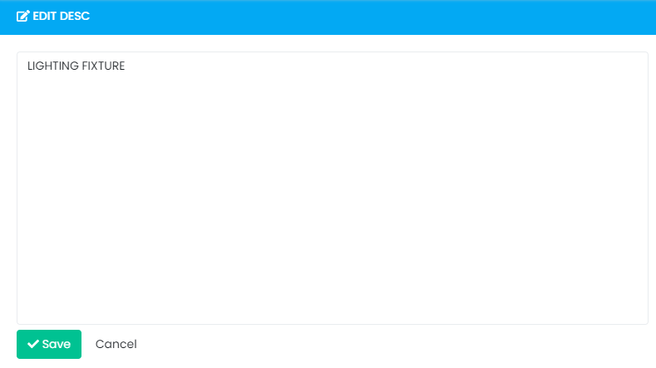

PRINT HBL
Purpose: 准备PDF格式的HBL
When: 基于请求/截止日期
**User should use laser printing and the printer setting should allow two-sided printing
- 转到Shipment顶部的工具栏，然后单击“Print”进入编辑
  - Shipper/Consignee/Notify/Delivery Agent （内容可现实五行*45个字符每行）
用户可以在此编辑排版。如果客人是更改了公司名称，请回到Shipment重新选择正确的公司
  - 港口信息可以在此编辑，如果更改了港口的，请回到Shipment重新选择正确的港口
  - Issue Date & On Board Date ,修改为提单要显示的日期
  - Commodity, 显示部分HBL的品名
  - Marks 请回到SHIPMENT-MARKS修改
  - Description 的柜子品名信息是从Shipment-Description & Container detail带过来的。如果要修改回到Shipment修改，在点 Refresh刷新。
Add Phases – 点击添加木质包装声明,选中要显示的木制声明，选好后再点X退出选项。
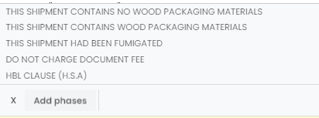
  - Freight Term – 如果要修改回到Shipment-General 修改 HBL-Freight Term
- 在右手边 ‘options’ 选择提单显示内容
  - 提单显示公司抬头，通常有HECNY SHIPPING+HECNY ORIGIN 两个名称可选择
  - SHOW MBL#,SHOW SO#,SHOW MOTHER VESEL,SHOW FEEDER VESSEL
AS AGENT ONLY/AS CARRIER ONLY/AS AGENT FOR THE CARRIER -不能修改内容。如果客人有要求请拒绝，或者把其他显示内容放在Description里面。
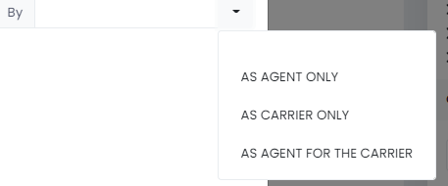
- 点击 PRTIN旁边的侧键，选择要打印的PDF类型，如果内容有缺失，系统会跳出提醒
HBL PDF (Original with T/C)，HBL PDF (Copy), HBL PDF (Draft) 内容都是一样的，但是提单会有相应的水印，请根据需要选择。
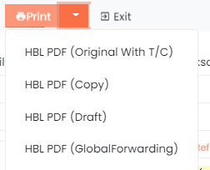
- 选中提单格式后，弹出以下提示
  - 是否保存HBL PDF到提单的ATTACHMENT位置？
YES-保存，No-不保存。大家可以根据需要选择。
点了保存后，大家可以在 HBL-ATTACHMENT位置查看到HBL PDF
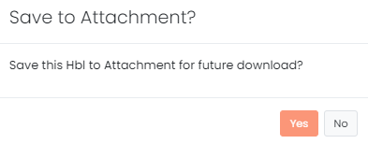
  - 是否 上传HBL PDF 到OID。
美国加拿大航线的同事根据需要选择YES OR NO。
YES- 提单就可以同步到OID。
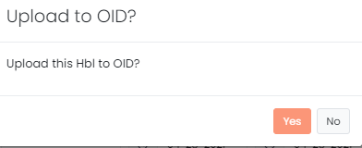
- 打开的HBL PDF会自动保存在电脑-下载目录

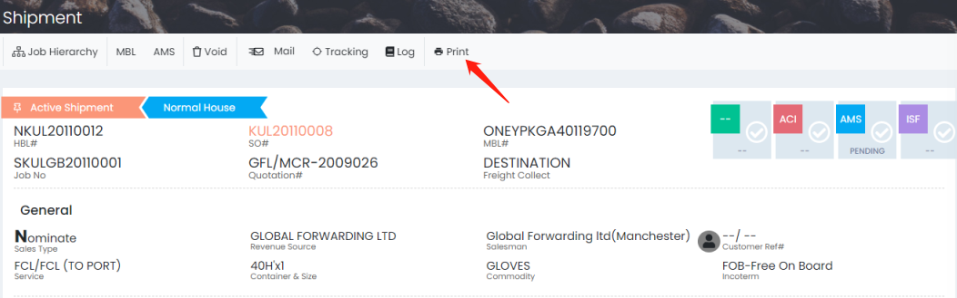
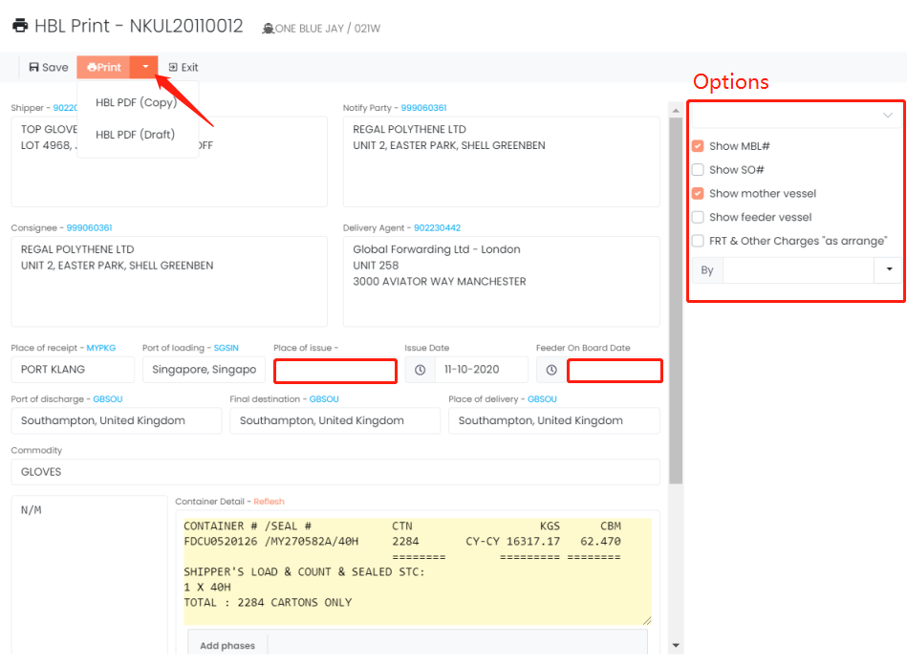
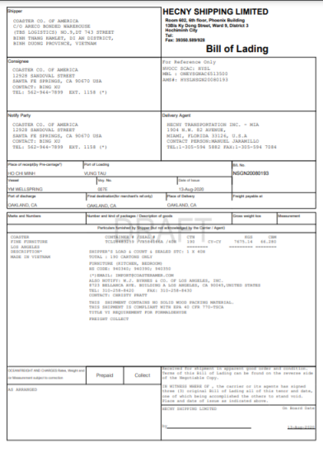
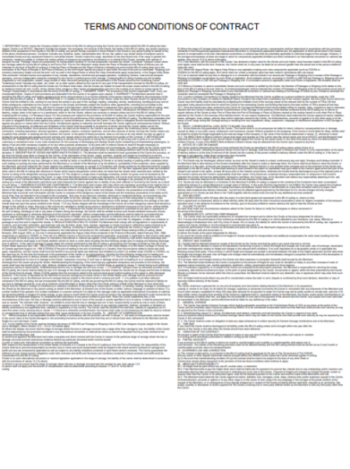

Attachment(s)
There are different types of documents need to be uploaded as supporting material. To keep the documents tidy, user could upload attachments here.
这里有不同类型的文件名可以选择，用户可以根据需要上传相关文件作为云存储记录，方便日后查找有关信息。
- 移动光标到 Attachment(s)
- 点击Upload
- 用户可以直接把文件夹里的文件拖到这个窗口里面(每个文件不超过 5 MB)
或者点击Choose Files 按钮从文件夹选中文件点击上传
- 文件上传之后要选择相应的document type, 有备注的填 Remarks 再点击 Upload all上传
文件类型必须选择，因为不同的用户在Quantuum权限不一致，选错类型可能导致文件泄漏。
- Status 显示说明文件上传成功了。
- 点击 Remove 删除文件
- 点击右上角的x 退出当前画面
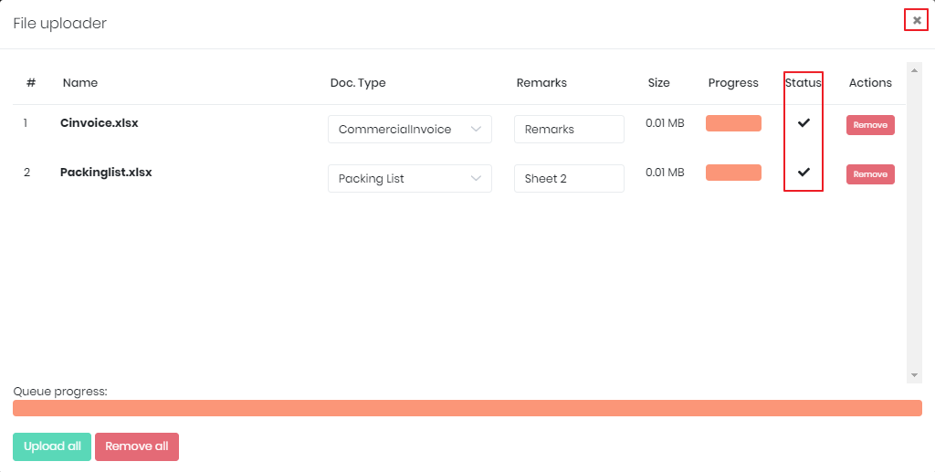
- 用户移动光标到文件的末端可以删除或者下载附件
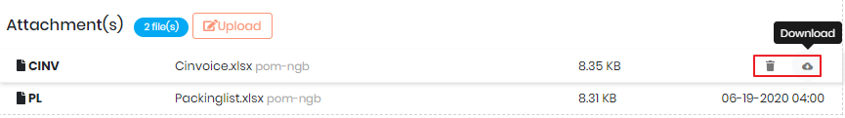

Charges
Purpose: 仅在本阶段显示来自 OF6的数据
When: NA

Comments
You can input and reply to the comment to share message with other parties. The comment will be showed under same booking/shipment to other parties’ account. You can review previous comments in this section as well. *Please do not input confidential information in comment
Choose the type from the tab, i.e. all, booking, container.
您可以输入并回复评论与其他使用Quantum的用户（SHPR/AGENT/SALES）共享消息。该评论将显示在同一Booking/HBL到其他方的帐户。您也可以查看票中以前的评论’请勿在评论中输入商业机密信息’

从选项卡中选择类型，即all、booking、container。
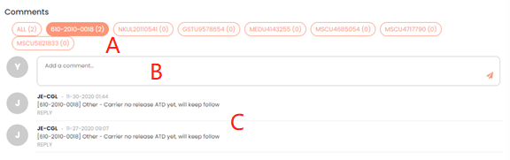
A – Comment type: booking, shipment, container
B – Comment box: 输入相关信息
C – Comment history: 显示最近的信息
在网页的顶部可以看到消息按钮，点开就可以看到最近的消息。
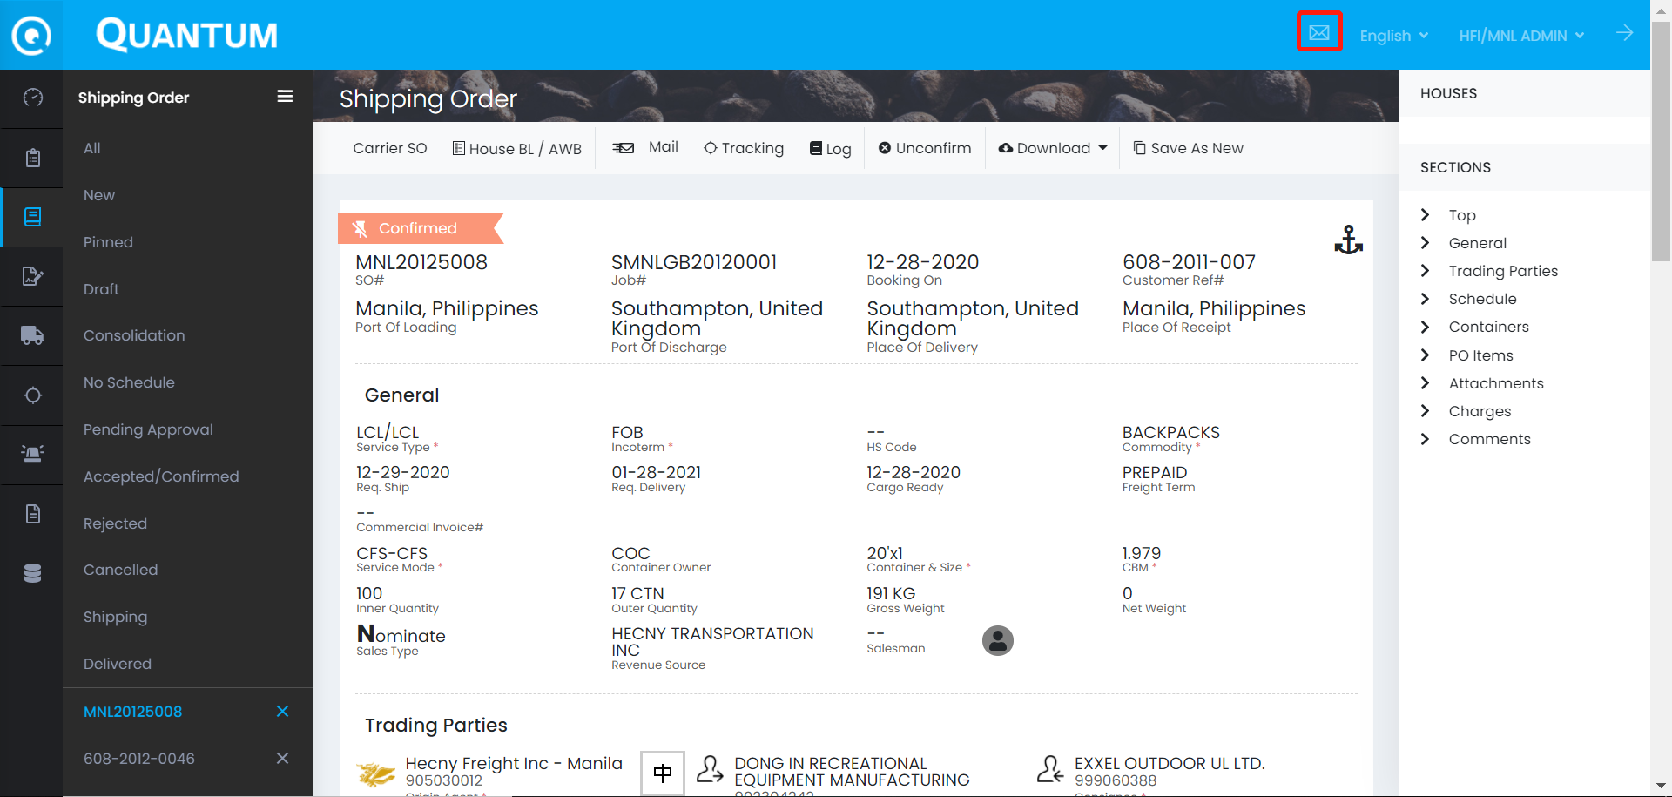
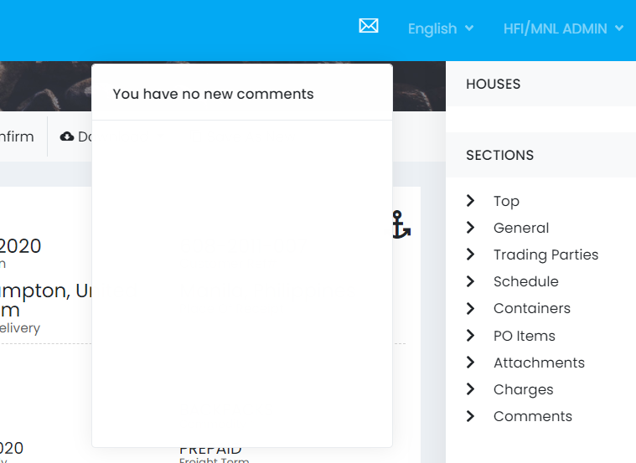

CHANGE JOB -功能还未完成
Purpose: For any request, want to separate/move the HBL to the other job
When: Before Telex/Original BL Release
- Go to shipment detail and click on Job Hierarchy
- Select Move HBL to other Job
- Search the other Job (destination)
- Drag and drop the HBL from original to destination
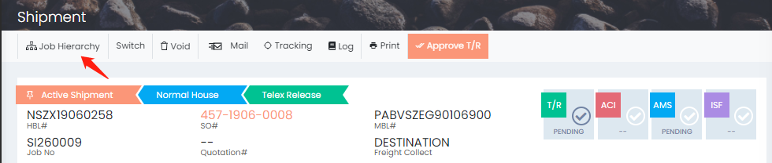
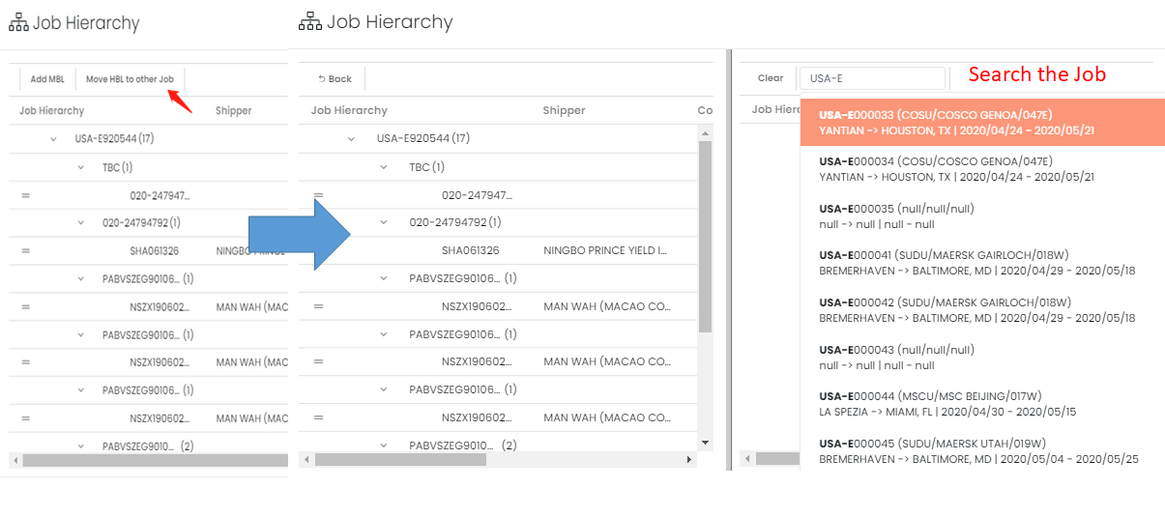
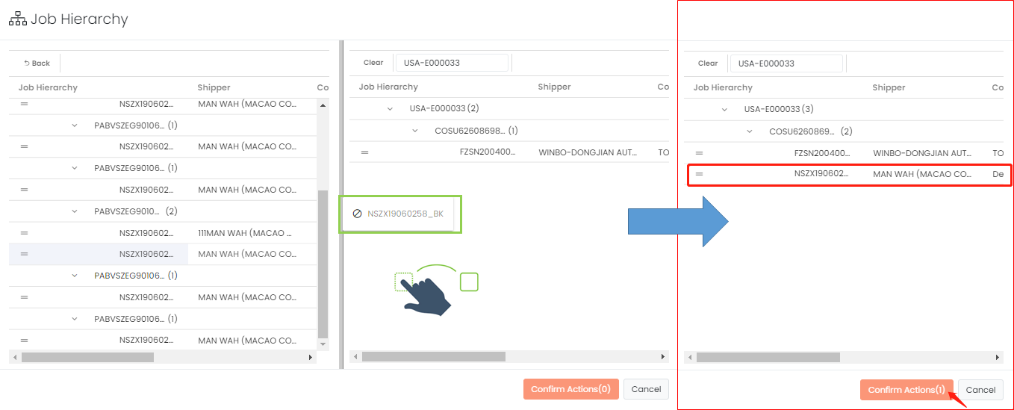

SWITCH BILL
Purpose: 如果客人基于商业考量不想暴露发货人和收货人之间的信息，请将HBL标记为1ST LEG (Original)&2ND LEG（Parent）
When:客人提出要求时，开船前准备HBL PDF
- 在2nd Leg提单上面，找到‘Switch’ 按钮
- 点击Switch 按钮，核对系统弹出的提示内容，如果确认无误，点击OK
- 当前HBL显示为 switch BL (Parent)
- 相同JOB的其他显示为 Original Bl (Child)

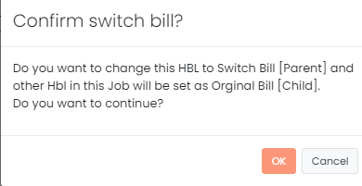
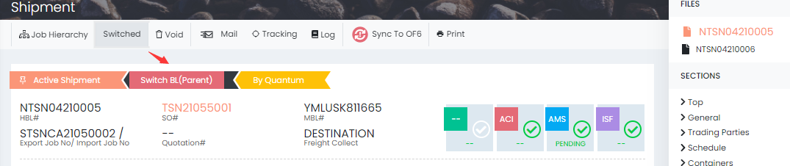
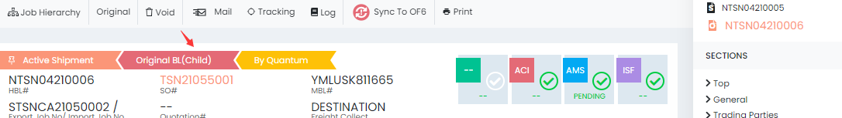

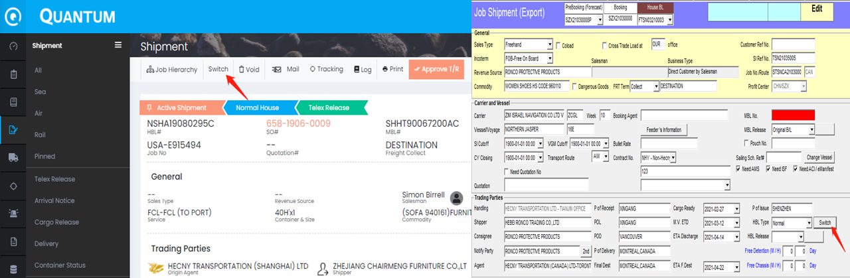

HBL电放或HBL正本状态
Purpose: 供用户管理HBL是否放行
When: 通常是客服已经付完全部本地费用，并提供相应电放保函通知我们电放/寄送提单正本时。

方法1 在HBL里面设置的TELEX/ORIGINAL BL状态
  - 用户首先要在HBL-GENERAL里面选择 HBL BILL TYPE
在HBL 上面的就出现对应的T/R Pending 或者Original Pending.
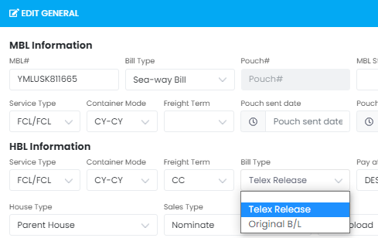

  - 确认可以电放或者寄送正本时，点击 Approve T/R or Original按钮
如果ATD未设置会弹出提示 ‘No ATD date ‘
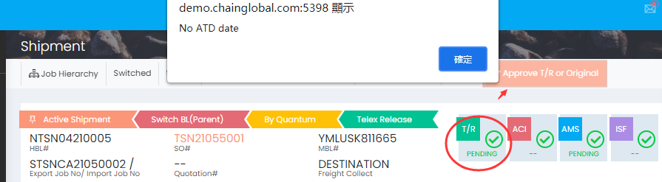
  - 设置ATD
    - Sailing Schedule 更新ATD 再UPDATE 回HBL (未完成)
    - 在Schedule 设置LOADING PORT的ATD, 有F.V的F.V ATD & M.V ATD都要设置好。（只设置F.V ATD不影响设置提单状态）
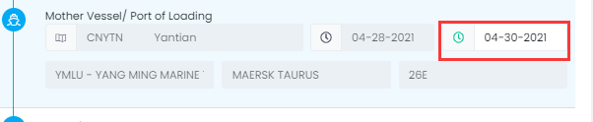
    - 在Milestone 更新ATD。
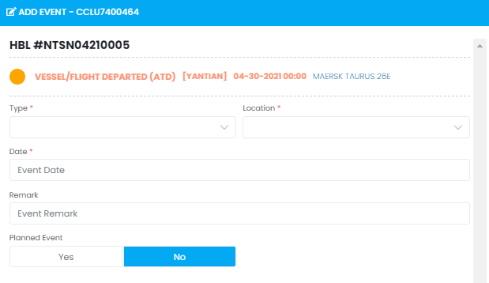
  - 确认电放的点击OK ，状态变成READY。 电放成功后USA/CAN的提单如果没有ERROR 会同步状态到OID
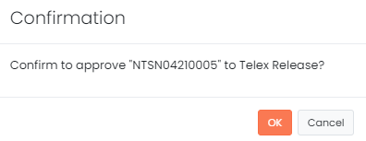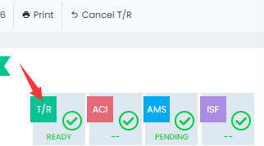
  - 删除Telex/Original
点击HBL上方的CANCEL T/R按钮，输入原因点击OK移除Telex/Original状态
用户可以去HBL -General 修改HBL状态。
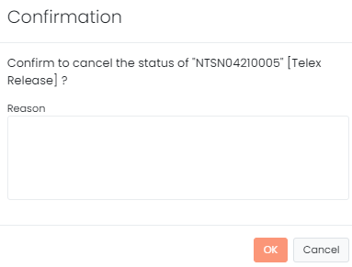

方法2 到 Shipment菜单下的 Telex Release 目录

  - 进入Shipment -Telex Release （设置TELEX/ORIGINAL都可以）
  - 在右侧搜索栏 找出相应的HBL
  - 搜索结果，提单右侧可以看到一些待选项目
ATD必须设定 ，可以上传水单
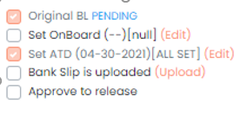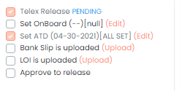
Bank Slip (上传水单) & LOI（上传电放保函）
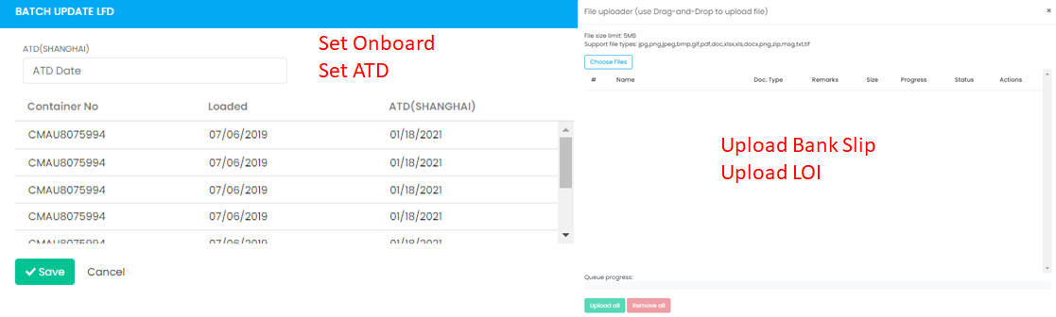
  - 勾选“Approve to release”（如果以上项目未完成，则提示错误）
输入电放理由。点击OK，设置电放成功。 （没有弹出电放邮件）
取消电放点击Cancel
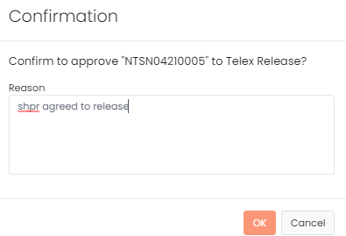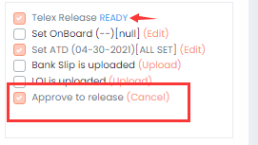
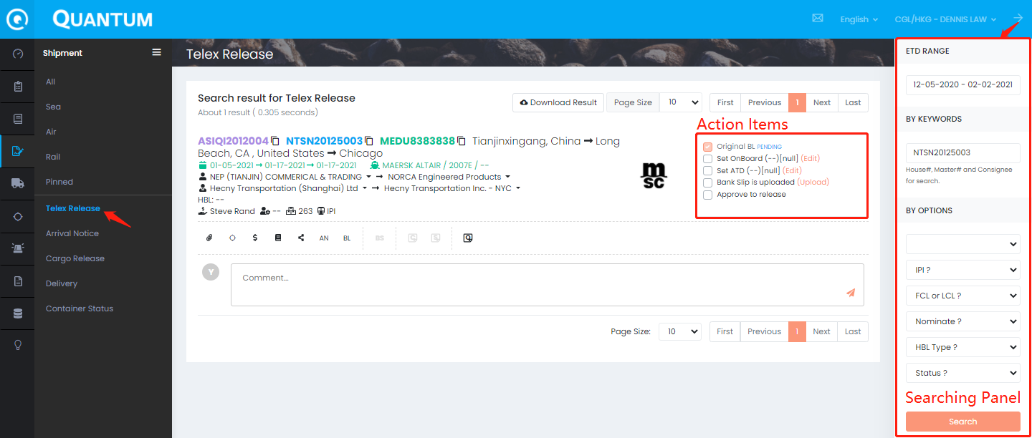

列印TELEX BL
  - 点击PRINT按钮进入到HBL PRINT ，点开侧键可以看到HBL(TELEX) 选项。
  - 普通用户只能打印一次TELEX BL。如果要重新打印需要重新设置TELEX状态
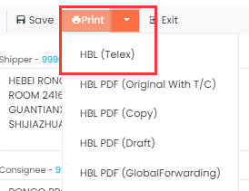
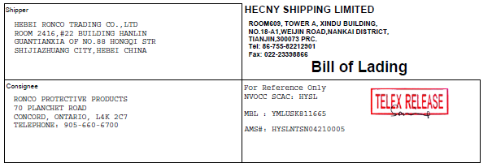

  - 如需发送TELEX BL给客人或者AGENT,可以在弹出来的邮件上面输入收件人发送。
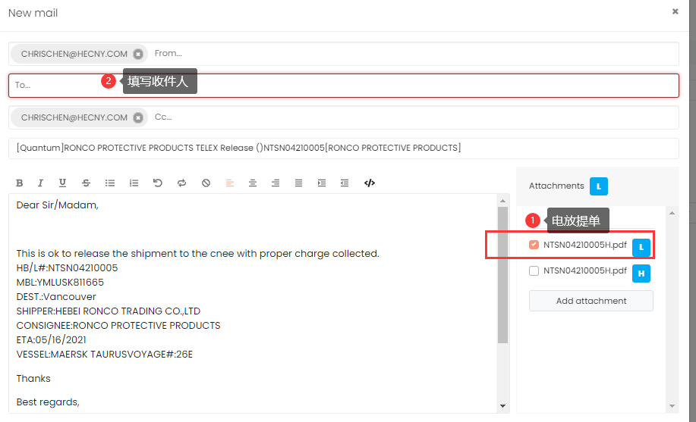

正本提单列印
Quantum 还不支持针孔式打印机，如果是列印正本提单的需要回到OF6打印提单正本。
如果是使用A4纸张的，可以选择HBL PDF (Original)，选择双面打印
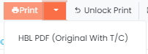

SUBMIT SI (ESI)/VGM – CARRIER-未完成
Purpose: Submit ESI/VGM to carrier
When: Before carrier cut off time (ESI/VGM)
**Data from Quantum will be synced to OF6. Please follow the original process at this moment.
In the next stage, we will integrate this session in Quantum. You can only check the Log to review the status.
- Go to shipment list or shipment detail
- Click the Log
- Select ESI to view the status
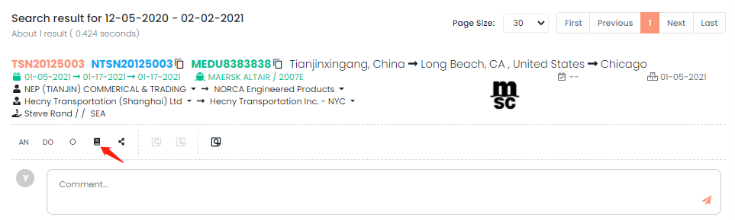
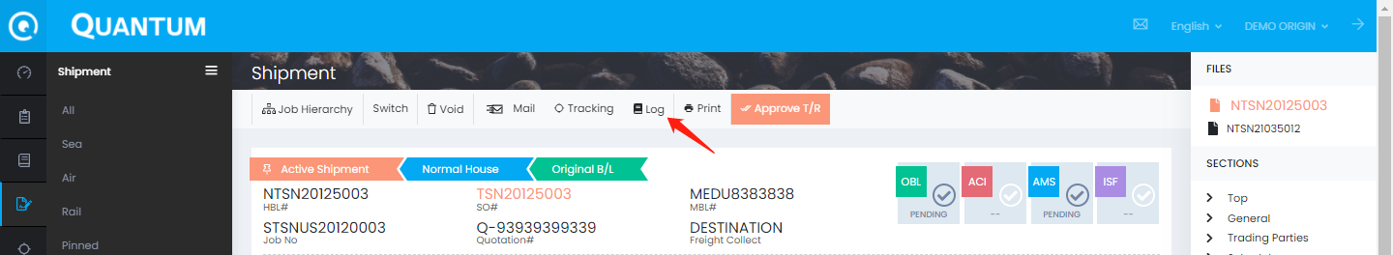
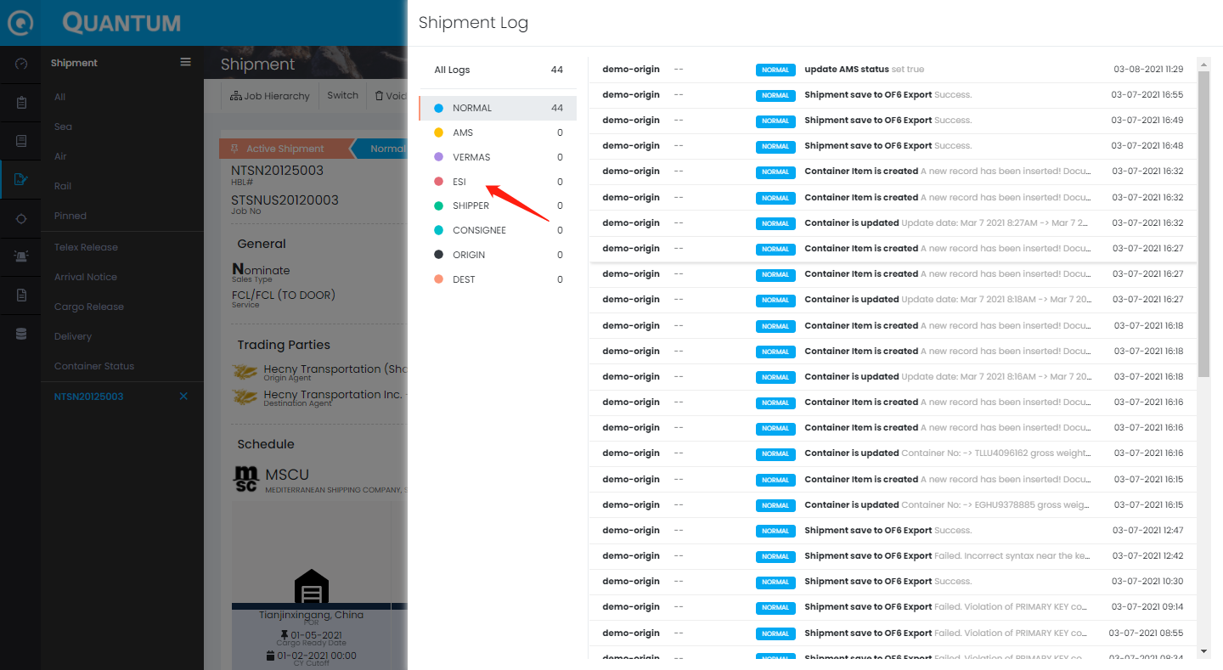

SUBMIT AMS/ISF - USA CUSTOMS-未完成
Purpose: Submit AMS/ISF to USA customs
When: Before customs cut off time (AMS/ISF)
- There are 2 check boxes in the top of the shipment detail
- If the place of delivery are USA or CAN, it will be default checked
- If you want to uncheck it because there is no need to submit AMS/ISF to customs, you may click on it
- Select the remove reason
- Click OK to confirm
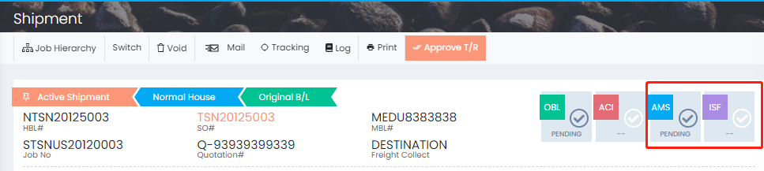
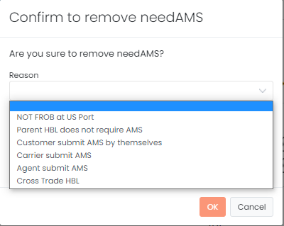
**Data from Quantum will be synced to OF6. Please follow the original process at this moment.
In the next stage, we will integrate this session in Quantum.

SUBMIT ACI - CAN CUSTOMS-未完成
Purpose: Submit ACI to CAN customs
When: Before customs cut off time (ACI)
- There are 1 check box in the top of the shipment detail
- If the place of delivery are USA or CAN, it will be default checked
- If you want to uncheck it because there is no need to submit ACI to customs, you may click on it
- Select the remove reason
- Click OK to confirm
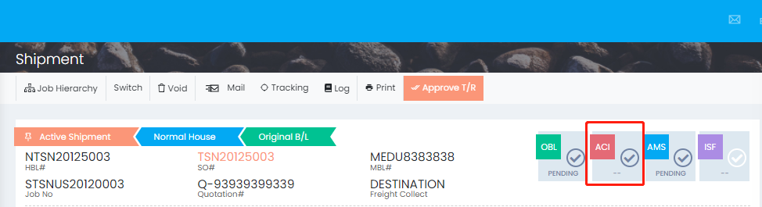
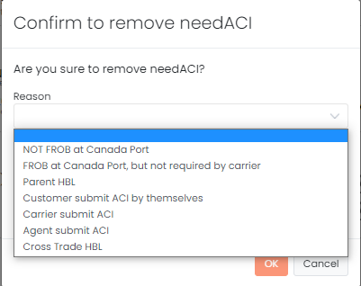

**Data from Quantum will be synced to OF6. Please follow the original process at this moment.
In the next stage, we will integrate this session in Quantum.

发送PRE-ALERT给国外代理
Purpose: 通知目的地代理，已经开船，他们将准备货物进口
When: 开船后5天内
- 打开HBL后再上门的工具栏找到‘Mail’
- 单击“Compose”挑选邮件模板
- 选择“Sea Pre-Alert” 或者 ‘Pre-Alert (NONUSA)，然后单击“应用模板”
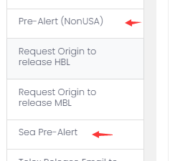
- 根据需要调整收件人/发件人、邮件详细信息
- 如果需要，选择/添加附件
用户可以先把相关文件上传到 Attachments，这样，在这里只要勾选文件就可以。
在这里添加附件的文件不会上传到Attachments
- 如果确认内容正确，请单击“发送”
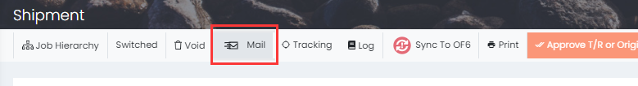
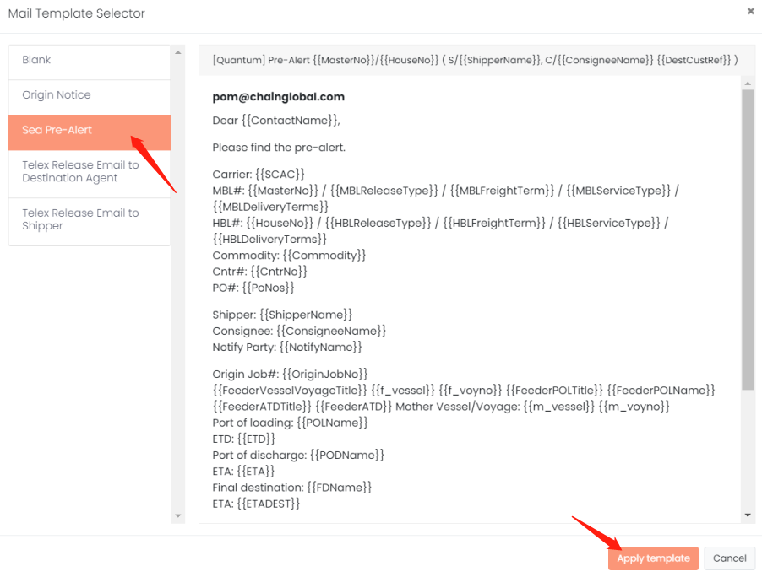
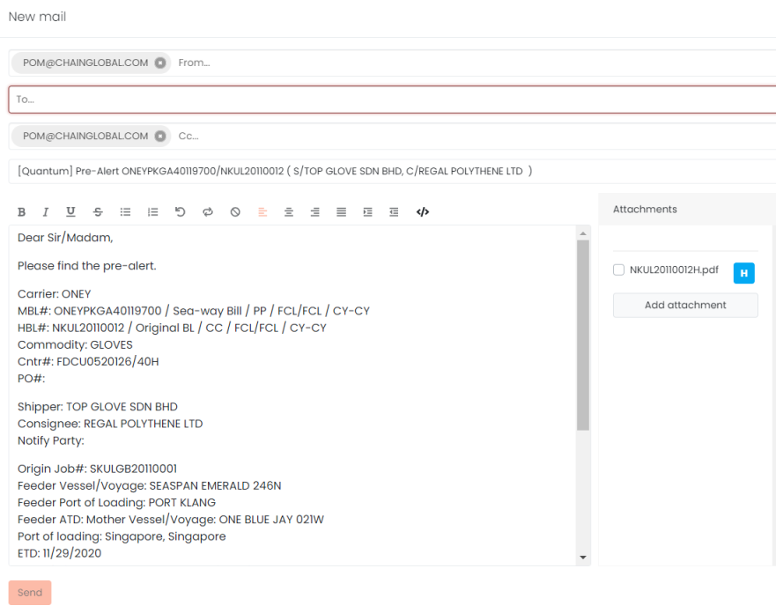

TRACKING
Purpose: Showing the last event and the tracking
When: Whenever user would like to track the containers, shipments, POs
- Go to Tracking and select the tracking type
- Search date range, number, customer name in the search panel
- View the list of result with last event
- Click on the numbers, i.e. container#, seal# to view the tracking
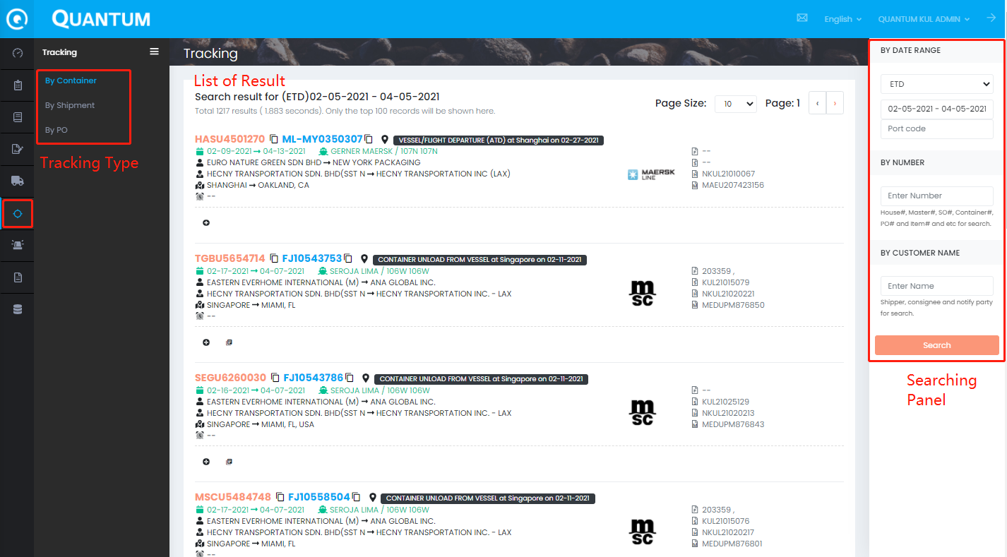
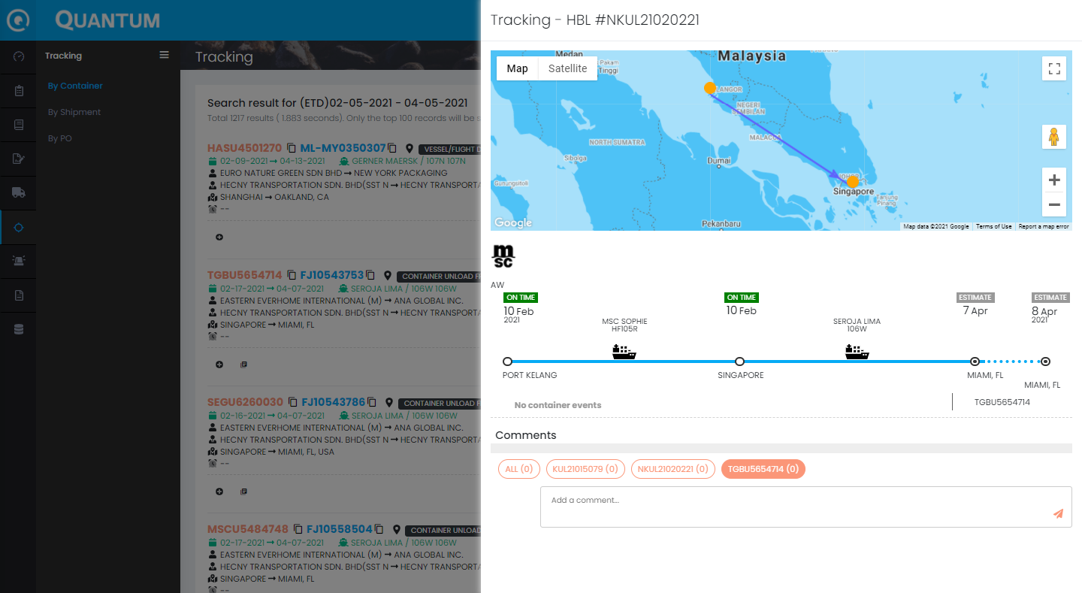

REPORT
Purpose: Generate the station report
When: Based on request
- Go to Reports
- Select Station folder
- Click Setting to select the criteria
- Amend the criteria
- Click Generate to export the raw data/Submit to Report Agent to generate the report from report server
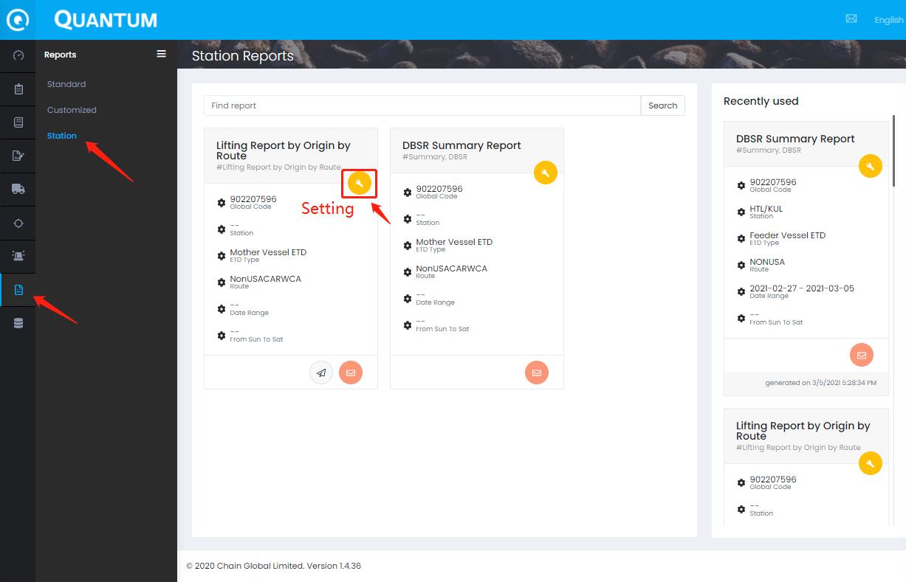
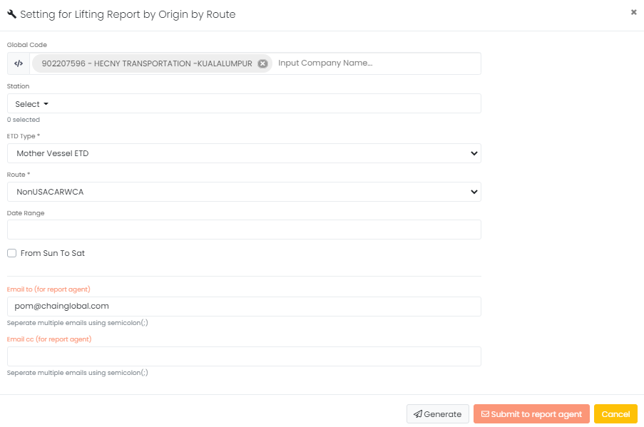

FAQ

Sales & RSR Selection
海运部门
- 我们应该为HECNY美国公司的提单选择正确的销售
- 如果这是USA R/O，请使用收货人+美国销售作为RSR
- 如果只是Hecny USA站业务，我们应该选择Hecny USA站作为RSR
- 如有遗失，请联系support@chainglobal.com

Helpdesk Contact
The Quantum Team is responsible for system testing, implementation, and helpdesk. If need any enquiry, you can contact the following key persons to resolve the daily operation issue.
Name | Role | Contact Information | Service Regions
Happy Lee | Helpdesk Manager | happylee@chainglobal.com | International
Eric Chan | Supply Chain Officer | ericchan@chainglobal.com | International
Support Team | Support Team | support@chainglobal.com | International
Judy Qin | Import Lead | judyqin@chainglobal.com | China & Taiwan
Chris Chen | Export Lead | chrischen@chainglobal.com | China & Taiwan

DOCUMENT HISTORY
Date | Prepared by | Change description | Reviewed by
2021-02-03 | Dennis Law | Initiation
2021-03-02 | Dennis Law | General content
2021-03-10 | Dennis Law | Finalize 1st Draft
2021-04-07 | Dennis Law | FAQ – Sales & RSR
2021-06-07 | Chris Chen | Chinese

